INVENTORY OF CONTENTS AND SCHEDULE OF CONDITION
Client
Property address
Date | 05/11/2014
Property type | 3 bedroom furnished garden apartment.
Clerk | James Cook

Inside Out Inventories
26 York Street
London
W1U 6PZ
info@insideoutinventories.co.uk
07515 884 894 - 0207 760 7624

Contents

SCHEDULE OF CONDITION 4
KEYS 5
UTILITIES 6
SIGNATURES 7
FRONT EXTERIOR 8
ENTRANCE AND SMALL HALLWAY 10
UNDER STAIRS STORAGE ROOM 14
RECEPTION ROOM (OPEN PLAN FROM ENTRANCE HALLWAY) 17
KITCHEN (NOT INCLUDING DINING ROOM) 24
DINING ROOM (SEMI OPEN PLAN FROM KITCHEN) 36
STAIRS LEADING UP 40
FIRST FLOOR LANDING 42
BEDROOM 1 (REAR OF PROPERTY) 45
BATHROOM 49
BEDROOM 2 (MIDDLE BEDROOM) 54
BEDROOM 3 (FRONT OF PROPERTY) 59
REAR GARDEN 64
Check-In Declaration – sign & print all names 71

SCHEDULE OF CONDITION
Cleaning | Professionally cleaned.
General Overview | 3 bedroom furnished garden apartment.
Decorative condition | Freshly decorated with light usage as noted.
Flooring | Carpets professionally cleaned with light usage as noted. Light scratches to wooden flooring.
Windows | Glazing sound and clean to both interiors and exteriors.
Curtains/Blinds | All in good working order.
Lighting | All lights tested and in working order unless noted.
Linen | Freshly laundered.
Furniture & Upholstery | Good order with minor defects as noted.
Kitchen & Appliances | All appliances tested for power and clean.
Bathroom | Water outlets working and clean.
Outside Space | Good seasonal order. Lawn patchy where noted.

KEYS

KEY TYPE | DOOR | COMMENT
3 x Banham. | Front. | Serial 0125112
3 x Banham. | Front. | Serial 11183537
3 x Chubb. | Back.
5 x mixed. | Windows and doors.
Keys to be handed to tenants by landlord.

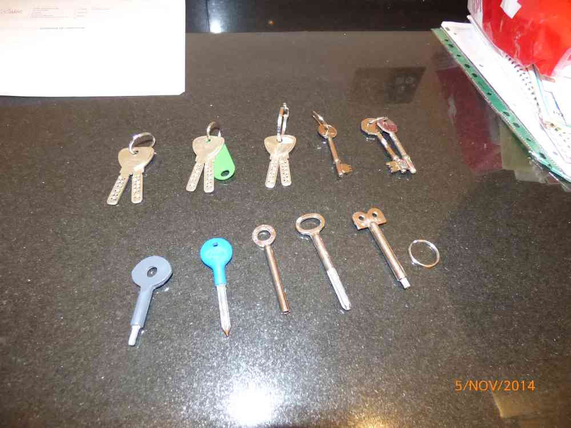

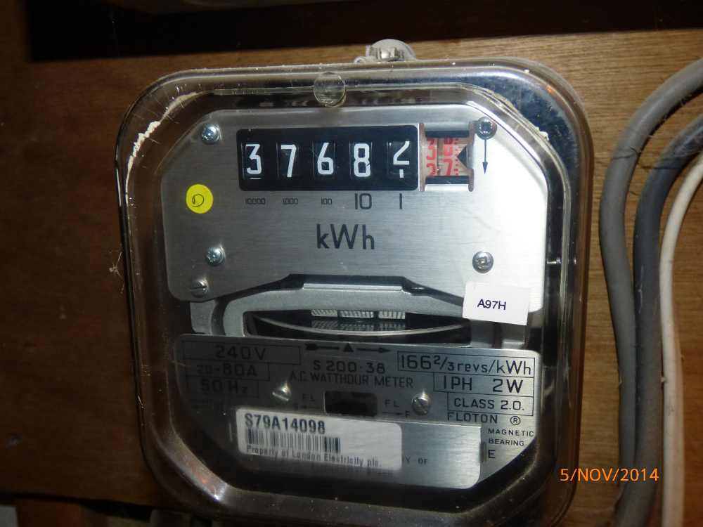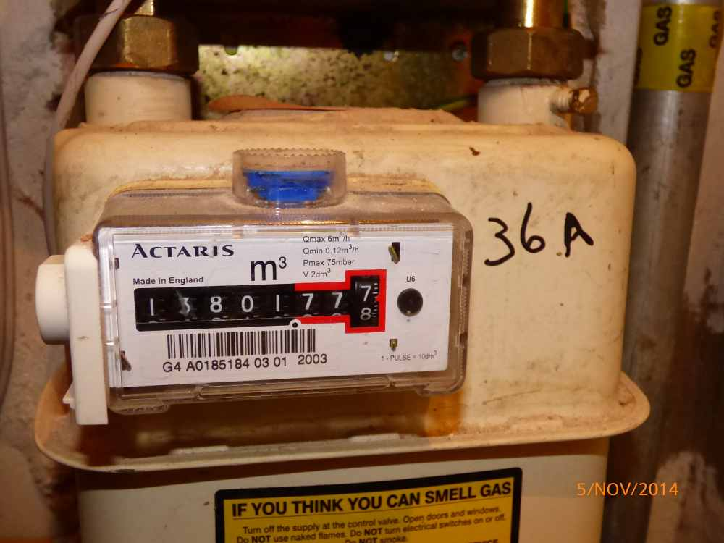

UTILITIES

 | Location | Serial | Reading | Supplier
GAS | Under stairs storage room. | A0185184 | 13801.778
ELECTRICITY | Under stairs storage room. | S79A14089 | 37682.38
WATER | NA.

SIGNATURES
 | Name | Signature | Date
Tenant
Landlord
Clerk

FRONT EXTERIOR
ITEM |  |  | CHECK IN COMMENTS | CHECK OUT
Flooring
 | Part concrete steps. |  | Slightly discoloured and weathered.  Light leaf debris.
 | Part pebble. |  | Leaf debris.
Walls
 | Part painted cream.  Part exposed brickwork.  Part wooden slatted fence. |  | Light marks and shading in places.
 |  | Left wall
 |  | Facing wall
 |  | Right wall
 |  | Rear wall
Woodwork
 | White painted exterior frames. |  | Paint peeling at lower level to centre frame.  General light discolouration.
Lighting
 | 1 wall mounted infrared flood light. |  | Not tested.
Miscellaneous Items
 | 1 black painted wall mounted handrail. |  | Slightly worn.
 | 1 white plastic wall mounted Barry Bros alarm panel with LED light.
 | 1 wall mounted satellite dish.
 | 2 drain pipes.
 | 1 bush. |  | In fair condition.
 | 1 brown and black rubber floor mat. |  | Worn and discoloured.

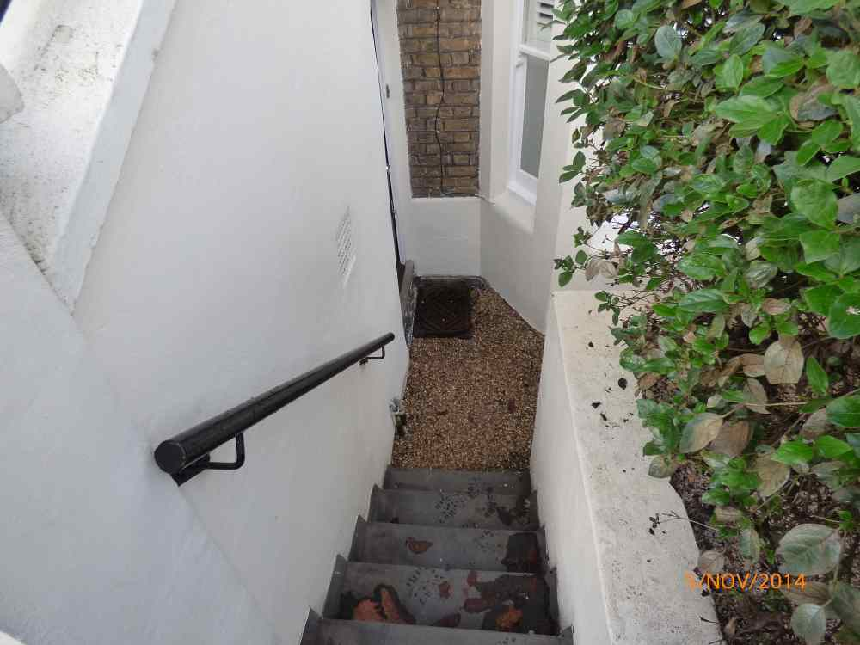 | 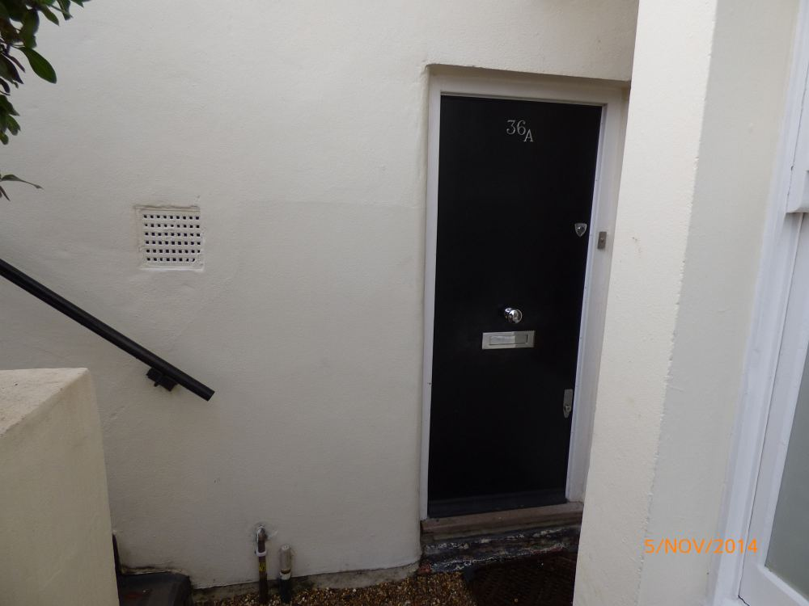 | 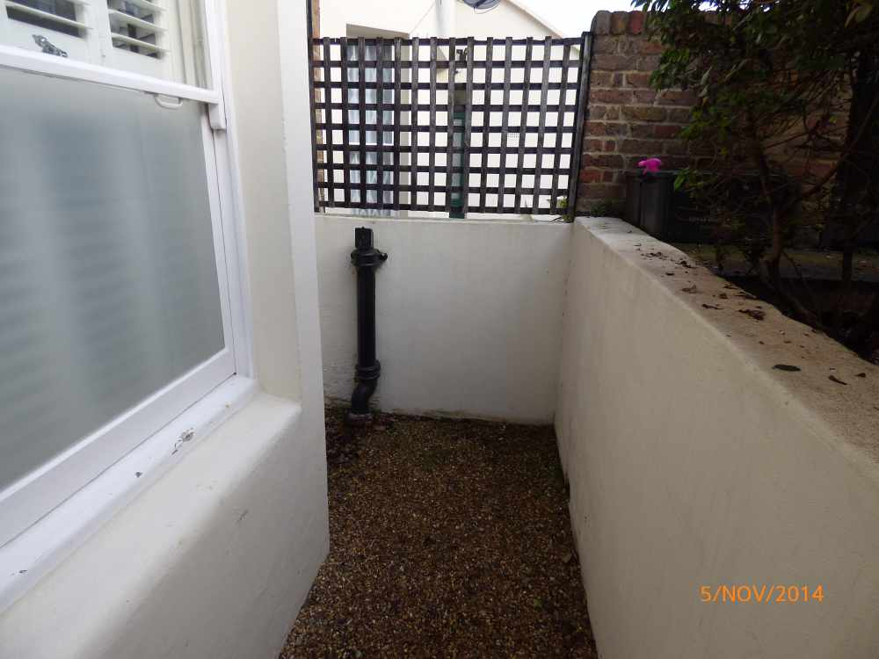 | 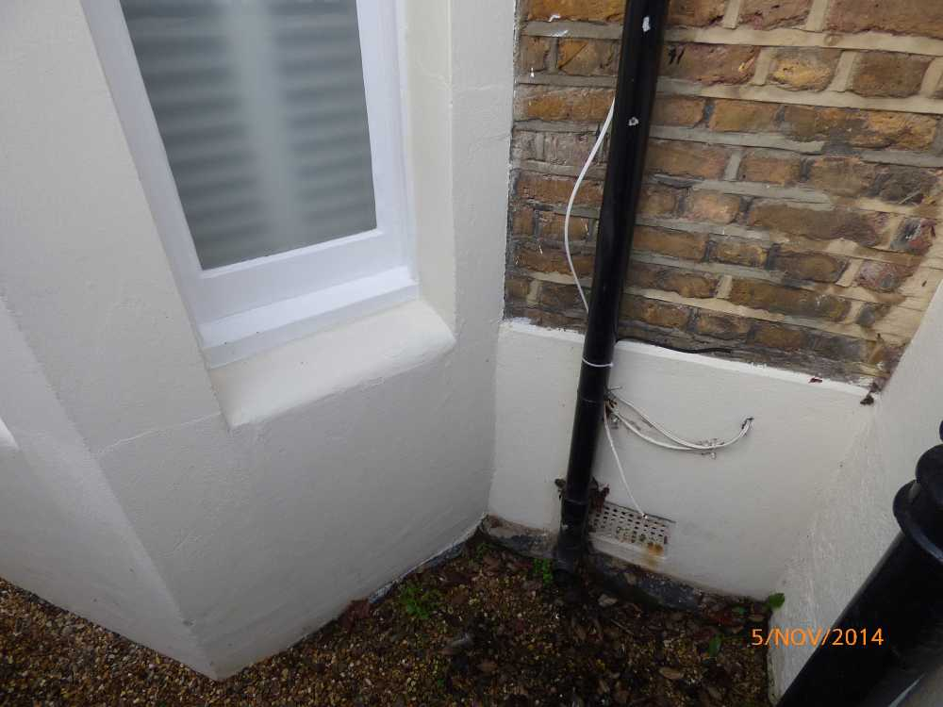
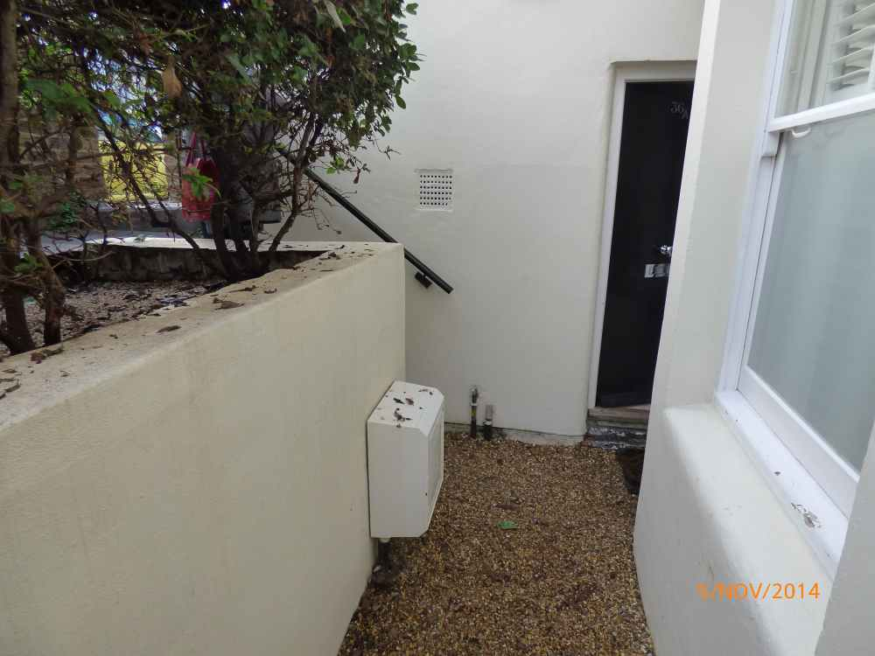 | 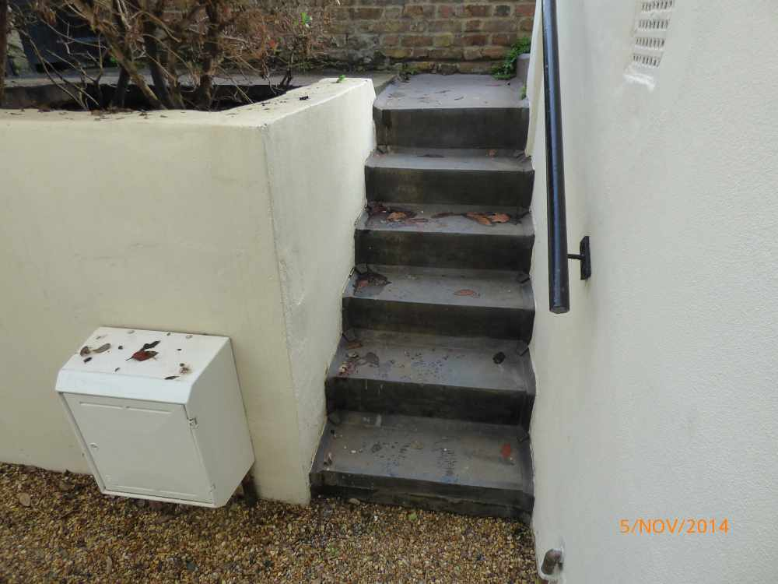

ENTRANCE AND SMALL HALLWAY
ITEM |  |  | CHECK IN COMMENTS | CHECK OUT
Exterior door frame
 | Painted white. |  | Old defects under.  Several small chip marks.
 | White and black draught excluder to the edges.
 | 1 chrome doorbell. |  | In working order.  Lightly tarnished and discoloured.
Exterior door
 | Black painted flat panel wooden door. |  | Old defects under.  Paint marks at edges.  Several small chips to edges.  Numerous scattered scratch marks.  Slightly worn.
 | 2 metal Banham locks. |  | Tarnished.
 | 1 circular chrome pull.
 | 1 chrome letterbox with flap. |  | Tarnished.
 | Numeral ‘36A’ in chrome.
 | 1 black wooden kick plate. |  | Slightly worn.
Threshold
 | Wooden. |  | Worn, scratched and discoloured.
Interior door frame
 | Painted magnolia. |  | Old defects under.
 | 1 white metal London bar fitted. |  | Slightly discoloured.
 | 1 Birmingham bar fitted to right hand side.
Interior door
 | Magnolia painted flat panel wooden door. |  | Old defects under.  Few very light marks.  Chipping/cracking around the bolt.
 | 2 chrome Banham locks. |  | Lightly tarnished and paint marked.
 | 1 white metal letterbox cover.
 | 1 metal bolt.
 | 2 magnolia painted plastic alarm contact points.
 | 1 chrome and black draught excluder strip.
Flooring
 | Cream fitted wooden strip flooring. |  | Main tread slightly worn and discoloured.  Numerous light surface scratch marks.  Few minor paint marks.
Skirting boards/woodwork
 | Magnolia painted skirting boards. |  | Old defects under.  Numerous scattered scuff marks.  Light angle chipping.  Several minor edge nicks.
Walls
 | Painted magnolia.
 |  | Left wall | Painted over rough patch around alarm panel.
 |  | Facing wall | Red large scuff mark to centre.
 |  | Right wall
 |  | Rear wall | Numerous light marks mid to lower level left hand side.  Several angle chip marks left hand side.
Switches and sockets
 | 1 chrome triple light switch. |  | Paint marked.
 | 1 plastic wall mounted alarm push button panel. |  | Paint marked and discoloured.
 | 1 white plastic wall mounted siren. |  | Not tested.  Paint marked and discoloured.
Ceiling
 | Painted white.
Lighting
 | 4 ceiling mounted recessed spotlights. |  | All tested.  1 not working.  Light fittings not fully flush with ceiling.
Furniture/accessories
 | 1 clear plastic and glittered wall mounted batten containing 5 chrome double clothes hooks. |  | Slightly scratched and paint marked.
 | 1 large umbrella.

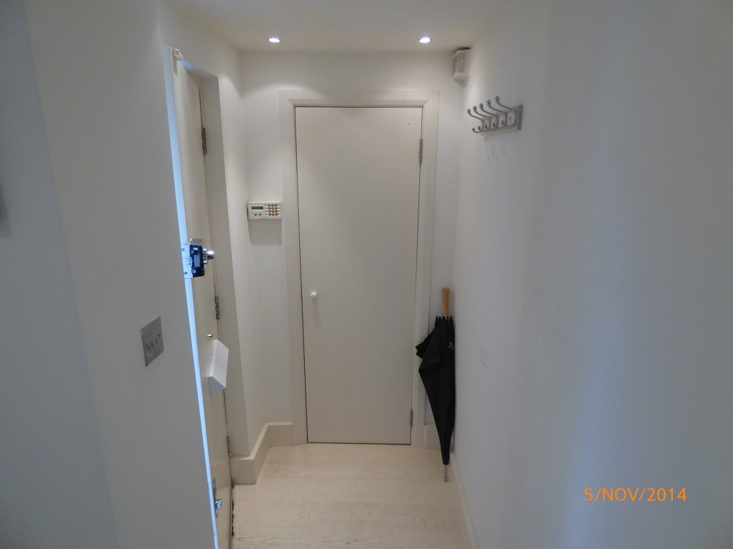 | 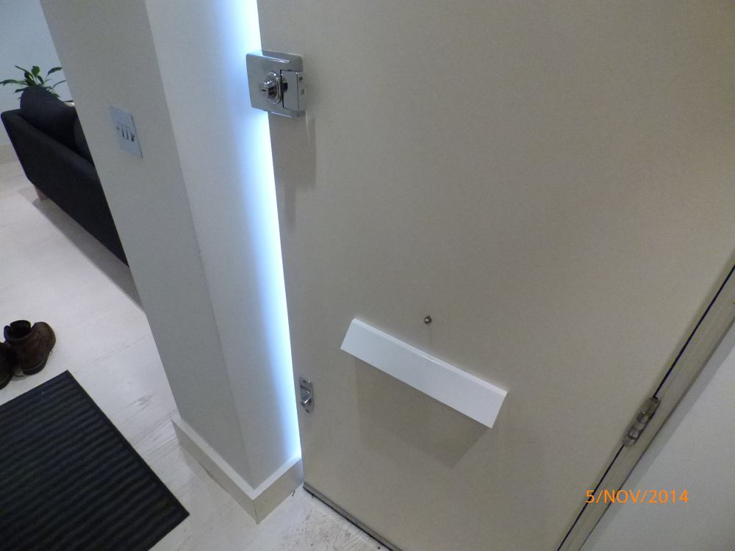 | 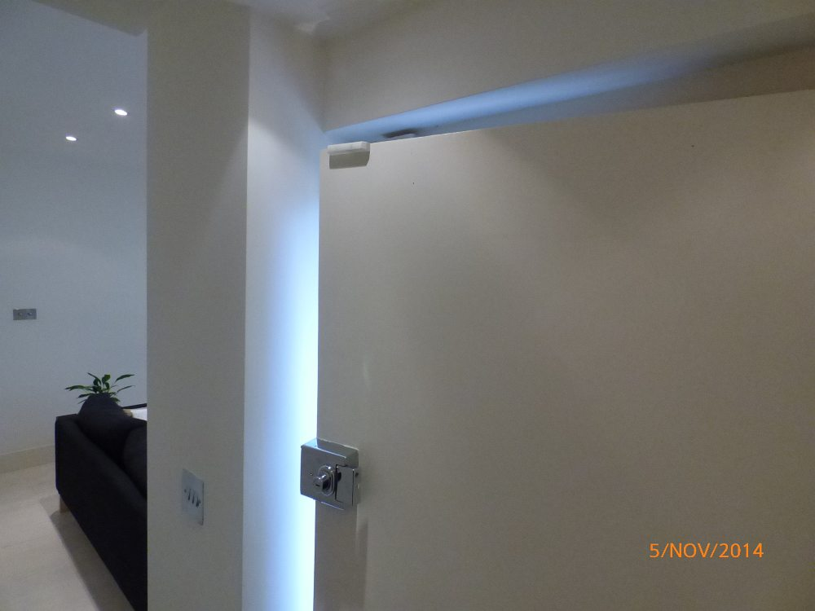 | 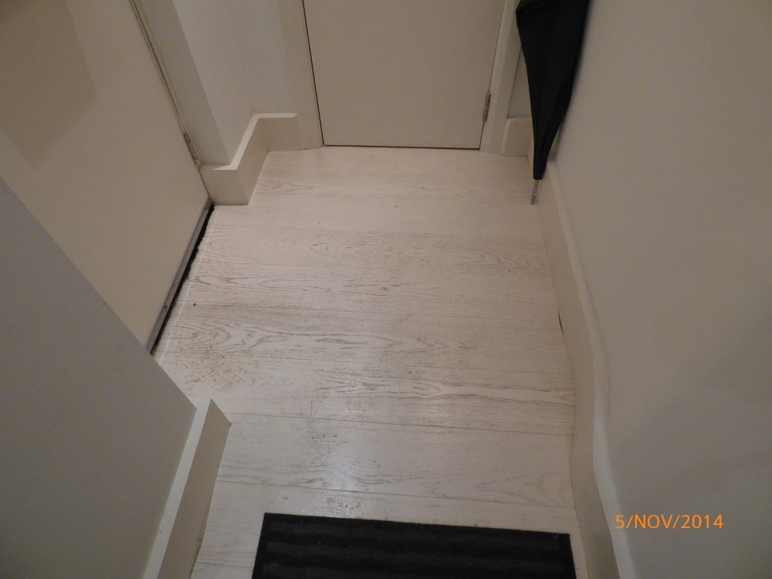
 |  |  | Scratches to flooring
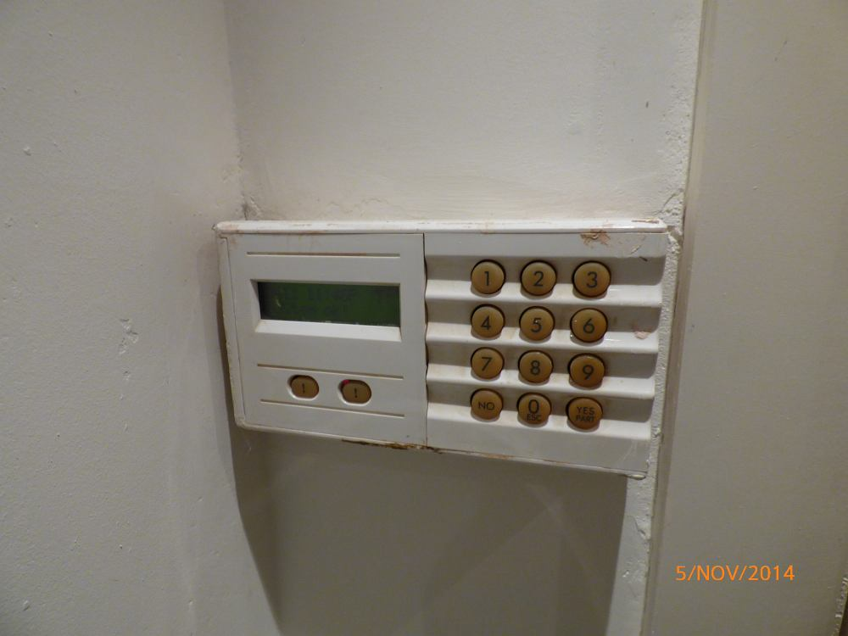
Paint marks to alarm panel

UNDER STAIRS STORAGE ROOM
ITEM |  |  | CHECK IN COMMENTS | CHECK OUT
Exterior door frame
 | Painted magnolia. |  | Old defects under.  Few minor finger marks.
Exterior door
 | Magnolia painted flat panel wooden door. |  | Several light scattered marks.  3 fitment holes at high level.
 | 1 circular white plastic pull.
Interior door frame
 | Painted magnolia. |  | Not fully painted.  Several scattered marks and chip marks.  Dusty.
Interior door
 | Magnolia painted flat panel wooden door. |  | Light angle nicks.  Several light scattered scuff marks.
Flooring
 | Concrete flooring. |  | Generally worn and discoloured throughout.  Sections cracked forward of entrance.  Not inspected below items.
Walls
 | Painted white. |  | Numerous scattered cracks and marks throughout.  Numerous watermarks.  Walls generally in poor condition.
 |  | Left wall | 1 painted over air vent.
 |  | Facing wall
 |  | Right wall
 |  | Rear wall
Switches and sockets
 | 1 white plastic single light switch. |  | Dusty.
 | 1 large plastic wall mounted fuse box with 2 plastic covers. |  | Paint marked and dusty.
 | 1 electricity meter.
 | 1 white plastic blanking plate.
 | 1 white plastic wall mounted Friedland doorbell chime. |  | Discoloured and paint marked.
 | 1 black plastic double fuse socket.
 | 1 white metal electrical panel.
 | Various wires to right hand side and rear walls.
Ceiling
 | Painted white. |  | Cracked and discoloured with numerous watermarks.  Generally in poor condition.  Numerous cracks and small sections missing.
Lighting
 | 1 plastic wall mounted light fitting. |  | No shade.  In working order.  Slightly discoloured.
Miscellaneous Items
 | Several wall mounted water pipes.
 | 1 wall mounted gas pipe.
 | 1 wall mounted gas meter. |  | Discoloured and paint marked.
 | Numerous empty boxes.
 | Numerous spare pieces of wooden flooring.
 | 1 spare of paint pot.
 | Several rolled up pieces of spare carpet cut-offs.

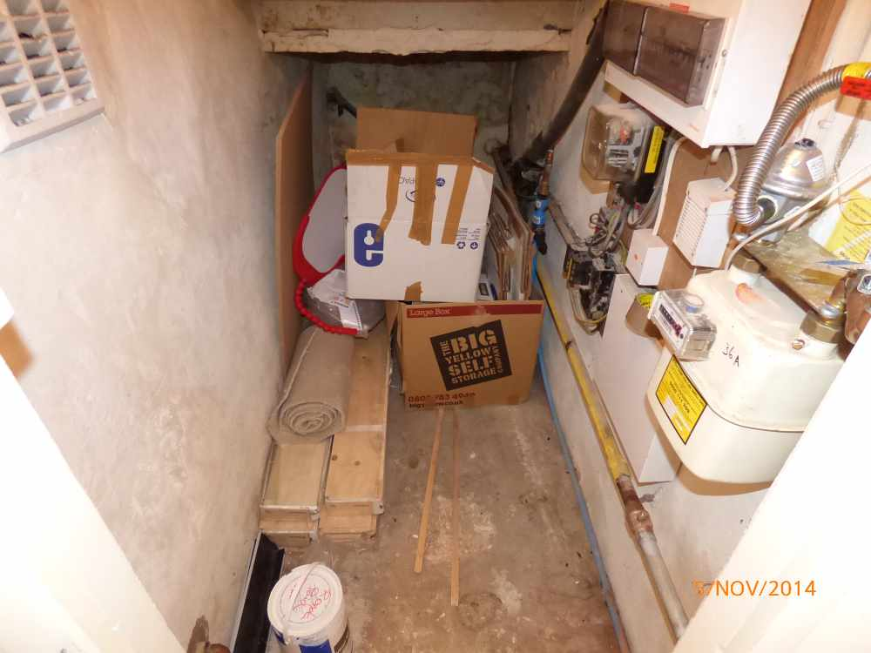 | 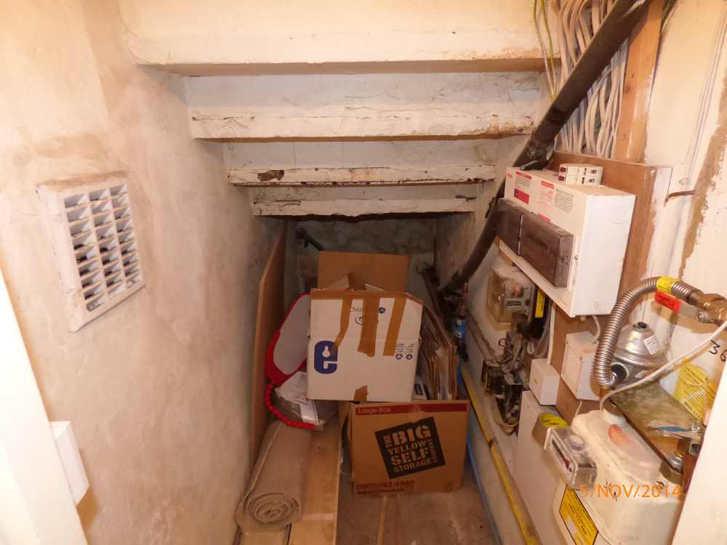 | 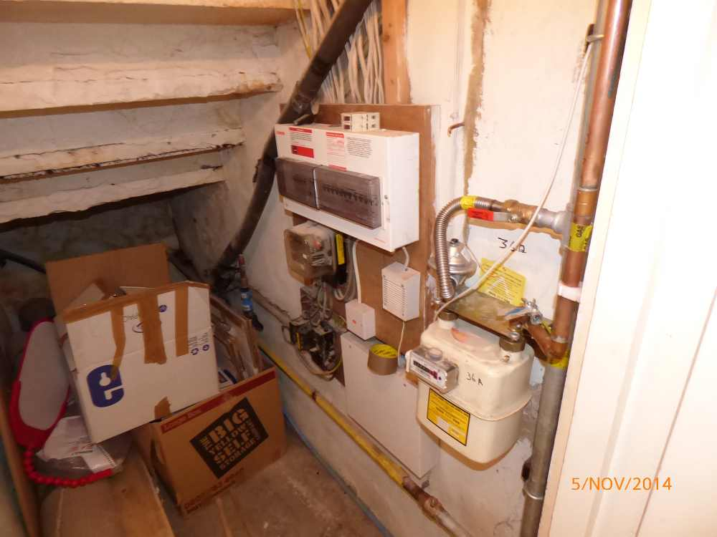 | 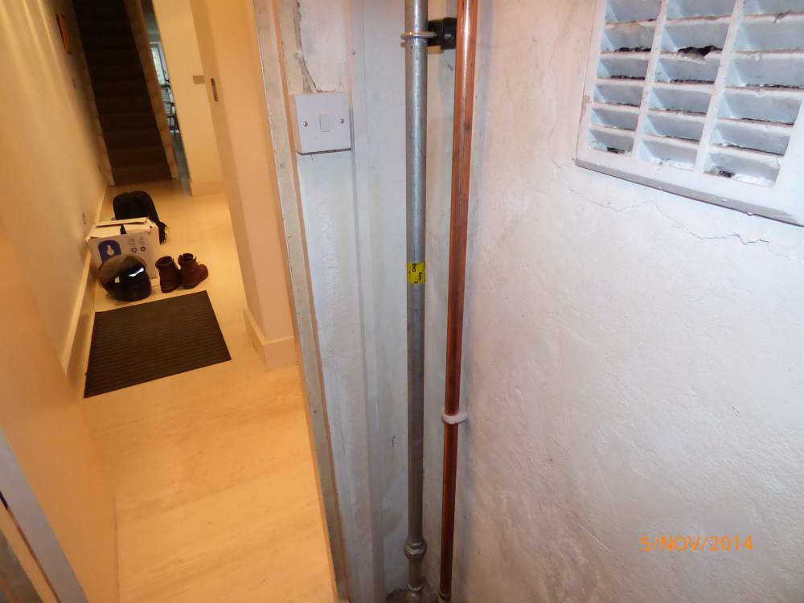

RECEPTION ROOM (OPEN PLAN FROM ENTRANCE HALLWAY)
ITEM |  |  | CHECK IN COMMENTS | CHECK OUT
Flooring
 | Cream fitted strip flooring. |  | Several light scattered surface scratch marks.  Few small scuff marks.  Generally in good condition.
Woodwork
 | Cream painted skirting boards. |  | Old defects under.  Slightly dusty.  General light usage marks.  Light angle chipping to corners in places.  Cabling clipped to section below window.
Walls
 | Painted magnolia. |  | Advised freshly painted.
 |  | Left wall | Few light usage marks.  Light shrinkage cracks to centre.
 |  | Facing wall | Few minor usage marks mid to lower level.
 |  | Right wall | Light usage marks around left hand side shelf.
 |  | Rear wall | Few minor finger marks mid to lower level to right hand section.  1 painted over air vent to high level.
Switches and sockets
 | 5 chrome double plug sockets. |  | Paint marked.
 | 1 chrome double dimmer switch.
 | 1 white plastic wall mounted BT telephone socket with ADL splitter with wire. |  | Slightly discoloured.
 | 1 white plastic wall mounted alarm motion sensor. |  | Not tested.  LED light working.  Discoloured and paint marked.
 | 1 plastic ceiling mounted Fire Angel smoke alarm. |  | Not tested.  LED light working.
Heating
 | Underfloor heating.
Windows
 | 3 white painted wooden sash windows containing:  A total of 6 single glazed panes.  2 chrome finger pulls.  1 chrome lock.  2 chrome locking bolts.  2 white window cords. |  | Frosting to lower 3 panes.  Glazing sound and clean.  Very light dust settlement.  Very light cracking to lower edges of lower left hand side frame.  Light scratch and paint marks to edges of panes.
Curtains/blinds/shutters
 | 8 white wooden folding slatted wooden shutters with adjustable slats. |  | Working.  In good condition.
Ceiling
 | Painted white. |  | Light patchy paintwork marks around window.
Lighting
 | 19 ceiling mounted recessed spotlights. |  | All tested.  1 not working.
Fireplace
 | Black slate base.  Cream granite surround and mantel.  Black slate inner section.  Gas decorative fire with artificial coals, metal surround and metal plate. |  | Base scratched and paint marked.  Surround generally worn and discoloured consistent with age.  2 small ring marks to mantel.  Several small chips to edges.  Large crack to rear wall interior section.  Several light marks to interior.  Interior dusty.  Decorative fire tarnished.
Furniture/accessories
 | 1 black 3-seater sofa with:  2 seat cushions.  2 back cushions.  2 armrests.  4 wooden legs. |  | Slight debris to underside.  Light usage marks to seat cushions and to armrests.  Fire label seen.
 | 1 green upholstered armchair with:  1 seat cushion.  2 armrests.  4 chrome legs. |  | Fire label seen.
 | 1 dark wooden framed armchair with dark leather seat and back section.
 | 1 6-foot tall black lamp with circular white shade. |  | In working order.
 | 1 x 30 inch tall 2-tier wooden table with:  4 wooden legs.  Wooden rippled edges to top section. |  | Numerous wooden ripples missing.  Ring marks and general wear to top section.  Several scratch marks throughout.
 | 1 wooden slatted storage box with removable lid. |  | Light usage marks.
 | 2 brown and floral patterned satin scatter cushions.
 | 2 white and grey patterned scatter cushions.
 | 2 black and white longer patterned scatter cushions.
 | 2 cream and red patterned scatter cushions.
 | 1 cream and grey patterned scatter cushion.
 | 1 approximate 32 inch Philips flat screen television. |  | Not tested.
 | 1 wall mounted canvas print of jugs.
 | 1 wall mounted print of jugs and a wine bottle in a wooden frame with glass front with initials ‘MJD’. |  | Frame slightly paint marked.
 | 1 wall mounted mirror in a mirrored frame.
 | 1 circular plastic rippled side table with 3 chrome legs. |  | Few minor paint spots.
 | 2 wooden bongo style drums.
 | 3 wooden elephant ornaments.
 | 1 crackling design glass vase.
 | 1 glass decanter with metal top.
 | 1 white plastic 6-socket extension lead.
 | 6 glass candle holders. |  | Discoloured.
 | 1 black metal ornament of a person.
 | 1 small green glass decanter with crystal lid.
 | 1 circular green glass paper weight.
 | 1 distress looked 12 inch square rippled plate.
 | 1 book by Keith Richards.
 | 1 white plastic cordless Vaillant digital heating control. |  | Not tested.
 | 5 wicker placemats.
 | 2 glass candle holders.
 | 1 square grey glass candle holder with candle.
 | 1 small purple and chrome container with lid.
 | 1 grey ornament of a turtle.
 | 2 further small grey ornaments.
 | 2 glass ornaments, one of cat, one of a dog.
 | 1 used candle in glass jar with metal lid.
 | 1 approximate 90cm long grey floor rug. |  | Worn and discoloured.
Built-in storage:
7 magnolia painted wall mounted shelves.
 | 1 small cream ceramic plant holder with plant. |  | Plant in fair condition.
 | Built-in storage 1 (left hand side):  Magnolia painted built-in storage unit with:  2 wooden slatted doors.  2 wooden pulls.  1 shelf to interior.  1 white plastic double socket to interior.  1 plastic telephone socket to interior. |  | Heavily scuffed to interior with several small chips.  Light scuffs to exterior.  Cut-out section to top section to accommodate cables.
 | Built-in storage 2 (right hand side):  Magnolia painted built-in storage unit with:  2 slatted wooden doors.  2 wooden pulls.  1 shelf to interior. |  | Scuff marks to interior.  Cut-out section to top section to accommodate pipes.  Light cracking to exterior edges.  Shelf not fully fitted to interior.  Several cut-out sections to interior to accommodate pipes and wires.

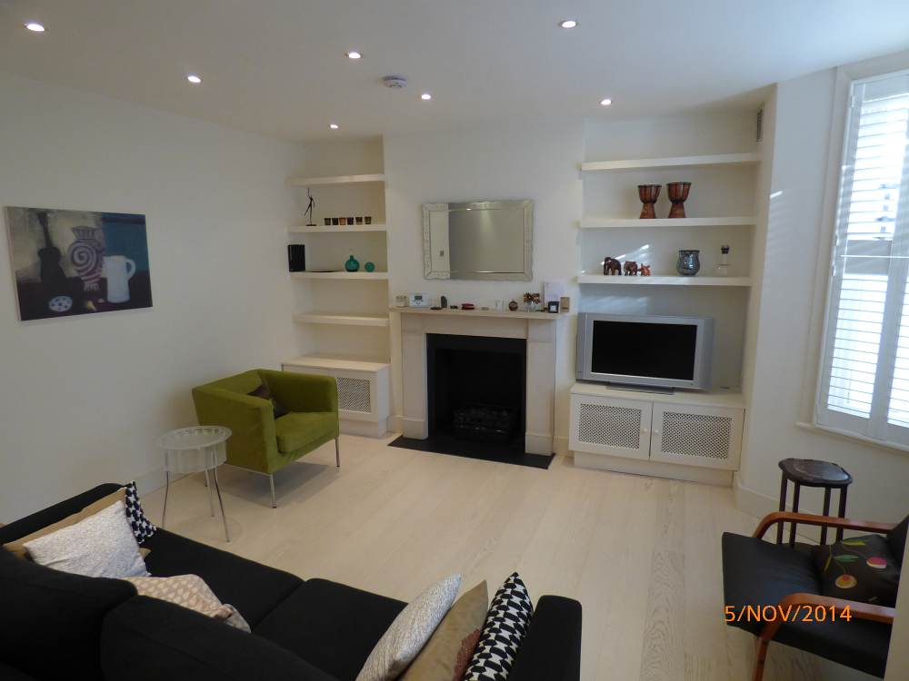 | 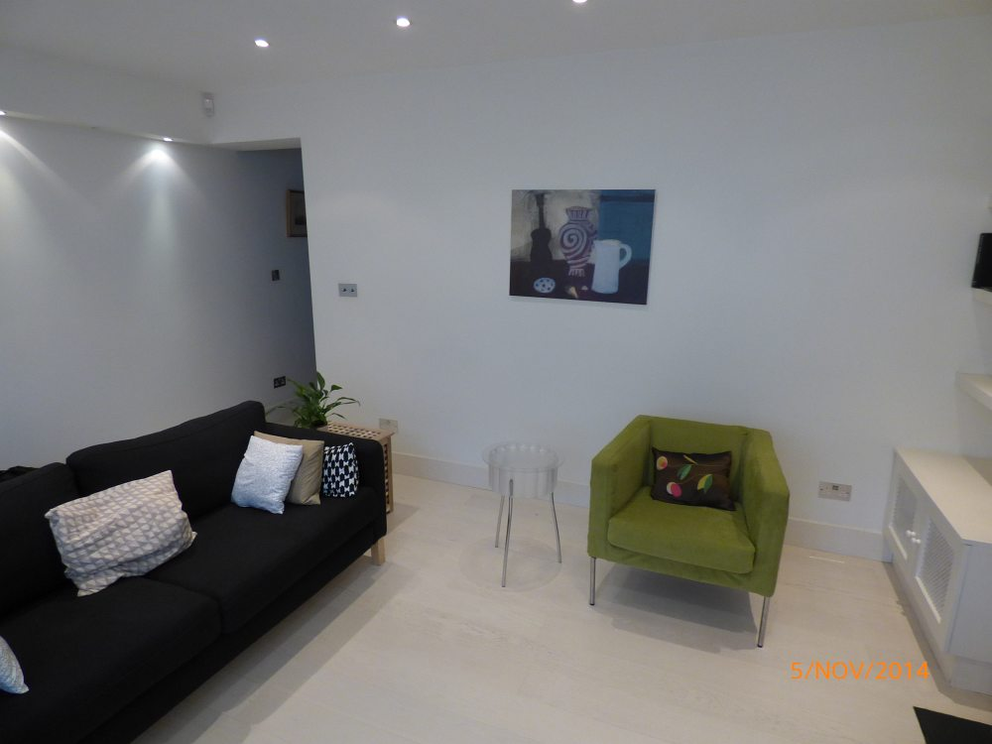 | 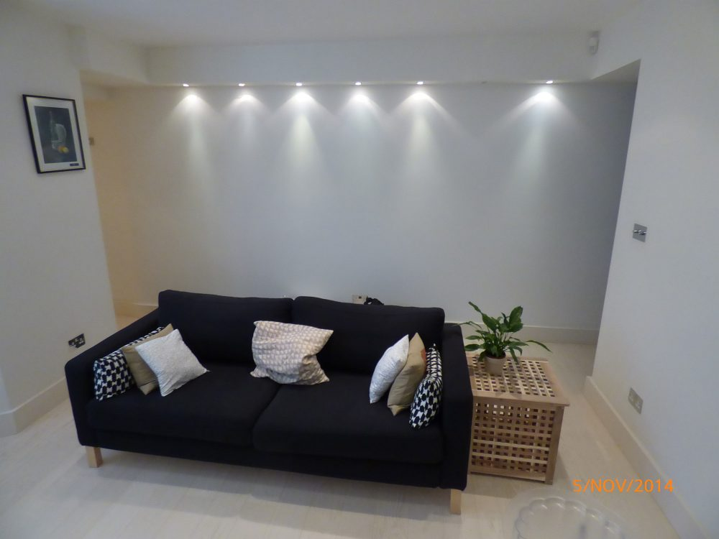 | 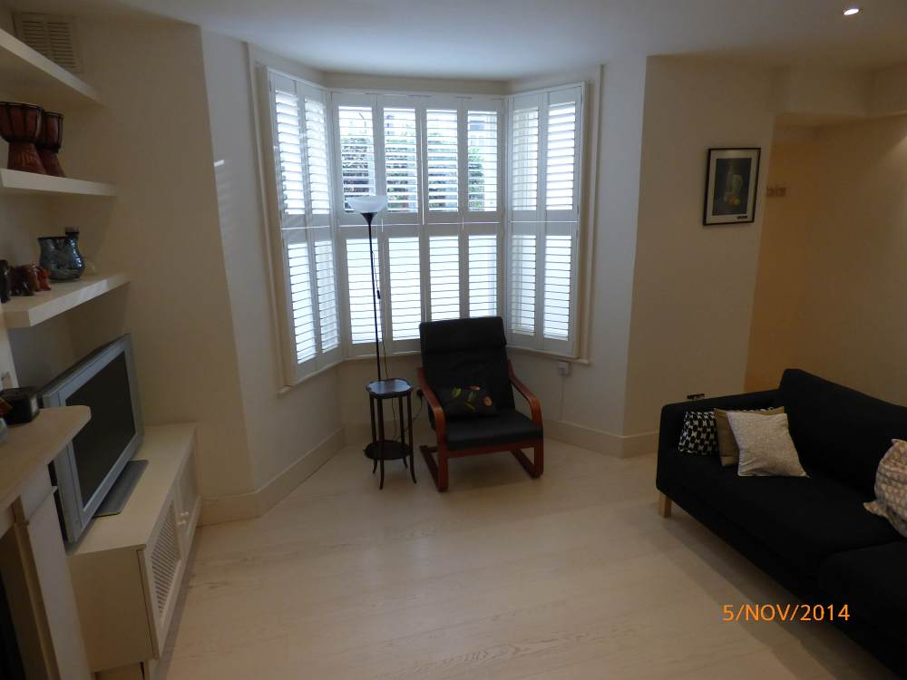
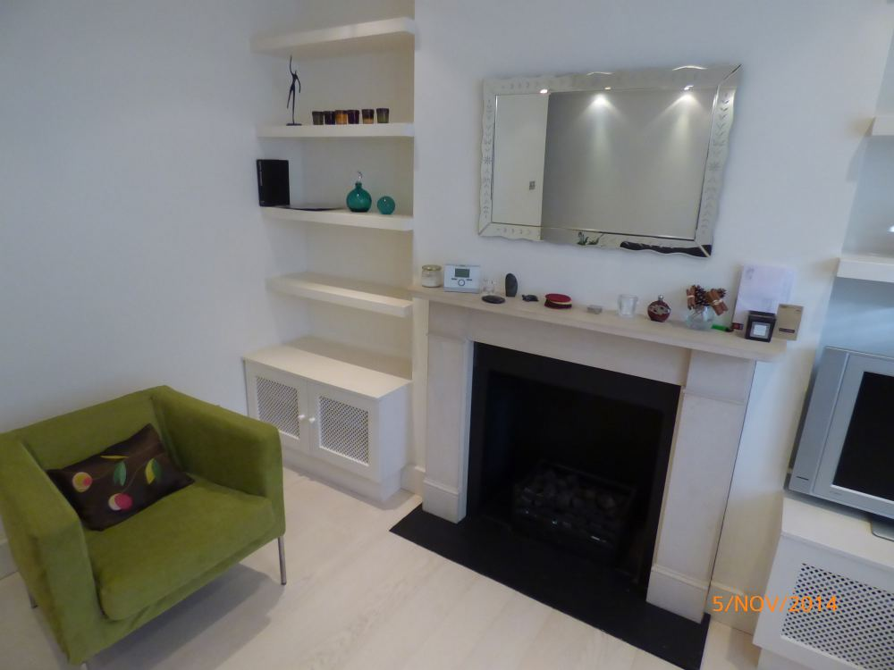 | 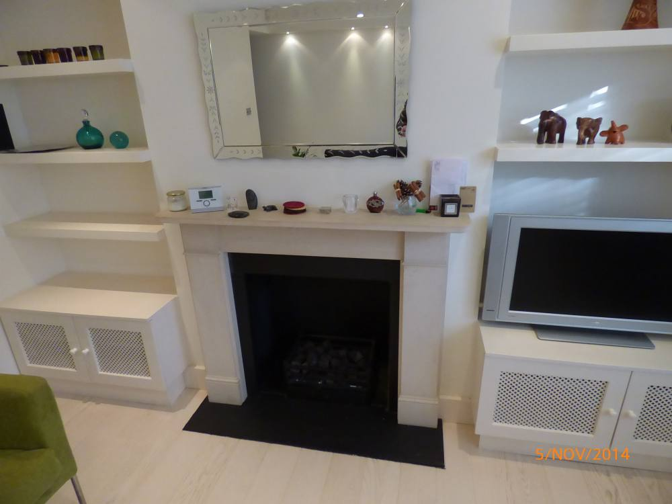 | 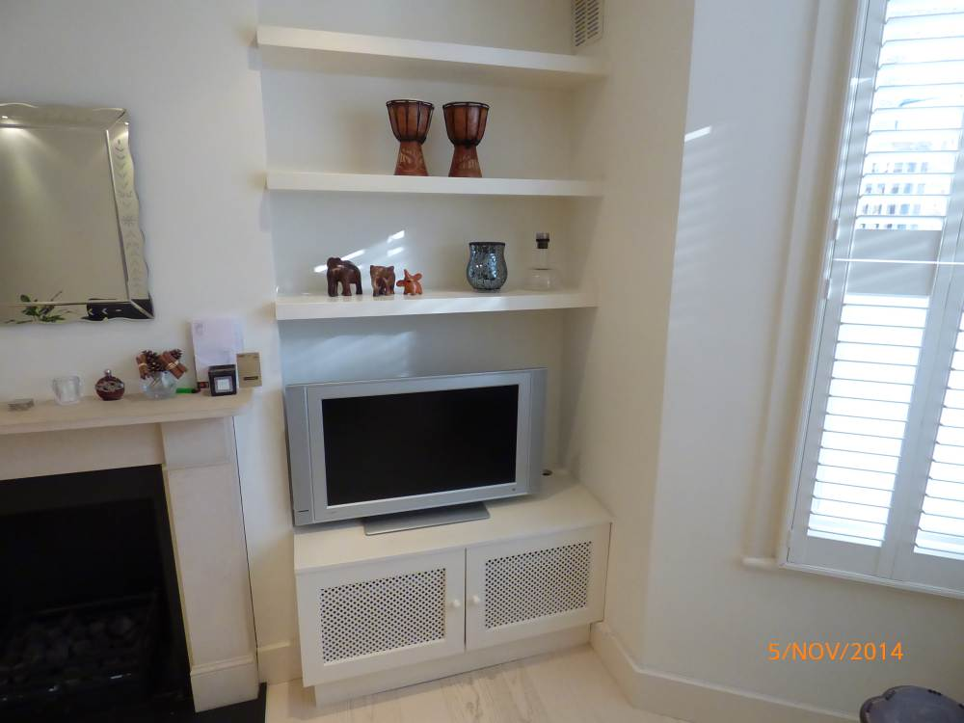 | 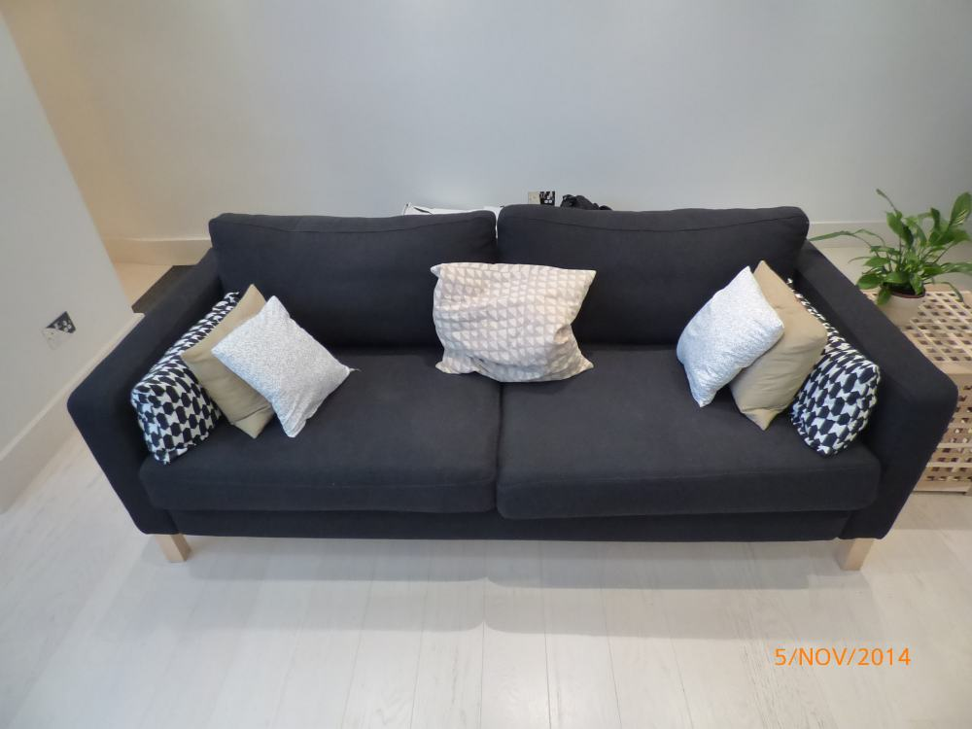
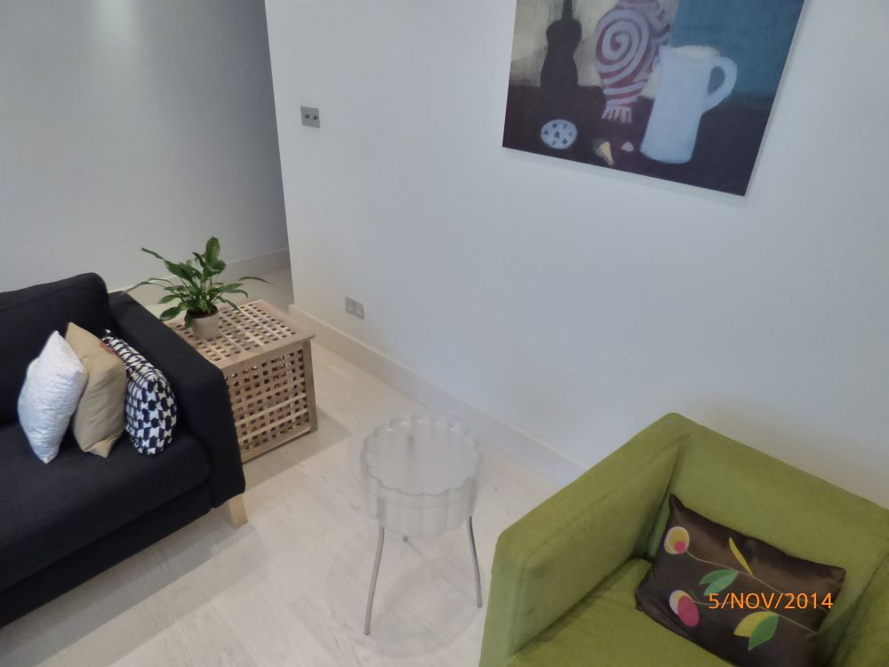 | 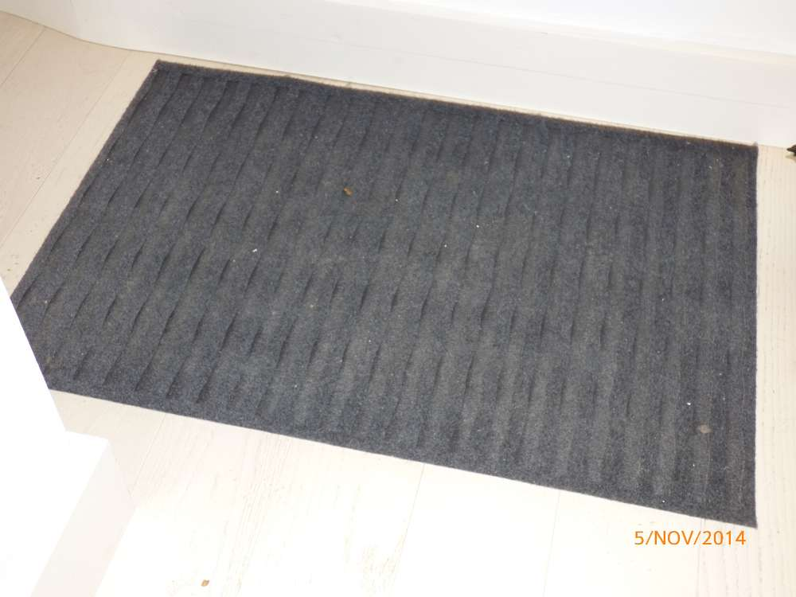 | 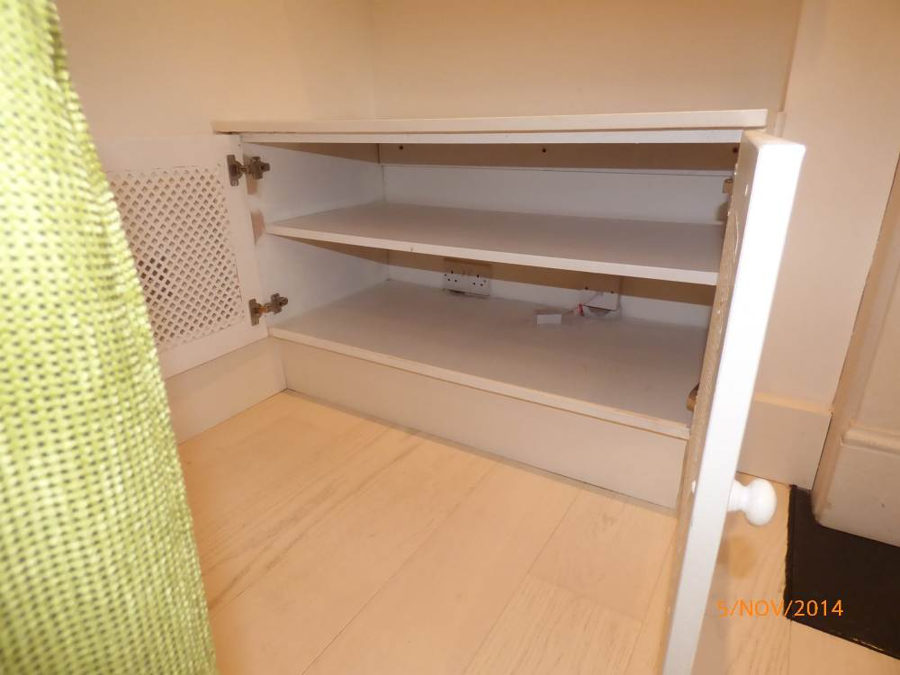 | 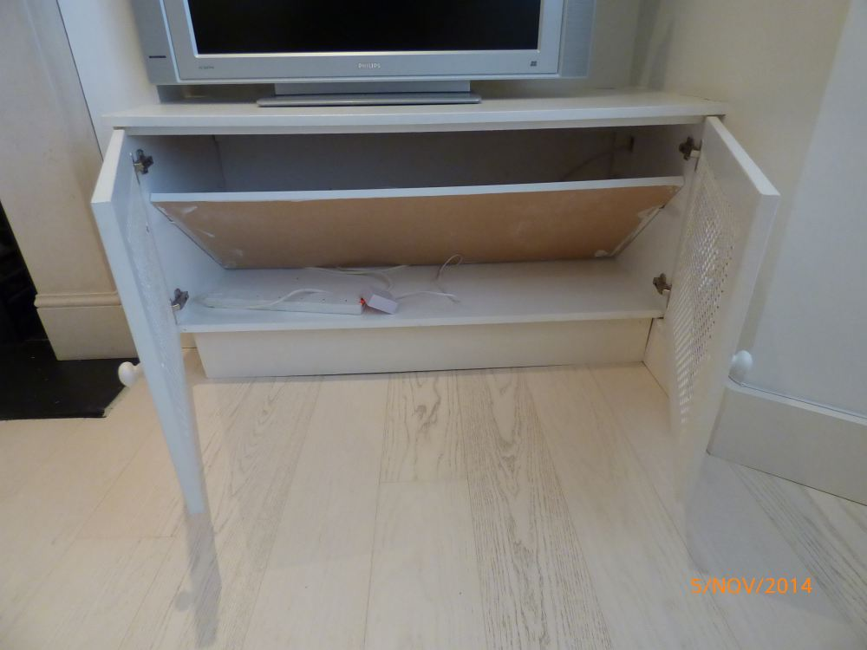

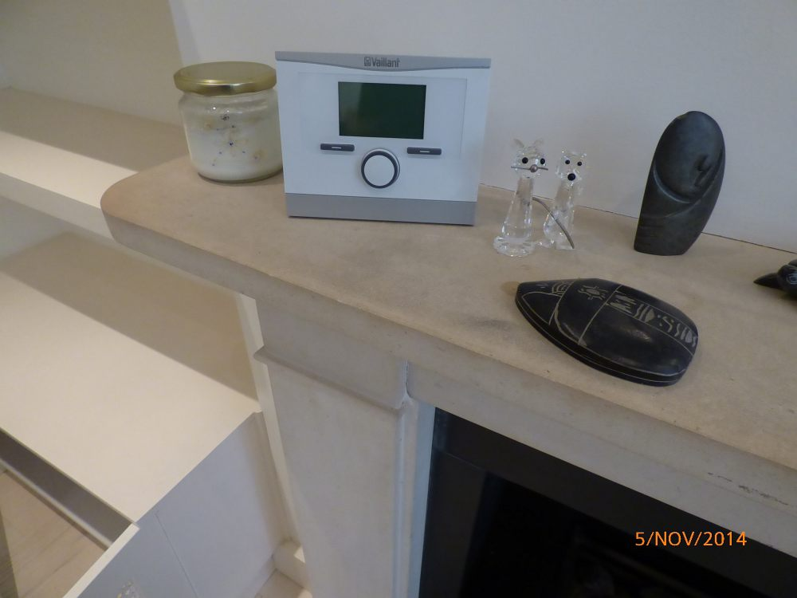 | 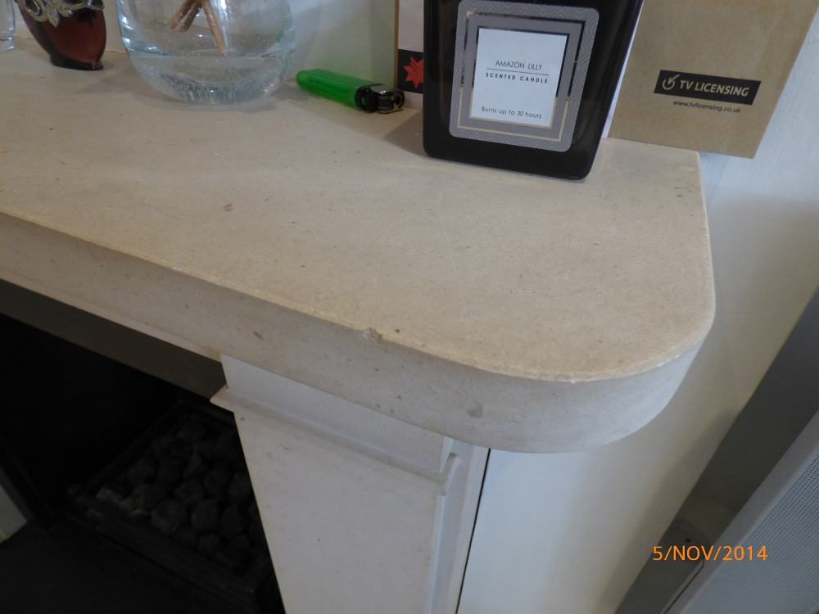 | 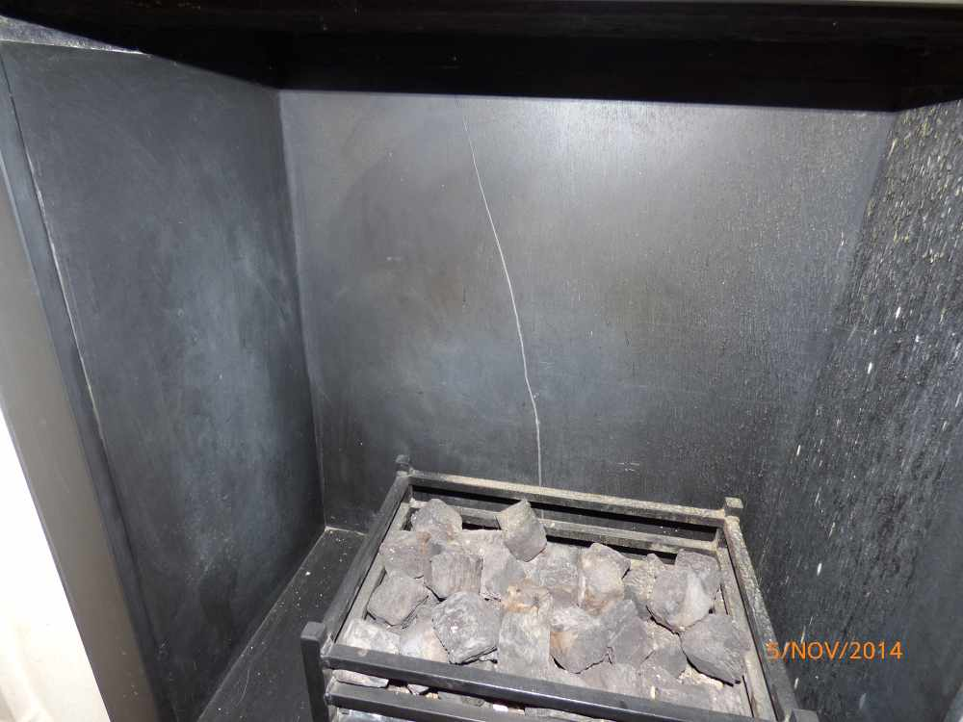 | 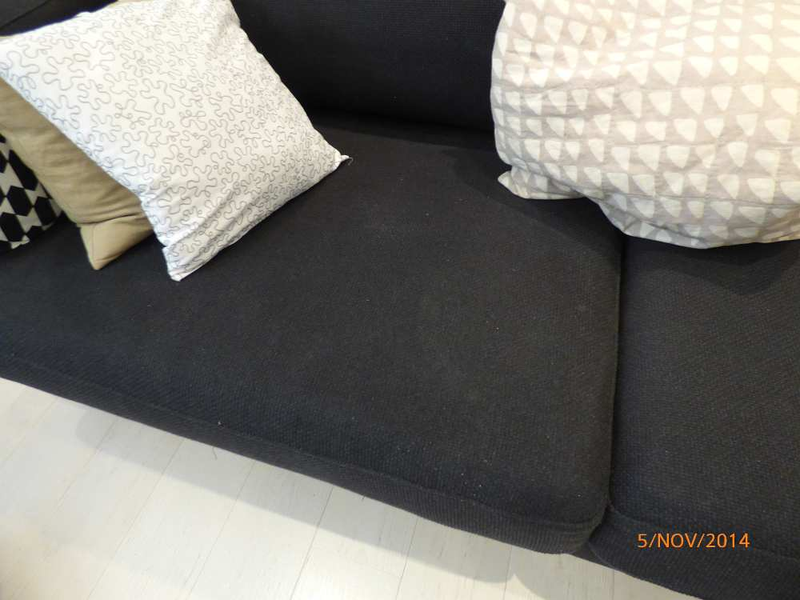
Shading to fireplace mantel | Chips to fireplace | Crack inside fireplace | Marks to sofa
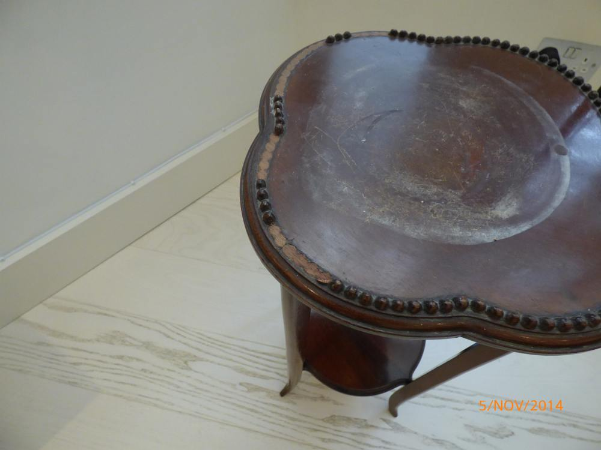
Condition of side table

KITCHEN (NOT INCLUDING DINING ROOM)
ITEM |  |  | CHECK IN COMMENTS | CHECK OUT
Flooring
 | Cream fitted wooden strip flooring. |  | Few light surface scratch marks.  Generally in good condition.
Woodwork
 | Painted magnolia. |  | General light usage marks.  Light angle chipping.  Section not seen behind fridge freezer.
Walls
 | Painted magnolia.
 |  | Left wall
 |  | Facing wall | Light cracking below the window sill.
 |  | Right wall | Several small chips to corner left hand side of extractor.
 |  | Rear wall | Few very light marks and shrinkage around wall mounted plastic bin.
 | Part cream tiled splashback around extractor.
Switches and sockets
 | 1 chrome double light switch.
 | 1 chrome double dimmer switch.
 | 6 chrome double plug sockets. |  | Paint marked in places.
 | 1 brass wall mounted doorbell chime. |  | Not tested.  Paint marked.
 | 1 plastic wall mounted alarm motion sensor. |  | Not tested.
 | 1 plastic ceiling mounted smoke alarm. |  | Not tested.  LED light working.
 | 1 cream metal wall mounted item with black aerial. |  | Usage unknown.  Paint marked and discoloured.
Heating
 | Underfloor heating.
Windows
 | Magnolia painted wooden sash window containing:  4 single glazed panes.  2 chrome finger pulls.  1 chrome lock.  2 sash cords.  2 metal bolts.  1 integrated air vent with 2 pull cords and plastic acorns.  Black granite window sill. |  | Glazing sound and clean.  Light scratch and paint marks to edges of panes.  Few light usage marks to frame.  Air vent discoloured.  Window sill paint marked.
Curtains/blinds
 | 1 white wooden Venetian blind with matching pelmet.  White pull cord, wooden acorns and metal tieback. |  | In working order.  Clean.
Ceiling
 | Painted white.
Lighting
 | 12 ceiling mounted recessed spotlights. |  | All in working order.  Lights not fully flush with ceiling.
 | 2 under unit spotlights. |  | Both tested.  1 not working.  Both discoloured.
Kitchen units
 | Range of cream units with white pulls.
Wall units
 | Unit 1: Single unit with 2 white sockets to the interior. |  | Light usage to interior.
 | Unit 2: Single unit with 2 glass shelves to interior and 1 light. |  | Light in working order.  Slightly dusty to interior.  Light usage.
 | Unit 3: Full length corner unit with:  White painted interior.  5 white shelves.  1 chrome double plug socket.  Cream wooden strip flooring. |  | Few light scratch marks to flooring.  Light usage and nicks to shelves.
Base units
To match wall units.
Matching cream kickboards.
 | Unit 1: Single unit housing dishwasher. |  | Light usage to door.
 | Unit 2: Single unit below sink with various pipes to interior.  1 plastic socket. |  | Cut-out section to flooring.  Usage to interior.  Sticker residue to exterior door.
 | Unit 3: Slide-out unit with 2 slide-out metal wire double tier shelves to interior.  1 child safety lock to exterior door. |  | Light usage to interior and exterior.
 | Unit 4: Single unit with 1 shelf to interior. |  | Light usage and nicks to interior.
 | Unit 5: Single unit with 1 shelf to interior. |  | Light usage to interior.
 | Unit 6: Single unit with 1 shelf to interior. |  | Light usage to interior.
 | Unit7: Double unit with 1 shelf to interior. |  | Light usage to interior.
 | Unit 8: Bank of 3-drawers. |  | Light usage to interiors of drawers.
Kitchen storage (position below stairs)
 | Unit 1: Magnolia painted door.  Magnolia painted interior. |  | Several usage marks and chips to interior.
 | Unit 2: Magnolia painted door.  Magnolia painted interior.  1 magnolia painted shelf. |  | Several marks and chips to interior.
 | Unit 3: Magnolia painted door.  Magnolia painted interior.  2 magnolia painted shelves. |  | General usage and chips to interior.
 | Unit 4: Magnolia painted door.  Magnolia painted interior.  1 magnolia painted shelf with integrated divider. |  | General usage and chips to interior.
Worktop
 | Black granite worktop with matching 3 inch high splashback. |  | Few minor paint spot marks.  1 small residue mark to corner left hand side of hob.  Light ring marks to right hand side of sink.
Sink
 | 1 stainless steel Franke sink with:  Double mixer tap.  1 waste.  1 chrome filter plug. |  | In working order.  Clean.  Lightly scratched and tarnished to interior.
Microwave
 | 1 stainless steel Neff microwave with:  Circular glass turn table to interior.  1 plastic splash guard.  Serial number U51170732. |  | Tested for power.  Clean.  Interior lightly tarnished.
Extractor
 | 1 stainless steel Smeg extractor with:  Glass screen.  2 lights. |  | In working order.  Clean.  Slightly dusty.  Light surface scratch marks.
Hob
 | 1 stainless steel gas hob with:  6 plates.  3 hob plate stands.  6 chrome controls. |  | Tested for power.  Clean.  Very light burnt-on food residue to rear plate.  Light surface scratch marks.
Oven
 | 1 stainless steel Smeg oven containing:  1 LED display.  5 black plastic buttons.  3 chrome controls.  2 glass doors.  2 metal pulls.  1 working light to left hand side oven.  3 metal wire shelves.  1 black metal shelf.  1 black metal baking tray.  1 metal lift-down front.  1 additional metal grilling pan with handles. |  | Tested for power.  Clean with expectation of very light burnt-on food residue to interior ceiling of left hand side of oven.  Front door is lightly tarnished.
Dishwasher
 | 1 stainless steel Neff full size dishwasher with:  2 grey shelves.  1 grey plastic cutlery container.  Serial number S5443X1GB. |  | Tested for power.  Clean.  Light scratch marks to interior door.
Fridge/Freezer
 | 1 grey Samsung freestanding fridge freezer.  Serial number A02TEAF800138V.  Fridge section –  2 plastic full size door shelves.  2 plastic half size door shelves.  1 plastic egg holder.  4 glass shelves with plastic edging.  1 plastic slide-out freezer drawer.  1 working light.  1 metal wire bottle holder. |  | Tested for power.  Clean.
 | Freezer section –  3 plastic slide-out freezer drawers. |  | Tested for power.  Clean.
Washer dryer
 | 1 white plastic Hoover Sensor Dry washer dryer.  Serial number 31005852. |  | Tested for power.  Clean.
Kitchen items
 | 1 chrome cordless kettle.
 | 1 wooden kitchen roll holder.
 | 6 glass jars with lids.
 | 1 metal utensil holder.
 | 2 plastic brushes.
 | 1 fire blanket. |  | Not fitted.
 | 1 pair of black and white oven mitt.
 | 1 large black and chrome sandwich press.
 | 3 tall glass vases.
 | 1 multicoloured oriental tall ceramic vase.
 | 1 yellow vase.
 | 1 pink vase.
 | 1 blue glass vase.
 | 14 mixed wine glasses.
 | 17 mixed glass tumblers.
 | 19 mixed mugs.
 | 10 circular blue dinner plates. |  | 2 chipped.
 | 6 circular blue bowls.
 | 5 circular blue side plates. |  | 2 chipped.
 | 9 mixed white plates.
 | 5 white cereal bowls.
 | 4 blue cereal bowls.
 | 2 white ceramic pie dishes.
 | 4 glass pie dishes.
 | 1 plastic colander.
 | 4 plastic mixing bowls.
 | 2 plastic jugs.
 | 1 glass Pyrex jug.
 | 2 small blue oven dishes.
 | 10 small brown dishes.
 | Several glass ramekin dishes.
 | 1 metal box grater.
 | 1 white plastic Russell Hobbs handheld blender with attachments.
 | 4 glass jars with lids.
 | 2 Pyrex oven dishes.
 | 1 blue oven dish.
 | 1 white oven dish.
 | 1 plastic cutlery container.
Chrome and plastic cutlery set containing:
8 dessert spoons.
8 forks.
8 knives.
8 teaspoons.
 | 2 further forks.
 | 2 further knives.
 | 9 knives with black handles.
 | 4 small knives with black handles.
 | 2 pairs of scissors.
 | 27 mixed utensils.
 | 2 frying pans. |  | Burnt-on food residue.
 | 3 small black metal saucepans.
 | 2 large metal saucepans.
 | 3 metal saucepan lids.
 | 1 metal oven tray dish. |  | Tarnished.
 | 4 wicker placemats.
 | 1 black placemat.
 | 1 white plastic Morphy Richards iron. |  | Metal plate tarnished.
 | 1 wicker and plastic tray.
 | 1 red Henry vacuum with attachments. |  | Not tested.  Worn and discoloured.
Miscellaneous items
 | 1 metal ironing board with multicoloured cover. |  | New, in packaging.
 | 1 metal clothes airer.
 | 1 grey plastic mop bucket.
 | Numerous tea towels.
 | 1 large plastic dustpan and brush set. |  | Scratched.
 | 1 wooden floor mop.
 | 1 red floor mop.
 | 1 floor brush.
 | 1 long chrome vacuum attachment.
 | 1 yellow plastic dustpan and brush set.
 | 1 blue plastic dustpan and brush set.
 | 1 wall mounted Quantum clock. |  | In working order.
 | 1 plastic wall mounted bin with no lid. |  | Discoloured.
 | 1 plastic wall mounted bag holder.
 | 1 wall mounted print of men on horses in a gold frame with glass front. |  | Paint marked.
Instructions for:
1 for the cooker.
2 for the boiler.
1 for the extractor fan.
1 for the heating control.
1 for the telephone.
1 for television.
1 for dishwasher.
1 for washer dryer.
1 for microwave.
1 for alarm panel

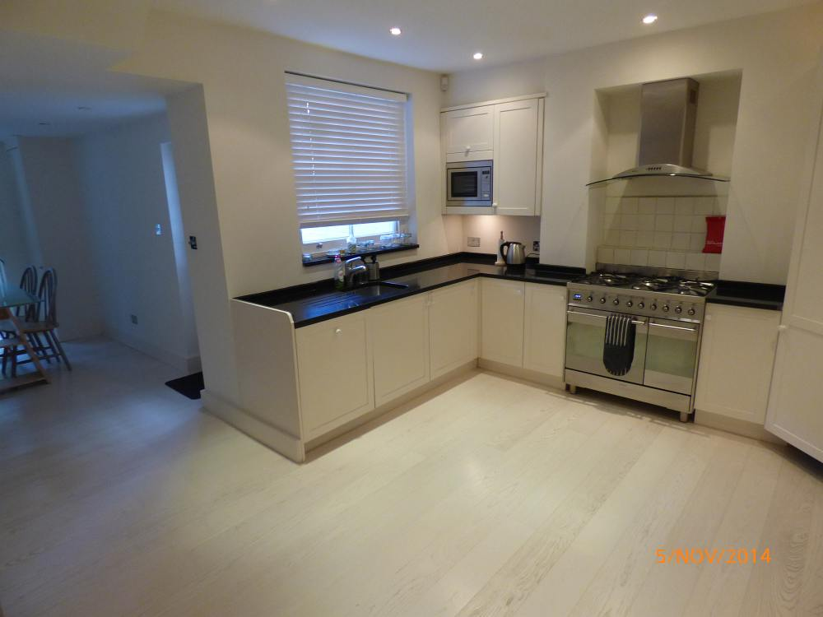 | 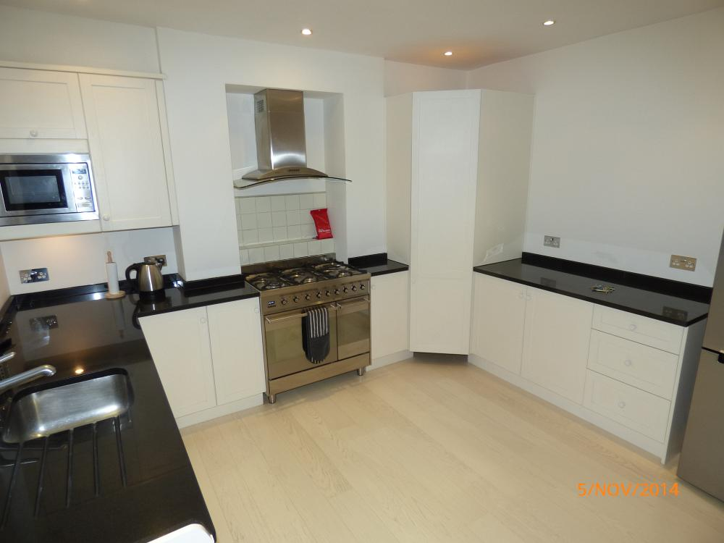 | 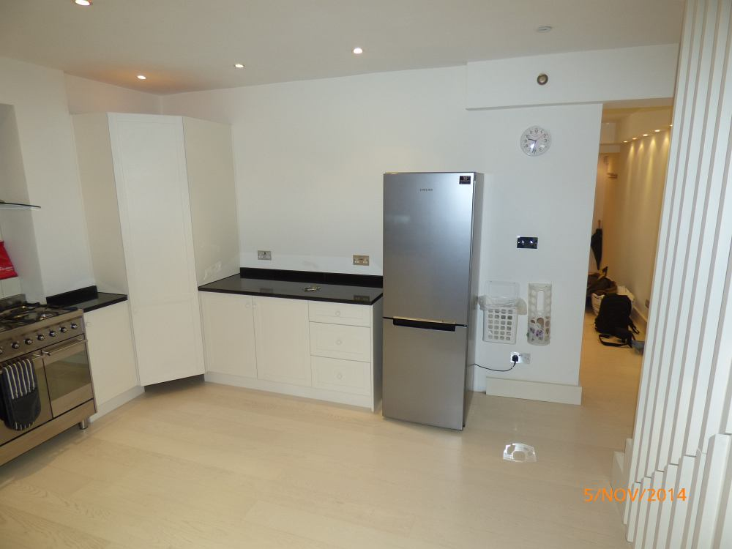 | 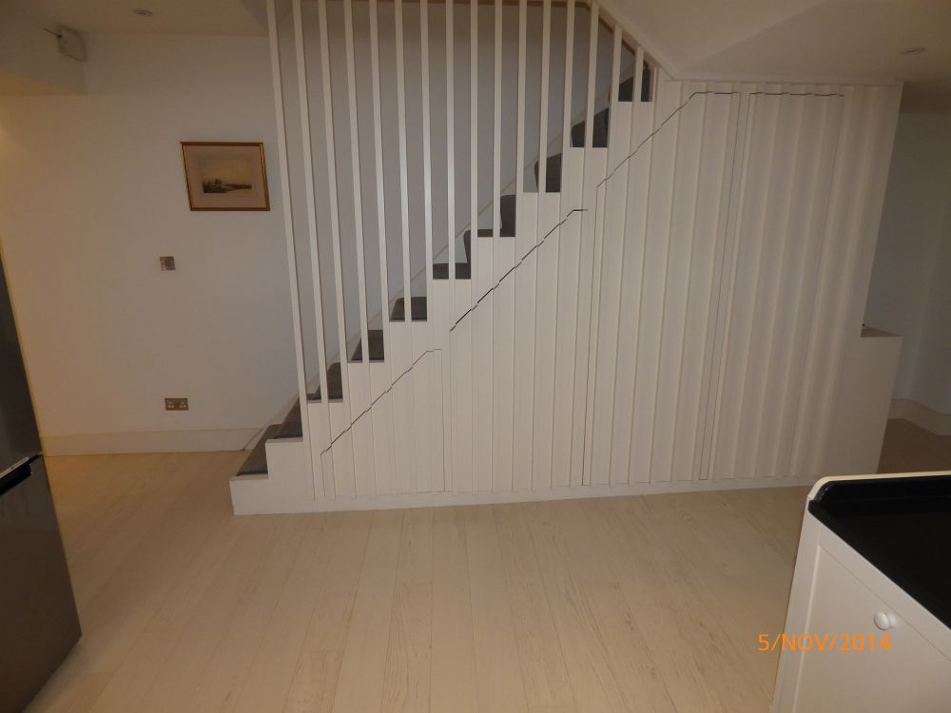
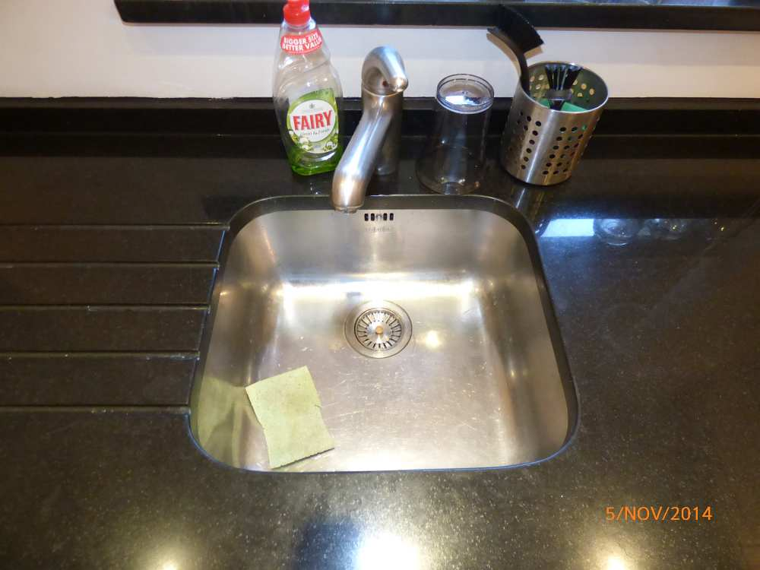 | 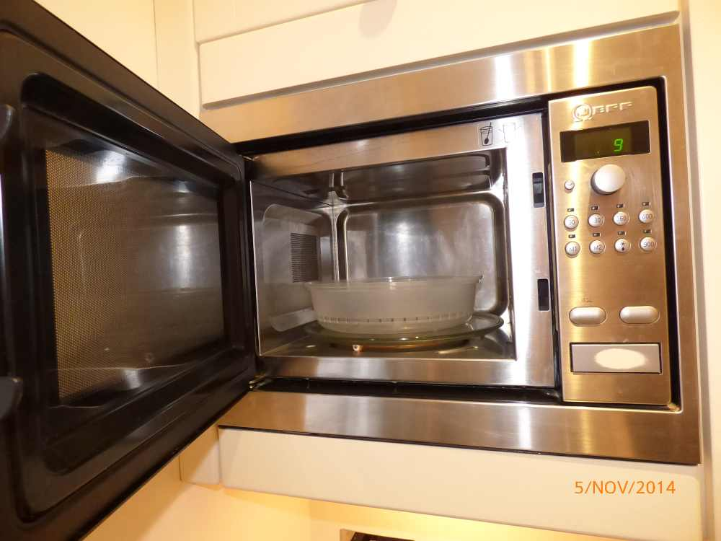 | 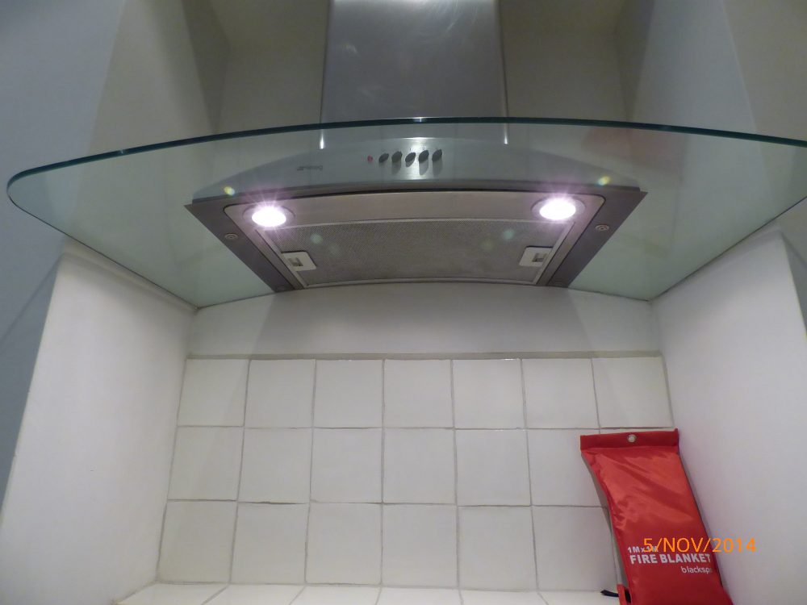 | 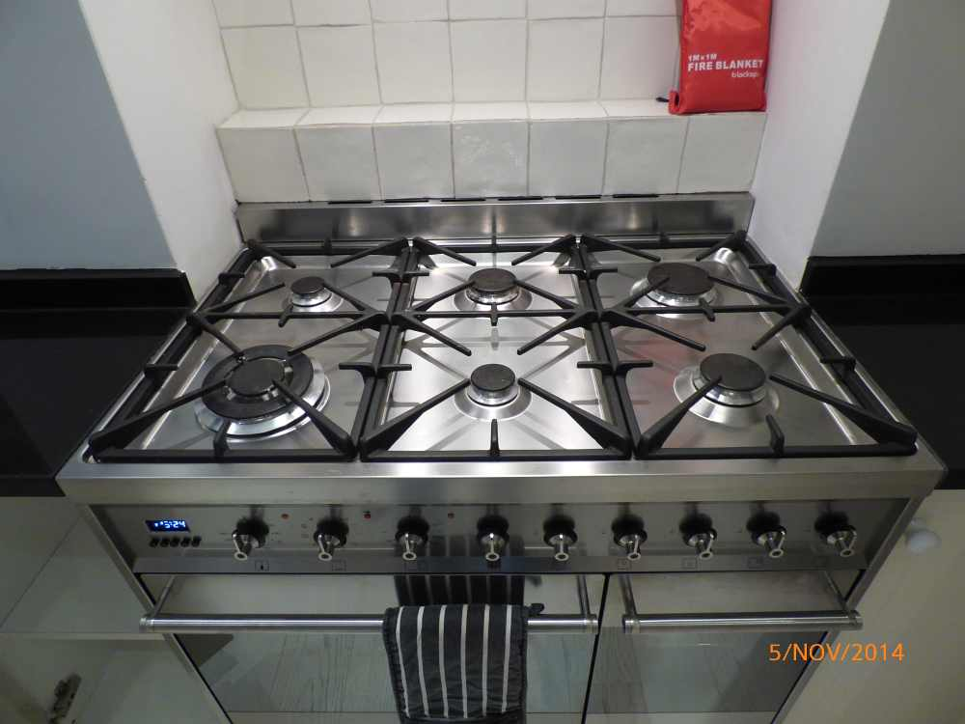
Sink | Microwave | Extractor | Hob
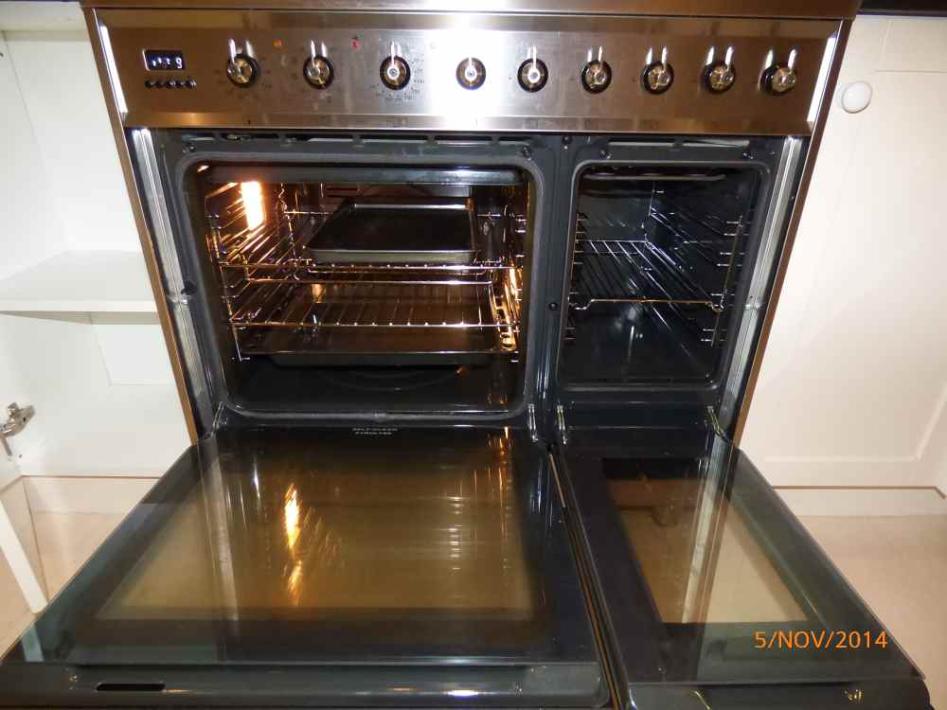 | 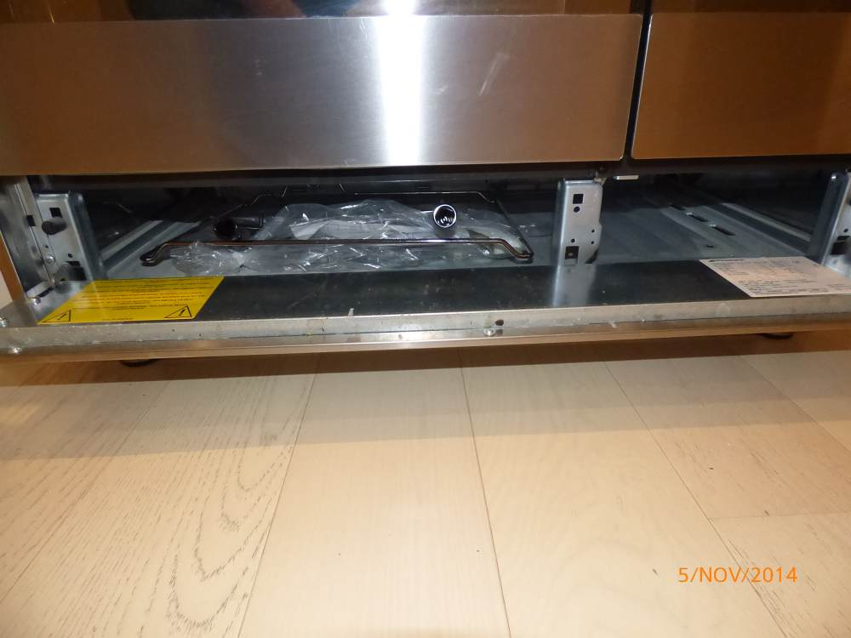 | 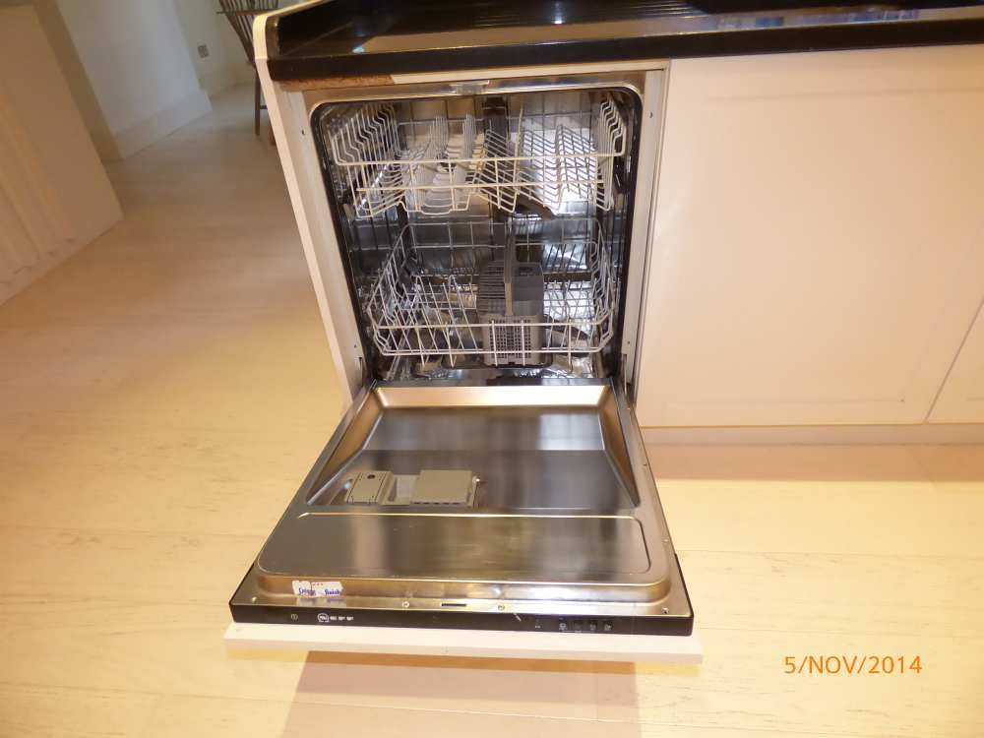 | 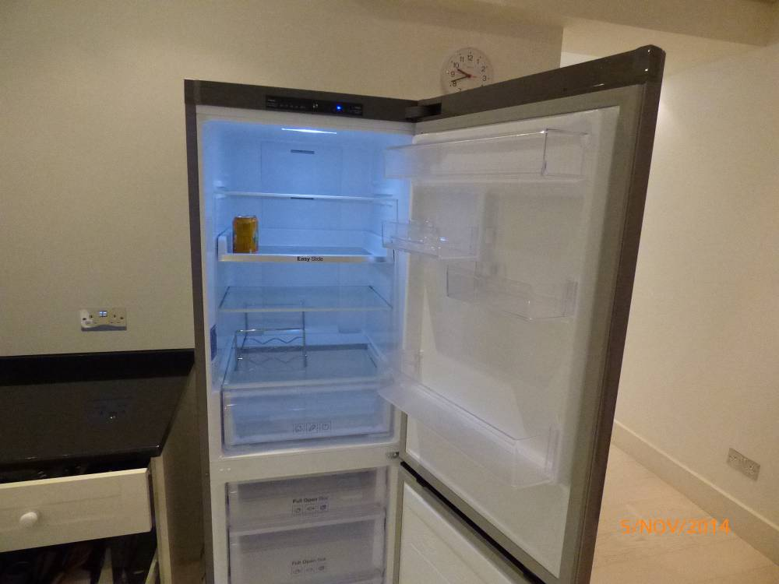
Oven |  | Dishwasher | Fridge

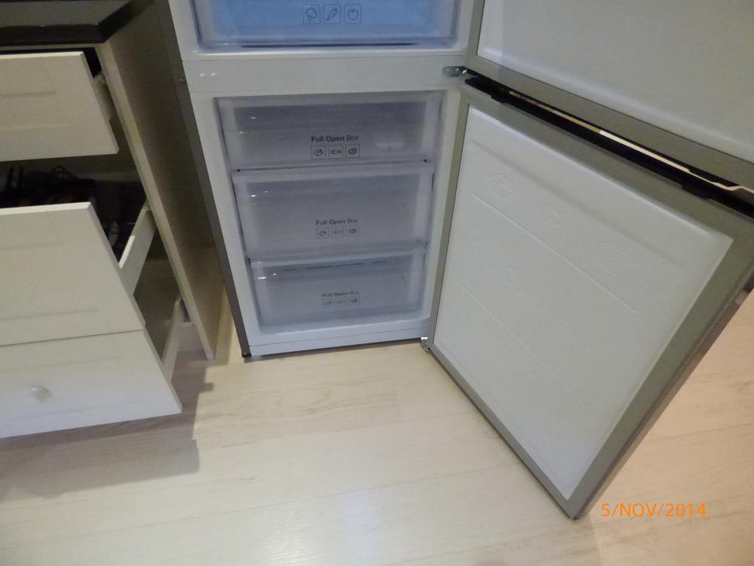 | 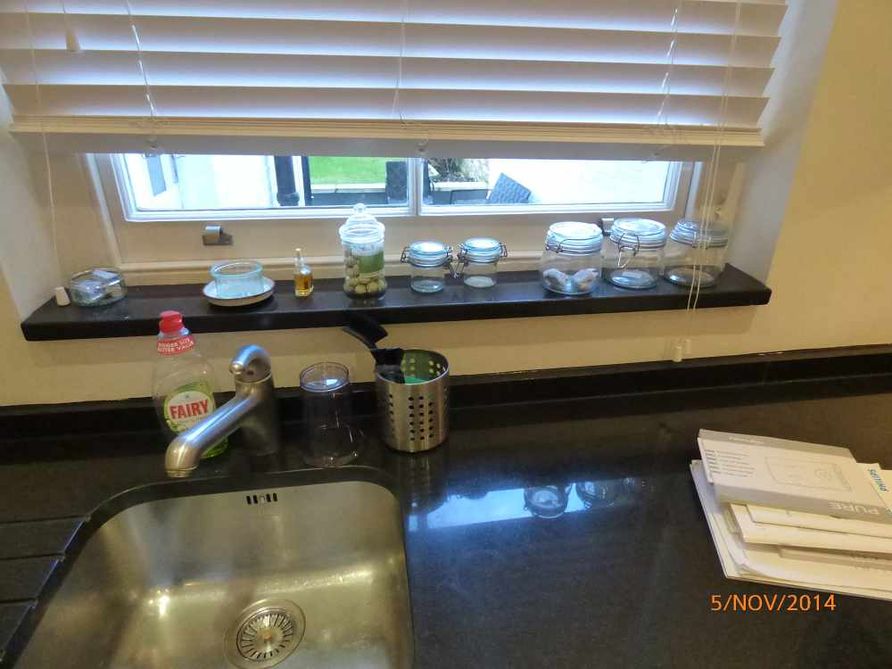 | 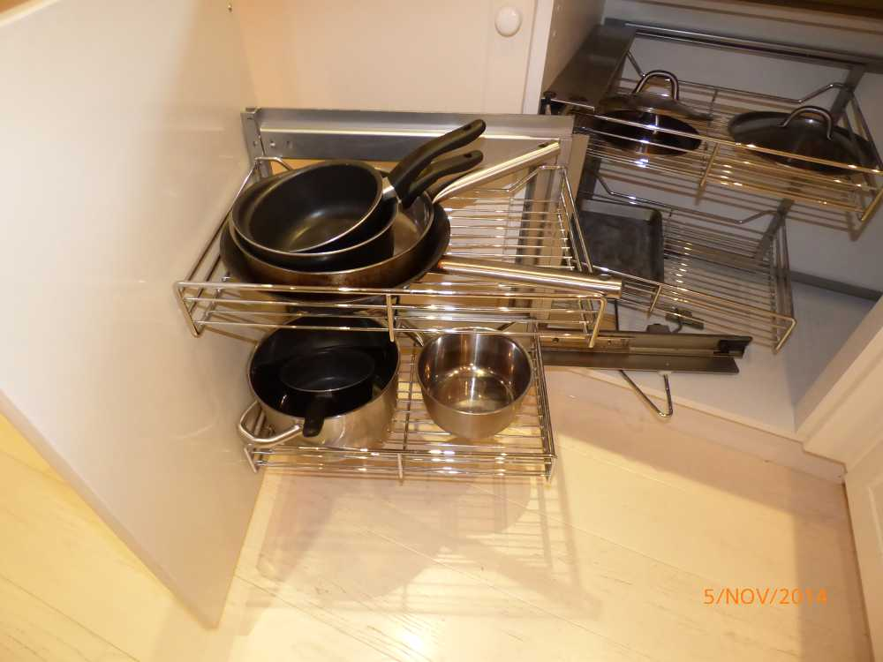 | 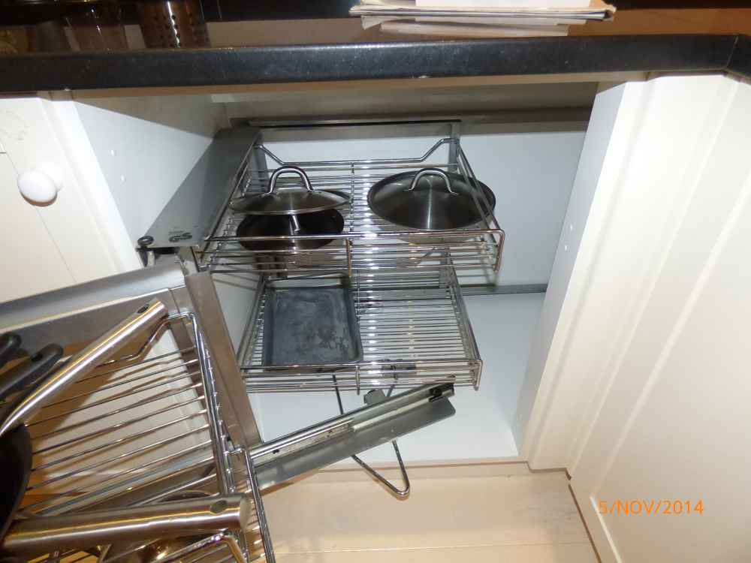
Freezer | Kitchen items
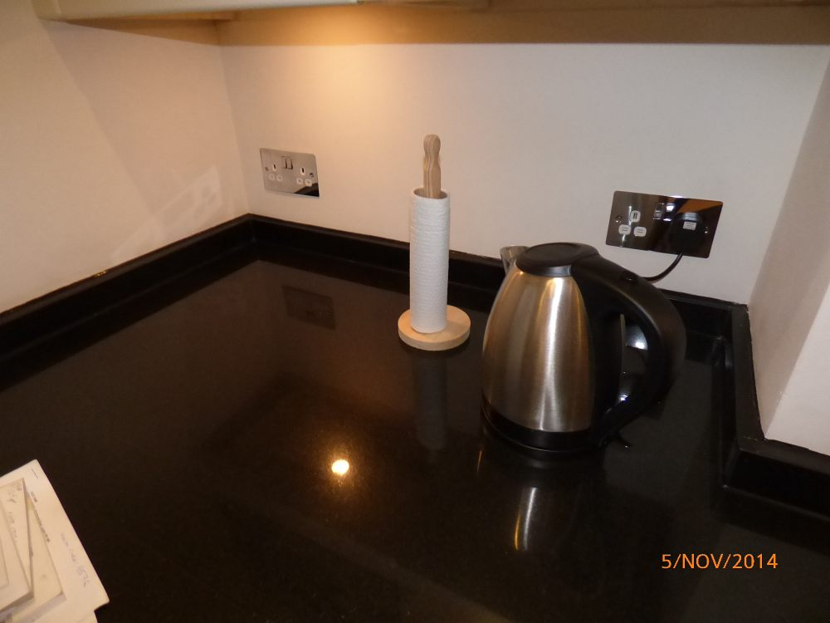 | 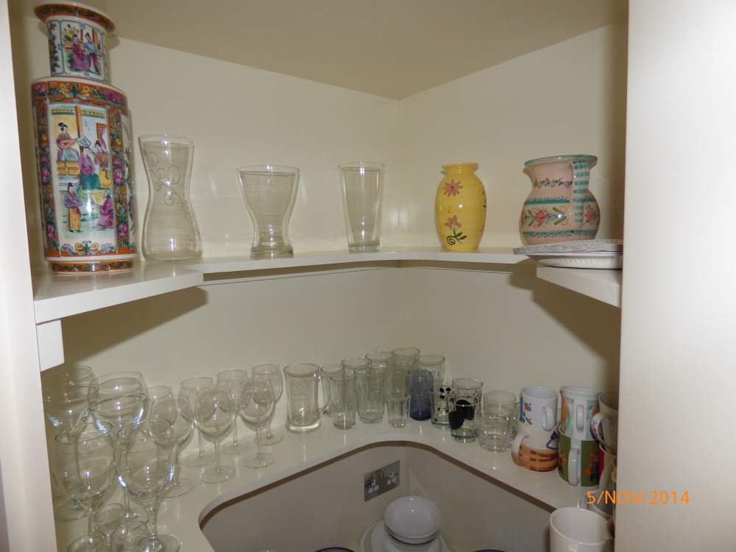 | 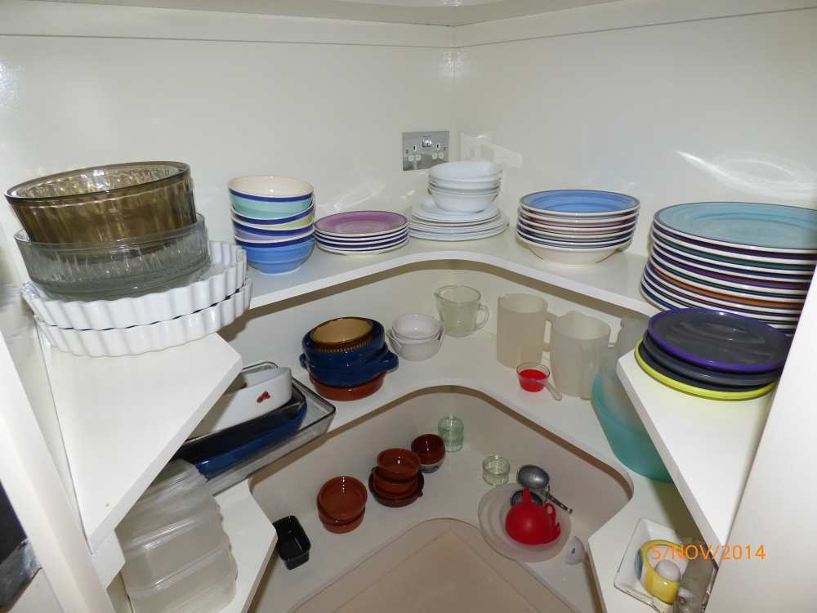 | 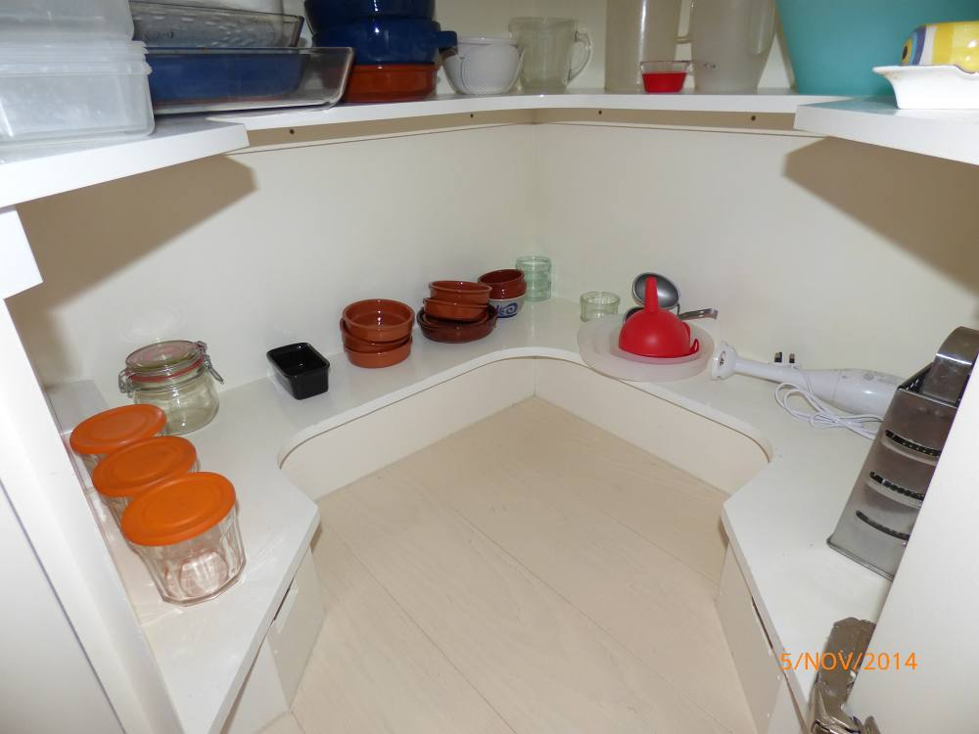
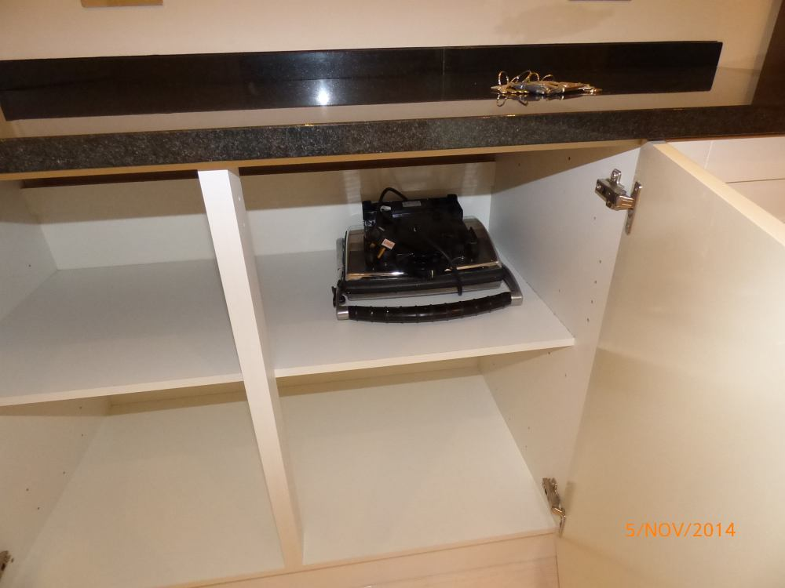 | 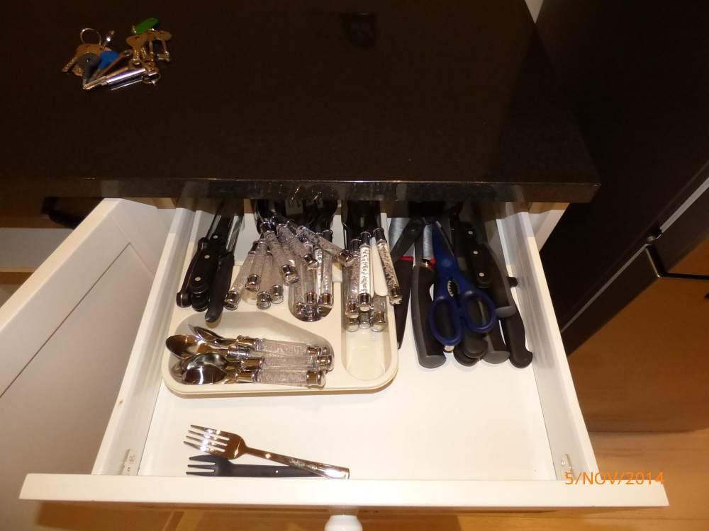 | 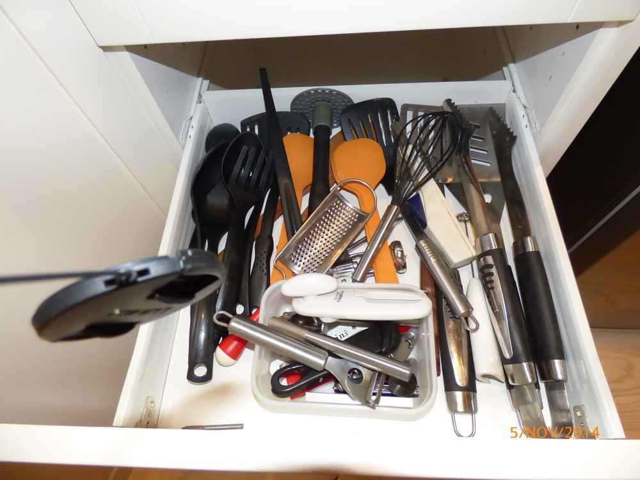 | 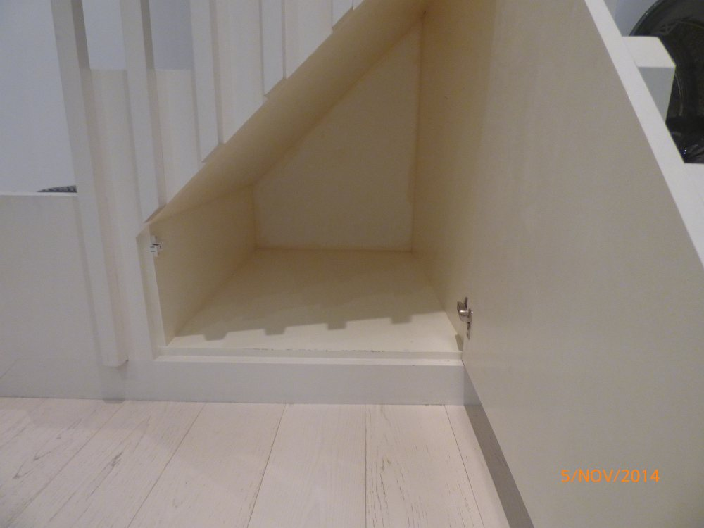
 |  |  | Kitchen storage

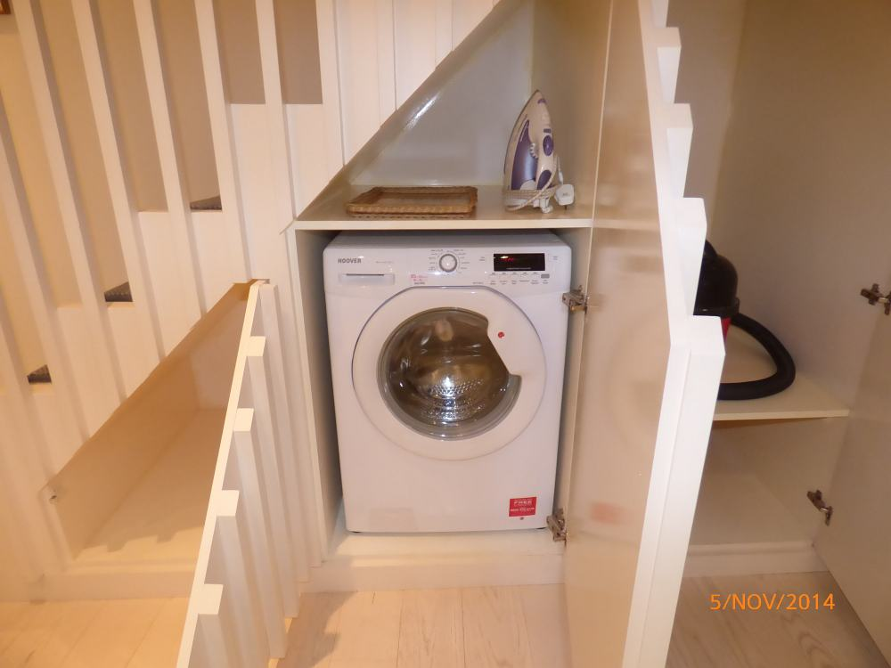 | 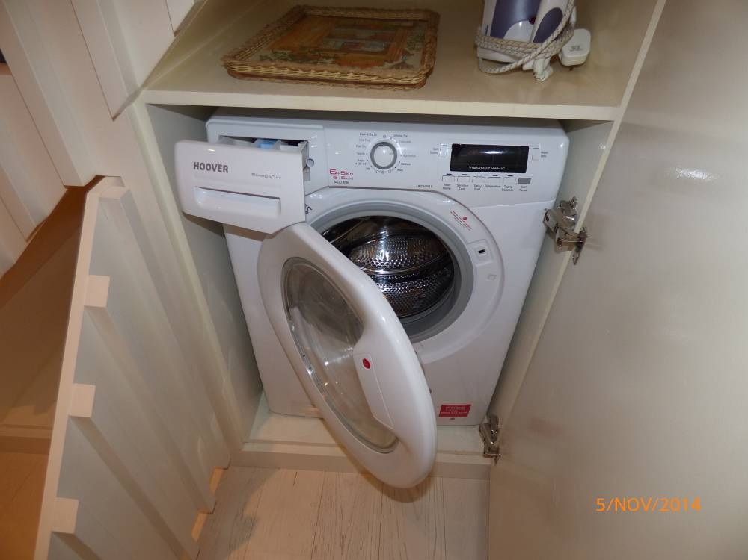 | 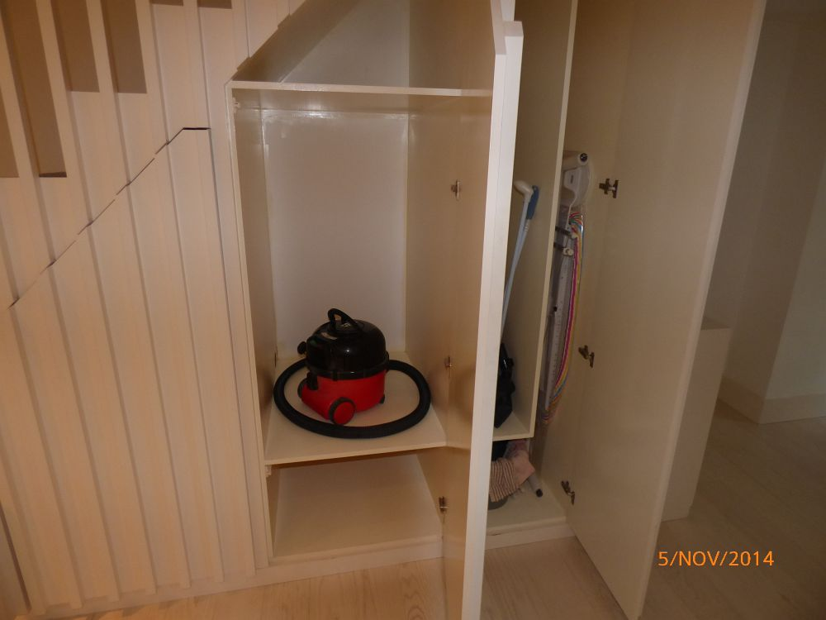 | 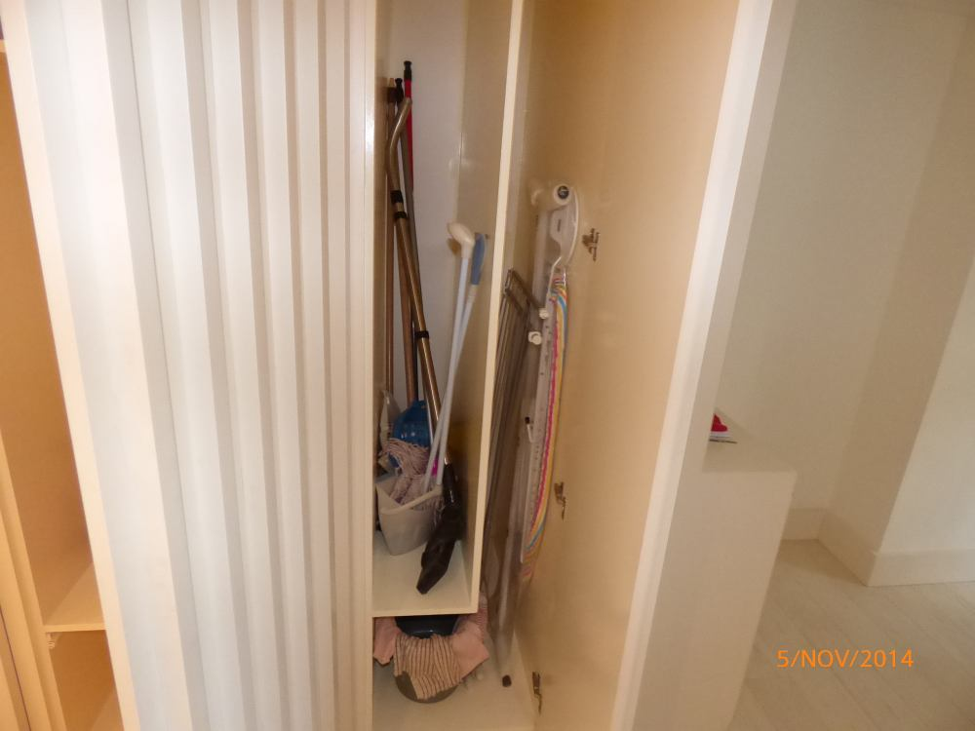
 | Washing machine

DINING ROOM (SEMI OPEN PLAN FROM KITCHEN)
ITEM |  |  | CHECK IN COMMENTS | CHECK OUT
Flooring
 | Cream fitted wall-to-wall strip flooring. |  | Few light surface scratch marks and paint marks.  Generally in good condition.  Some light scrape marks to flooring caused by garden door catching.
Woodwork
 | Painted magnolia skirting boards. |  | Light cracking to edges.  Few very light usage marks.
Walls
 | Painted magnolia.
 |  | Left wall | Couple of light usage marks lower level.
 |  | Facing wall
 |  | Right wall | Light patchy paintwork to edges.
 |  | Rear wall
Switches and sockets
 | 1 chrome double dimmer switch.
 | 1 chrome single light switch.
 | 1 chrome double light switch.
 | 3 chrome double plug sockets.
 | 1 plastic ceiling mounted smoke alarm. |  | Not tested.
 | 1 plastic wall mounted alarm motion sensor. |  | Not tested.  Paint marked and discoloured.
Heating
 | Underfloor heating.
Doors
 | Door 1:  White painted double doors containing:  20 double glazed panes.  2 built-in chrome bolts.  1 chrome lever pull with Chubb lock. |  | Glazing sound and clean.  Fittings lightly tarnished.
 | Door 2:  White painted double stable door containing:  9 double glazed panes.  3 chrome built-in bolts.  1 chrome lock.  1 chrome lever pull with Chubb lock. |  | Glazing sound and clean.  Cracking to edges of door.  Seal coming loose to lower right hand side pane.
Curtains/blinds/shutters
 | 2 wooden folding shutters with adjustable slats. |  | General light usage marks.  In good condition.
Ceiling
 | Painted white. |  | Light patchy paintwork marks to centre.
Lighting
 | 10 ceiling mounted recessed spotlights. |  | All working.
Furniture
 | 1 grey glass topped dining table with 2 wooden trestle style legs. |  | General usage, nicks and scuff marks to legs.  Light surface scratch marks to glass.
 | 4 matching wooden dining chairs with grey painted legs.
 | 1 circular plastic planter with plant. |  | Plant in good condition.
 | 1 wall mounted print of flowers with letters XXV in a wooden frame with glass front.
 | 1 Fire Angel carbon monoxide alarm. |  | Not tested.  LED light working.
 | 1 black floor mat. |  | Paint marked.
 | Built-in storage 1:  Magnolia painted built-in storage with 2 shelves.  To exterior 2 doors.  2 white pulls.  1 white plastic double plug socket to interior. |  | Numerous scuff marks to interiors and exteriors.  Several small brown marks to the shelf.  1 cut-out section to accommodate wires.  Cracking to edges.  Several chips to exterior edges.
 | Built-in cupboard 2 (housing the boiler):  Magnolia painted unit with magnolia painted flat panel wooden door.  1 brass lock.  Part white painted walls.  Part wooden walls.  1 Vaillant boiler with cover.  Numerous wires and pipes. |  | Interior slightly dusty.  Boiler tested for power.  Cut-out section to far wall to accommodate pipes.  Several marks to walls at lower level.  Section of paintwork missing to far wall at high level.

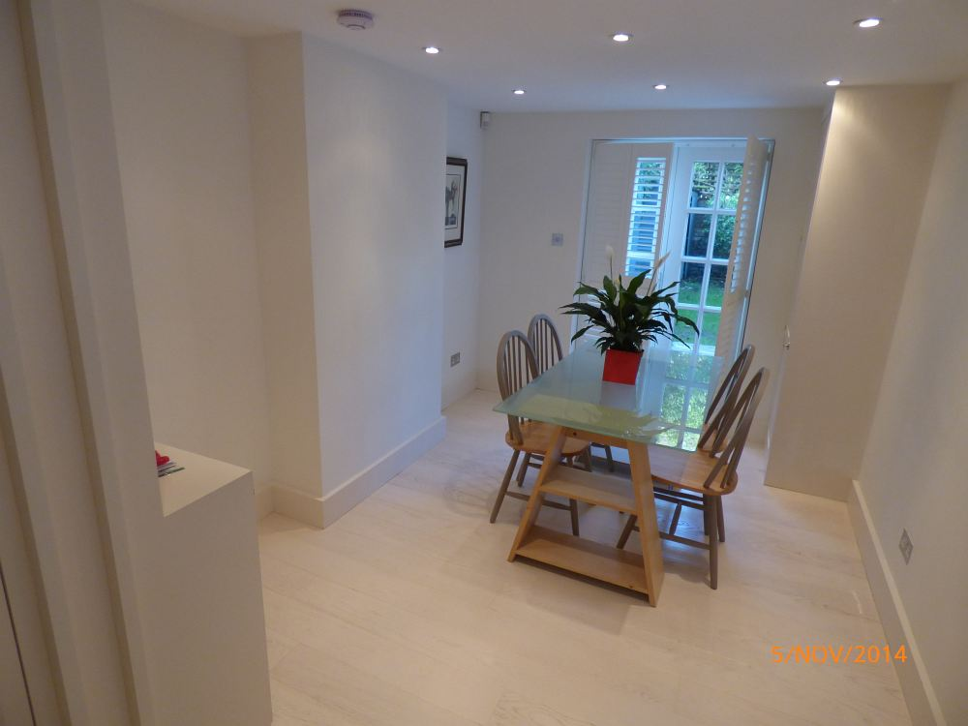 | 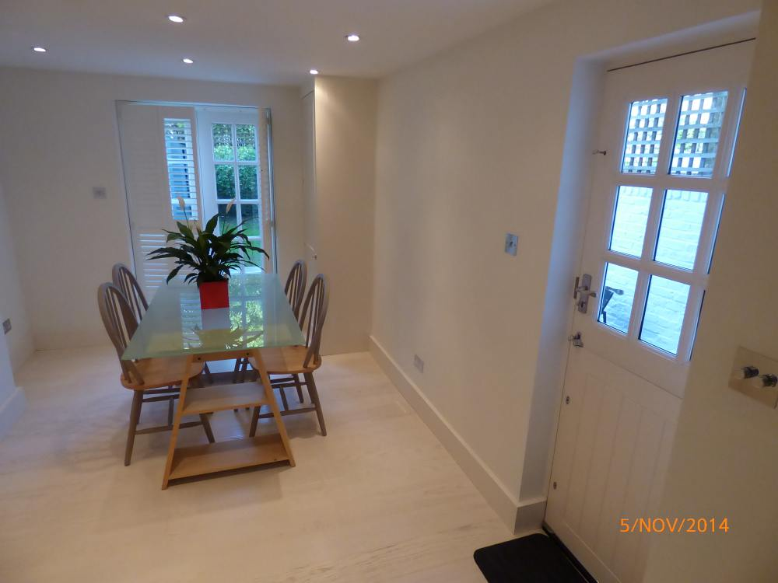 | 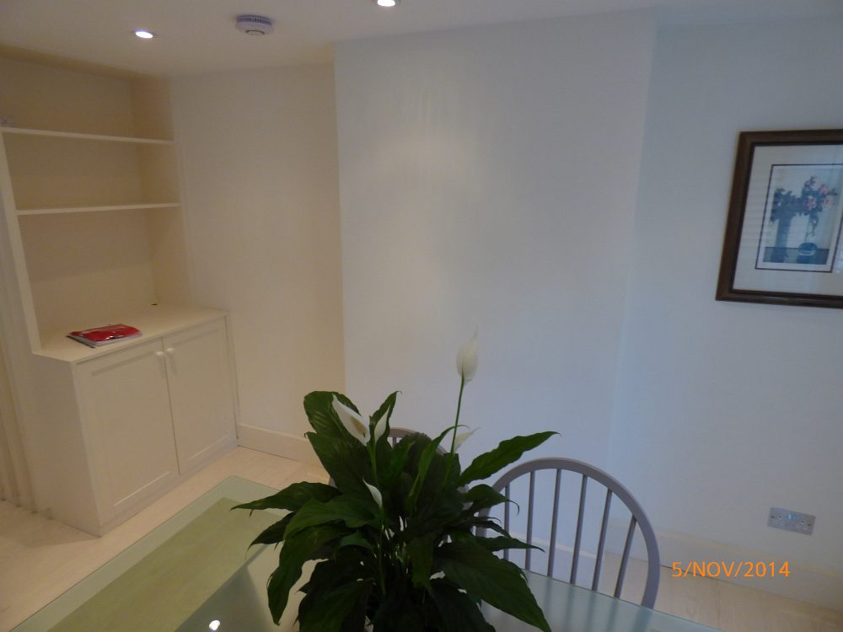 | 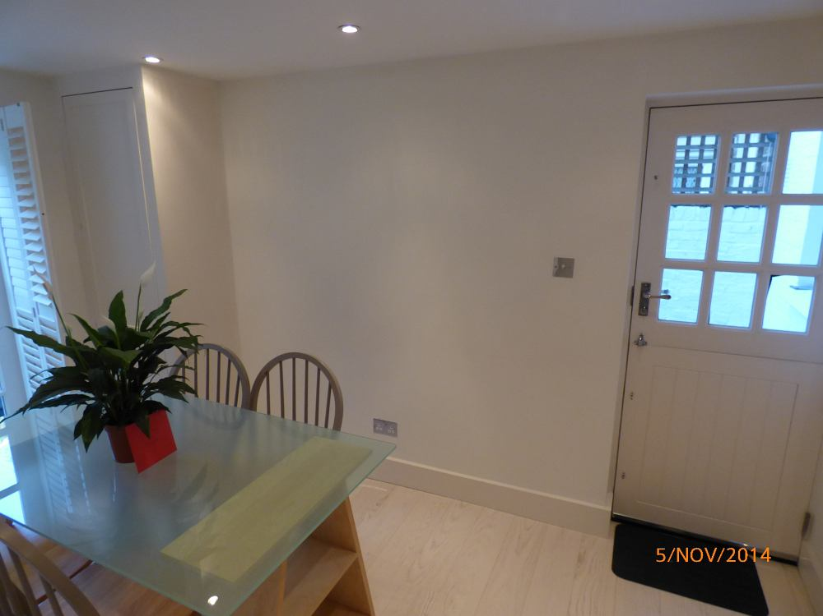
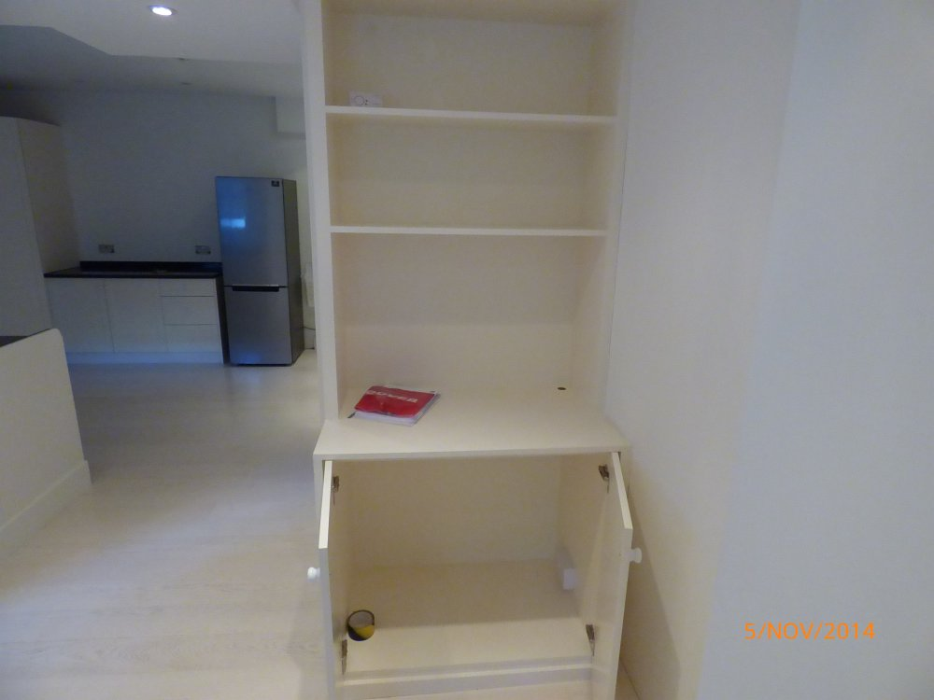 | 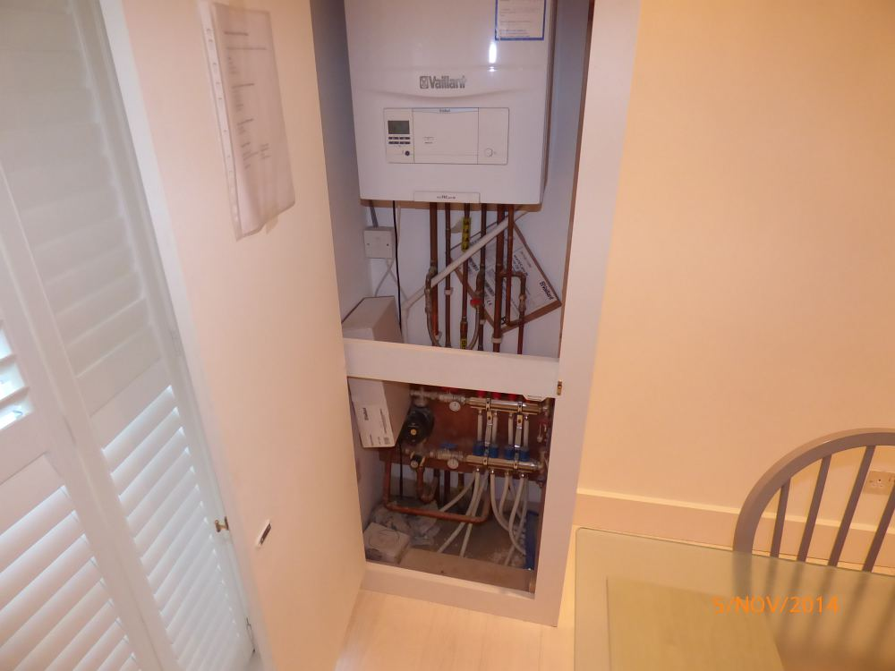 | 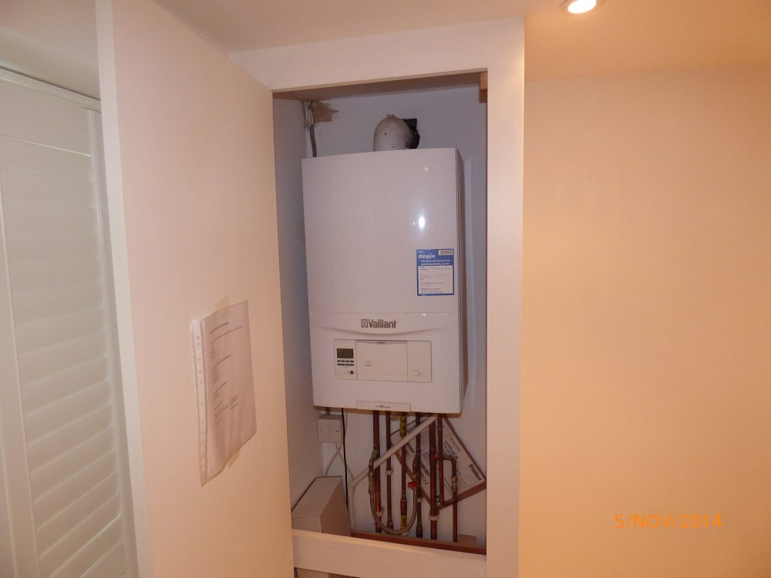

STAIRS LEADING UP
ITEM |  |  | CHECK IN COMMENTS | CHECK OUT
Flooring
 | Part white painted wooden flooring. |  | Several angle chips.  Light wear.
 | Part grey and cream patterned carpet. |  | Main tread slightly worn.  Professionally cleaned.
Skirting boards/woodwork
 | White painted skirting boards. |  | General light usage marks.
 | White painted wooden spindles.
Walls
 | Painted magnolia.
 |  | Left wall
 |  | Facing wall
 |  | Right wall
 |  | Rear wall
Ceiling
 | Painted white.

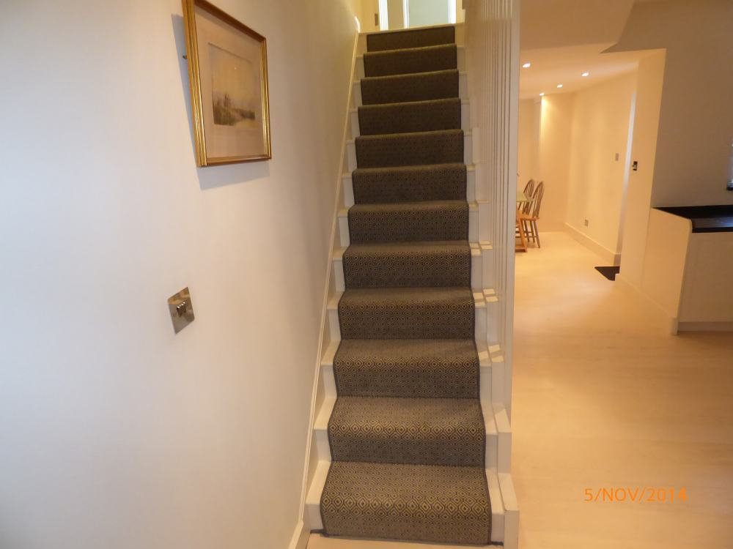

FIRST FLOOR LANDING
ITEM |  |  | CHECK IN COMMENTS | CHECK OUT
Flooring
 | Cream fitted wall-to-wall carpeting. |  | Professionally cleaned.  Draught marks to edges.  2 green marks forward of entrance to bedroom 2.  Several light grey spot marks forward of entrance to bathroom.
Skirting boards/woodwork
 | Cream painted skirting boards. |  | Cracking to top corners to right hand side.  Several light scattered usage marks.
 | Cream painted banister with cream spindles. |  | Several light usage marks and light angle chips.
Walls
 | Painted magnolia. |  | Very minor painted over defects.
 |  | Left wall
 |  | Facing wall
 |  | Right wall
 |  | Rear wall
Switches and sockets
 | 2 chrome double light switches. |  | Paint marked
 | 1 chrome single light switch. |  | Paint marked.
 | 1 plastic ceiling mounted smoke alarm. |  | Not tested.  LED light working.
 | 1 chrome wall mounted fan isolator switch. |  | Paint marked.
 | 1 plastic wall mounted alarm motion sensor. |  | Not tested.  Slightly discoloured.
Ceiling
 | Painted white.
Lighting
 | 2 ceiling mounted recessed spotlights. |  | Both working.  Not fully flush with ceiling.
 | 1 chrome ceiling mounted light fitting with 2 chrome arms.  A total of 4 spotlights. |  | All tested.  1 light not working.

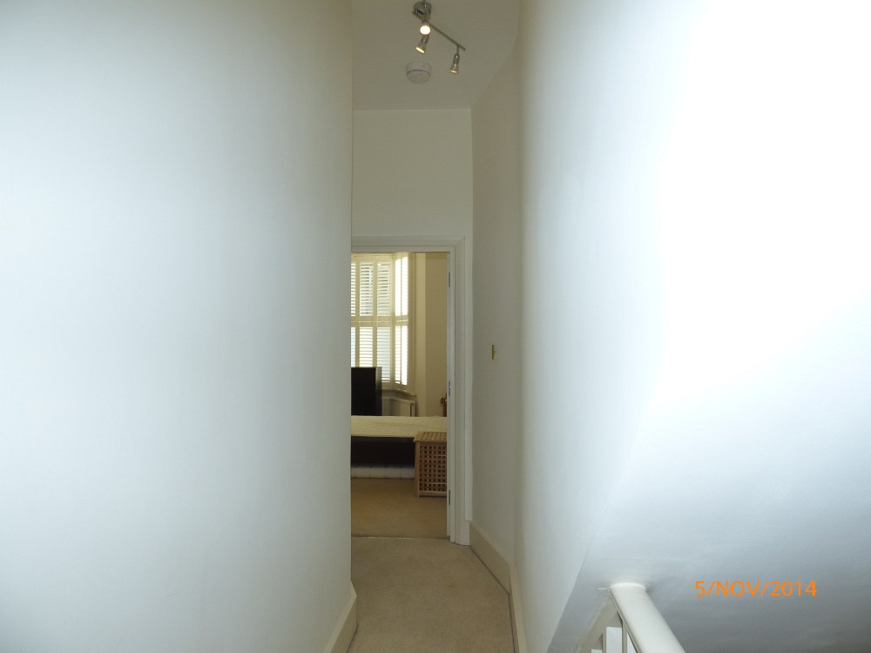 | 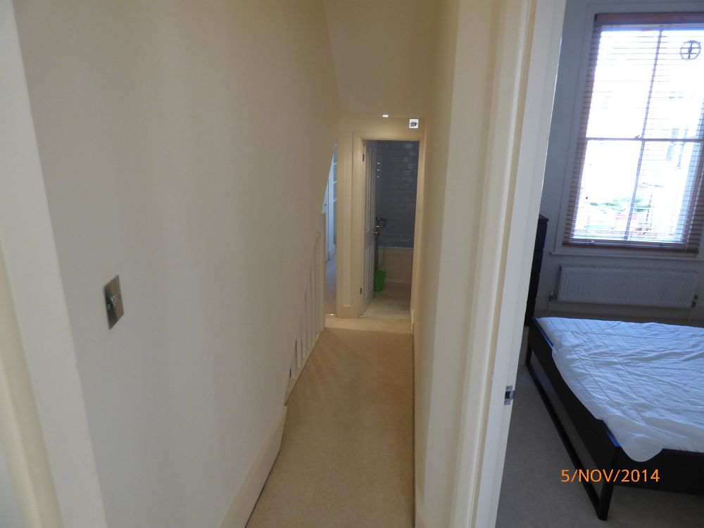 | 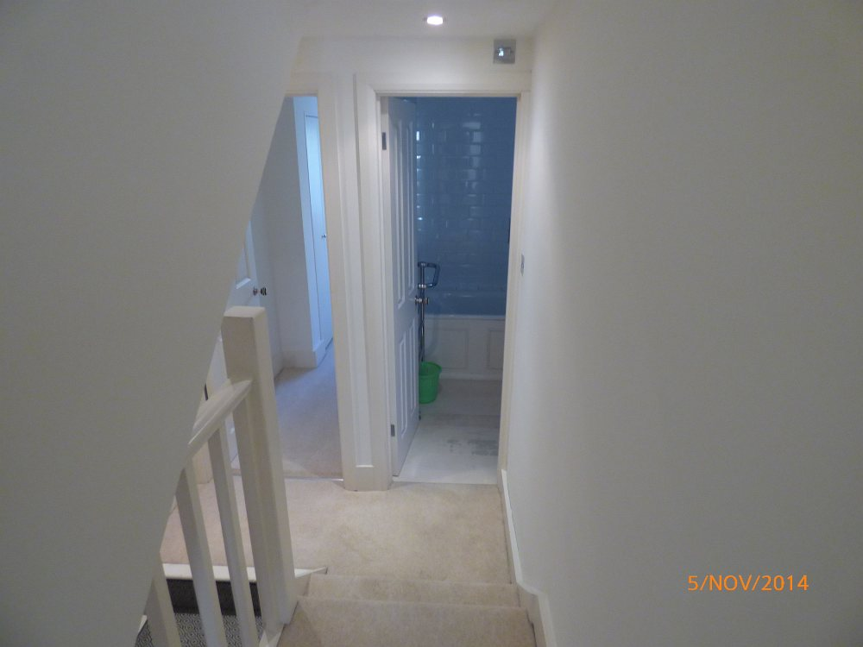 | 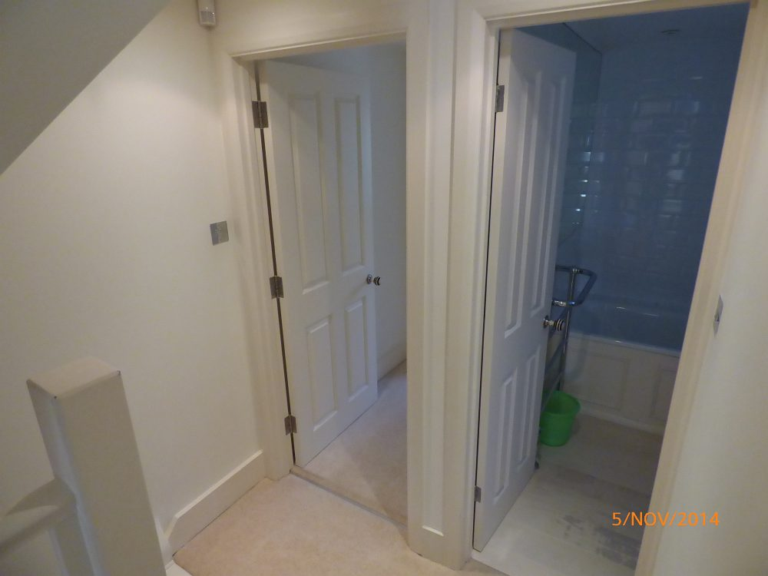
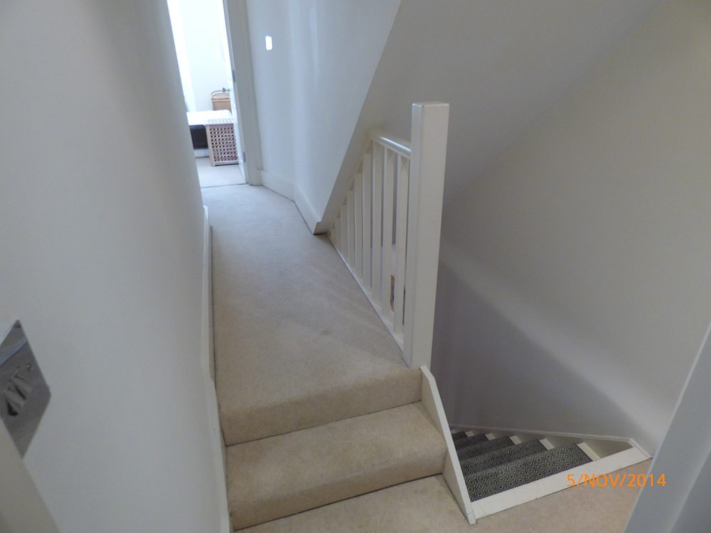 | 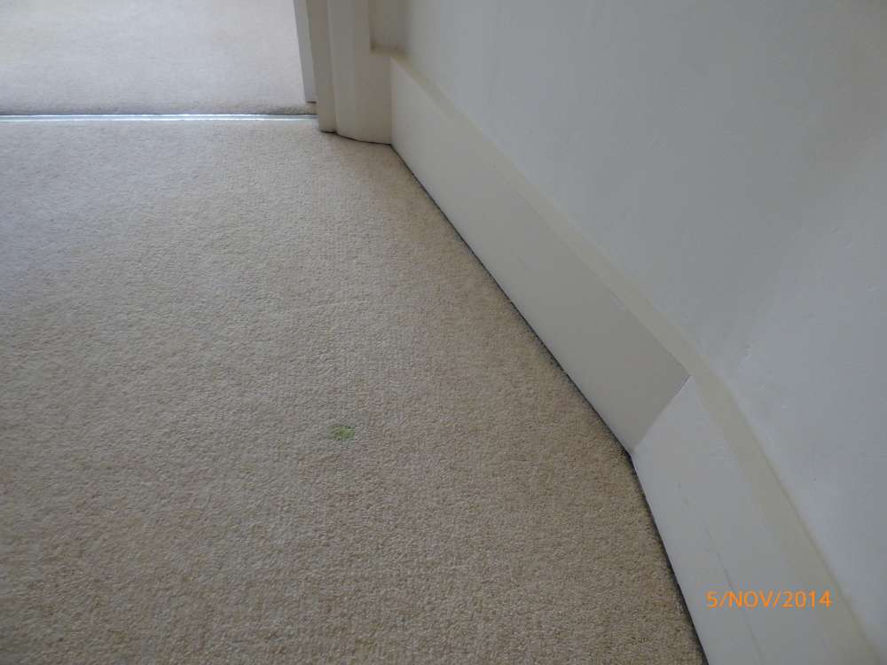
 | Green marks to carpet

BEDROOM 1 (REAR OF PROPERTY)
ITEM |  |  | CHECK IN COMMENTS | CHECK OUT
Exterior door frame
 | Painted magnolia. |  | Old defects under.  Several small nicks to right hand side.  Light wear to lower right side corner.  Several painted over chips.
Exterior door
 | Magnolia painted 4-panel wooden door. |  | Minor finger marks around pull.
 | 1 circular chrome, black and cream plastic pull.
Threshold
 | Aluminium.
Interior door frame
 | Painted magnolia. |  | Painted over chips lower left hand side.  1 small chip lower left hand side.
Interior door
 | Magnolia painted 4-panel wooden door.
 | 1 circular chrome, white and black pull. |  | Lightly tarnished.
Flooring
 | Cream fitted wall-to-wall carpeting. |  | Draught marks to edges.  Professionally cleaned.
 | 1 plastic floor mounted doorstop.
Skirting boards/woodwork
 | Magnolia painted skirting boards. |  | Cracking to edges.  General scuff marks, quiet heavy in places.  Angle chip marks.
Walls
 | Painted magnolia.
 |  | Left wall | Couple of very light marks to left hand side of wardrobe at lower level.
 |  | Facing wall
 |  | Right wall | 1 small mark at lower level with 2 very small corner angle chips.
 |  | Rear wall
Switches and sockets
 | 1 chrome single dimmer switch.
 | 2 chrome double plug sockets. |  | Paint marked.
Heating
1 white metal wall mounted double panelled box radiator containing:
1 white plastic thermostat.
1 white plastic valve fitting.
Windows
 | Magnolia painted wooden window frame containing:  3 double glazed panes.  3 chrome fittings.  Magnolia painted wooden window sill and recess. |  | Glazing sound and clean.  Few minor paint marks to edges of panes.  Woodwork cracking to lower left hand side of frame.  1 small chip to window sill.
Curtains/blinds/shutters
 | 2 white wooden folding double wooden shutters with adjustable slats. |  | In good condition.  Working.
Ceiling
 | Painted white. |  | Light cracking around third light fitting.  Light patchy paintwork to centre.
Lighting
 | 5 ceiling mounted recessed spotlights. |  | All tested.  1 not working.  Lights not fully flush with ceiling.
Built-in wardrobe
 | Magnolia painted wooden frame.  2 magnolia painted flat panel wooden doors.  2 small circular chrome pulls.  Magnolia painted interior.  3 magnolia painted shelves. |  | Several scratches, small chips and scuff marks to interior.  Small chip to edge of left hand side door.
Miscellaneous items
 | 4 magnolia painted wall mounted wooden shelves each with 2 metal brackets. |  | Old defects under.
 | 1 white duvet being stored inside wardrobe.

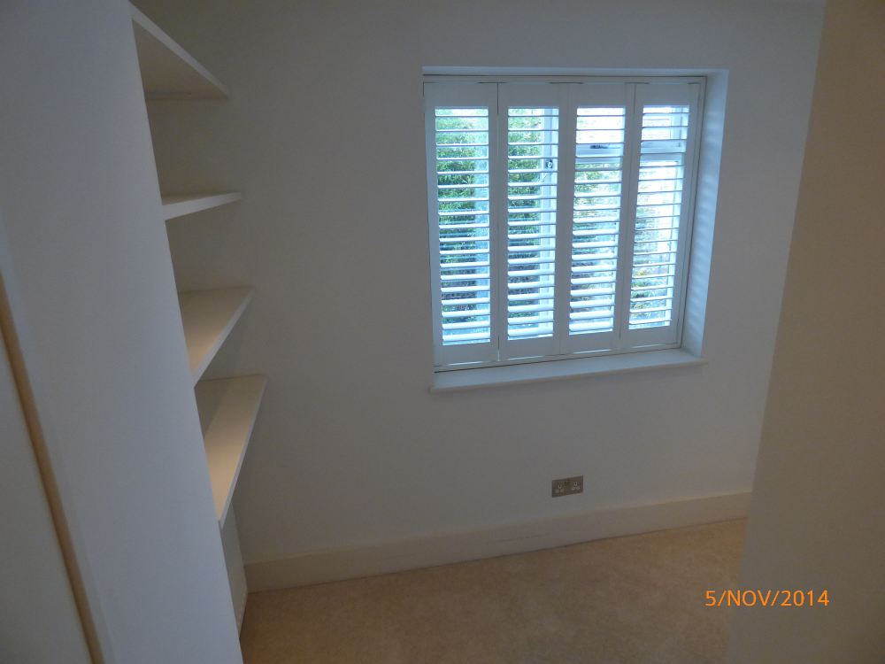 | 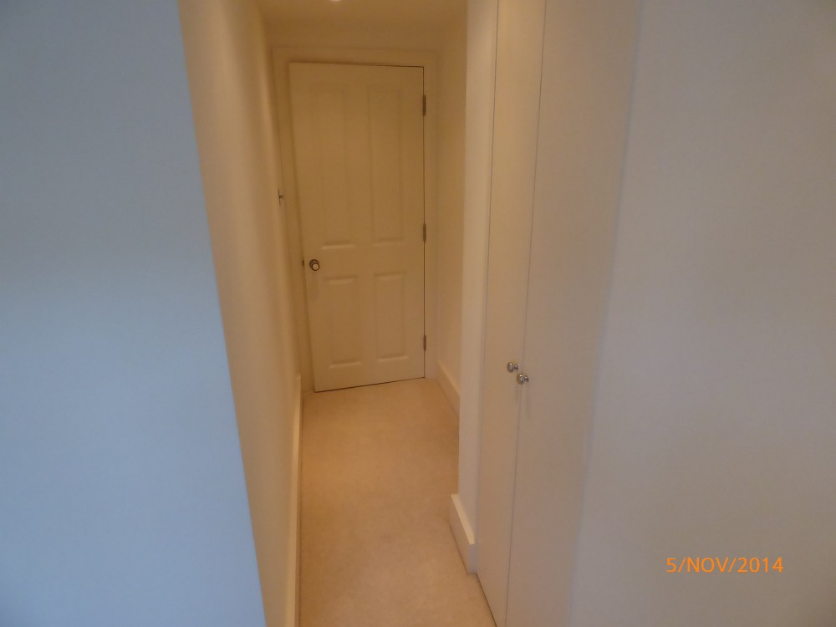 | 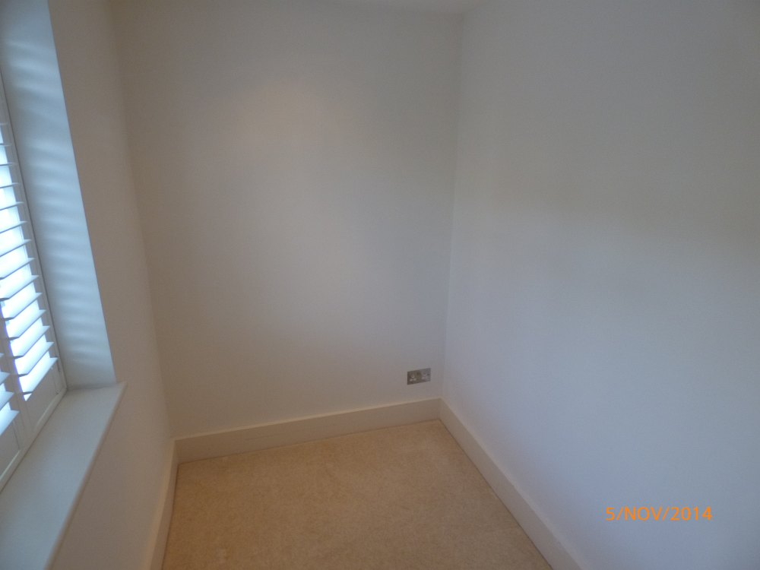 | 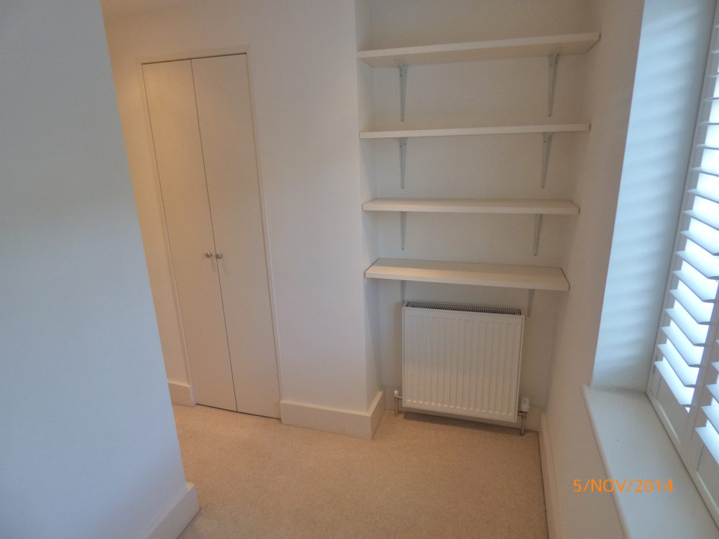
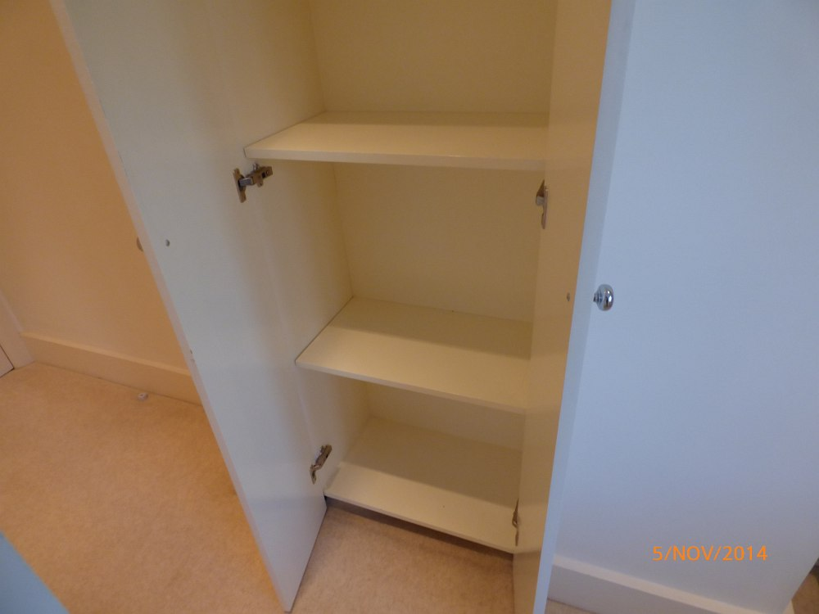 | 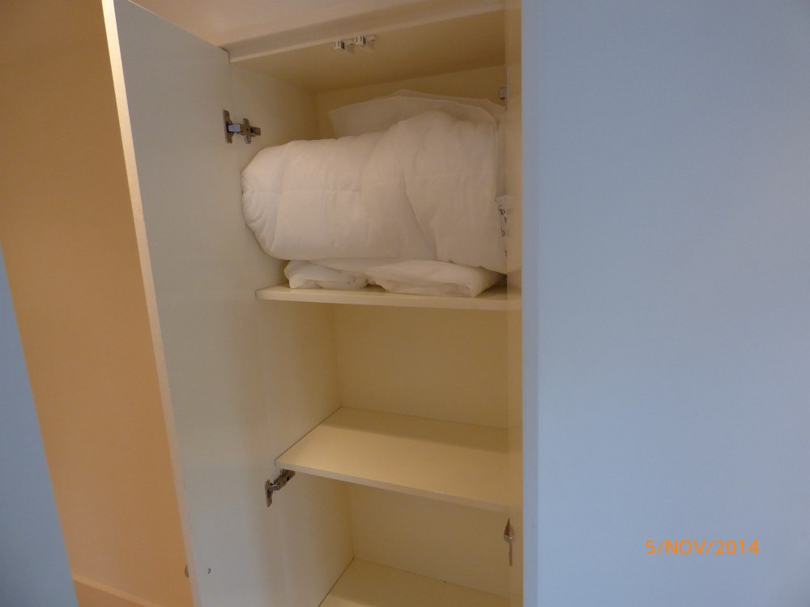 | 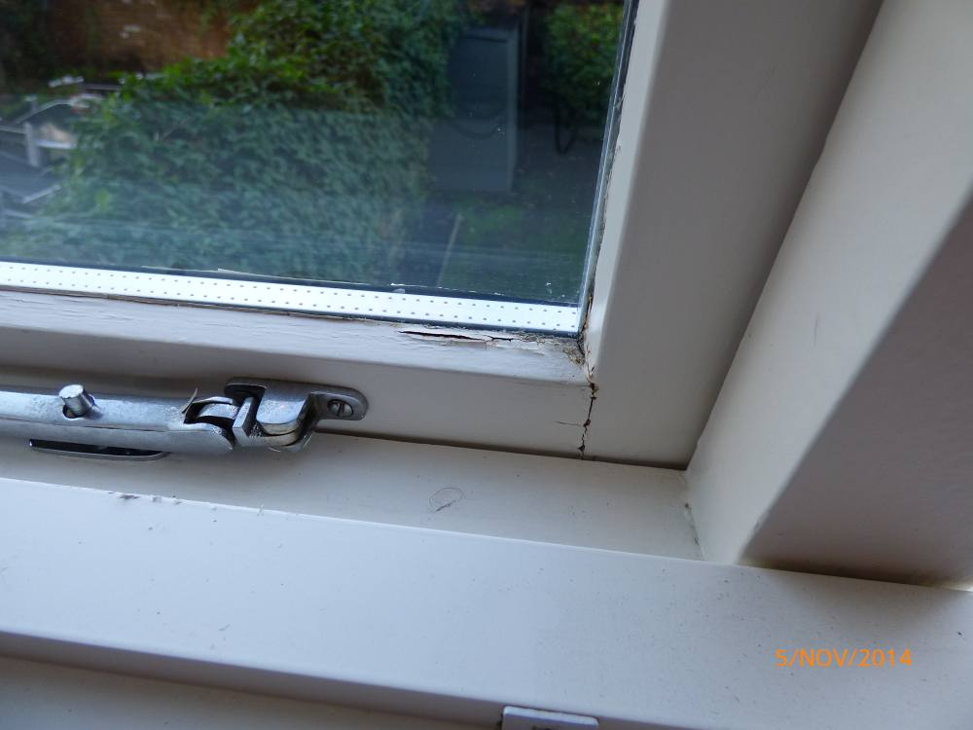
 |  | Cracking to window woodwork

BATHROOM
ITEM |  |  | CHECK IN COMMENTS | CHECK OUT
Exterior door frame
 | Painted magnolia. |  | Old defects under.  Light angle wear and nicks to left hand side.
Exterior door
 | Magnolia painted 4-panel wooden door. |  | Few very minor usage marks at lower level.
 | 1 circular chrome, black and white pull. |  | Slightly tarnished.
Interior door frame
 | Painted magnolia. |  | Old defects under.  Few very faint usage marks.  Light cracking to left hand side exterior edge.
Interior door
 | Magnolia painted 4-panel wooden door. |  | Several light usage marks.  1 small chip to base.  Light finger marks left hand side.
 | 1 circular chrome, white and black pull. |  | Lightly tarnished.
 | 2 brass butterfly effect clothes hooks.
 | 1 chrome bolt with receiver.
Flooring
 | Cream wooden strip flooring. |  | Few light surface scratch marks.  Generally in good condition.  2 floorboards have grey patches to centre (possibly part of design).
Walls
Part painted magnolia.

Part blue and white patterned tiling.

Part white tiling with white grouting.
 |  | Left wall | Small watermark to lower section.  Grouting slightly discoloured.
 |  | Facing wall | Grouting slightly discoloured.
 |  | Right wall | Grouting slightly discoloured.  1 metal fitting with hook at high level.
 |  | Rear wall | Watermarks to lower section.
Switches and sockets
 | 1 chrome double shaver socket. |  | Paint marked.
 | 1 black and chrome ceiling mounted extractor fan. |  | In working order.  Tarnished and worn.
Heating
 | 1 chrome wall mounted 4-tier ladder style towel heater with 2 chrome and white taps.
Windows
 | White painted wooden window frame containing:  2 frosted double glazed panes.  1 white metal lock with metal catch. |  | Glazing sound and clean.
Ceiling
 | Painted white.
Lighting
 | 3 ceiling mounted recessed spotlights. |  | All in working order.
 | 2 chrome wall mounted light fittings each with a circular glass shade.  White pull cord and metal acorn. |  | In working order  Fittings slightly dusty.
Toilet
 | 1 white ceramic toilet with concealed cistern containing:  1 chrome and white lever flush  White plastic seat and lid with plastic stoppers. |  | In working order.  Clean.  Flush very slightly loose.
Sink
 | 1 white ceramic Burlington white ceramic sink with:  Chrome mixer tap with plug mechanism.  Chrome waste.  1 chrome pop-up plug. |  | In working order.  Clean.  Few light watermarks to fittings.  Light scale to waste and plug.
Bath
 | 1 white metal bathtub in a cream painted wooden surround containing:  1 chrome double mixer tap.  1 chrome waste.  1 chrome overflow.  1 chrome shower flex pipe.  1 chrome and white showerhead.  1 chrome and plug and chain.  White tiling to edges with light grouting. |  | Plug and chain are not attached.  Bath tested, working and clean.  Grouting discoloured.  Some light paint peeling to the edges of the bath panel.
Shower
 | 1 circular chrome ceiling mounted showerhead with chrome double mixer tap |  | In working order.  Clean.  Light scale to underside of showerhead.
Miscellaneous items
 | 1 curved glass and chrome shower screen.
 | 1 large wall mounted unframed mirror. |  | Paint marked to edges.  Small silvering marks forming to lower corner.
 | 1 chrome wall mounted toilet roll holder.
 | 1 white plastic toilet brush with canister.
 | 1 circular green plastic bin.
 | 1 chrome and black floor mounted doorstop.
 | 1 cream painted built-in storage unit below sink with:  2 cream doors.  2 circular white pulls.  1 white pipe to interior. |  | Several light marks to interior.  Cut-out section to accommodate pipe.

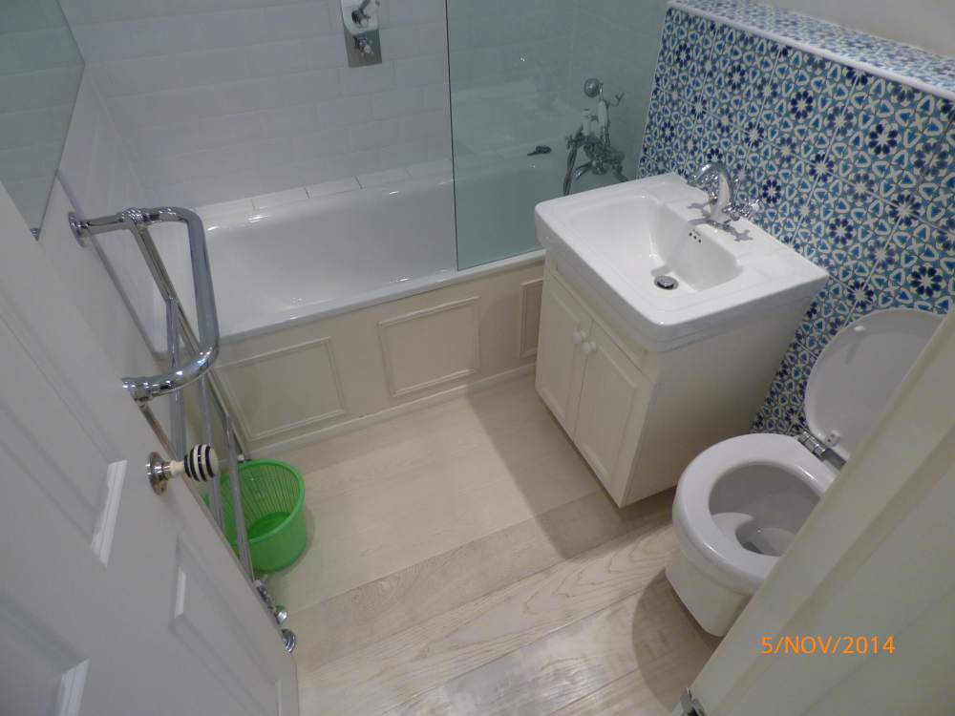 | 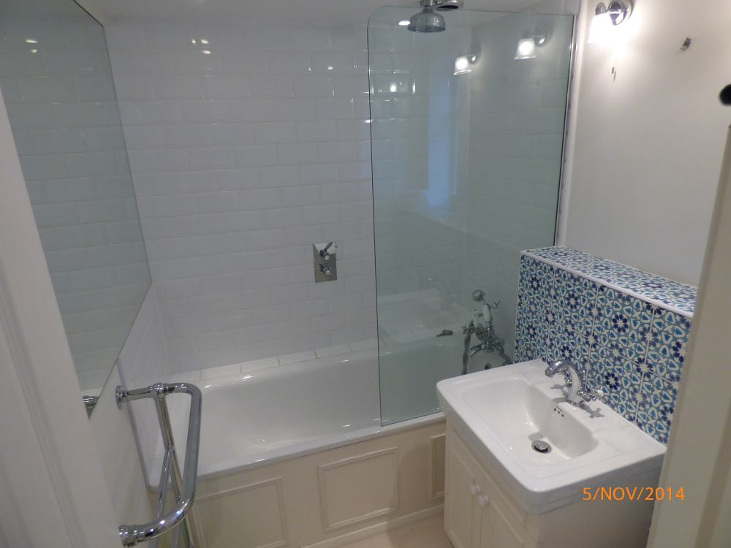 | 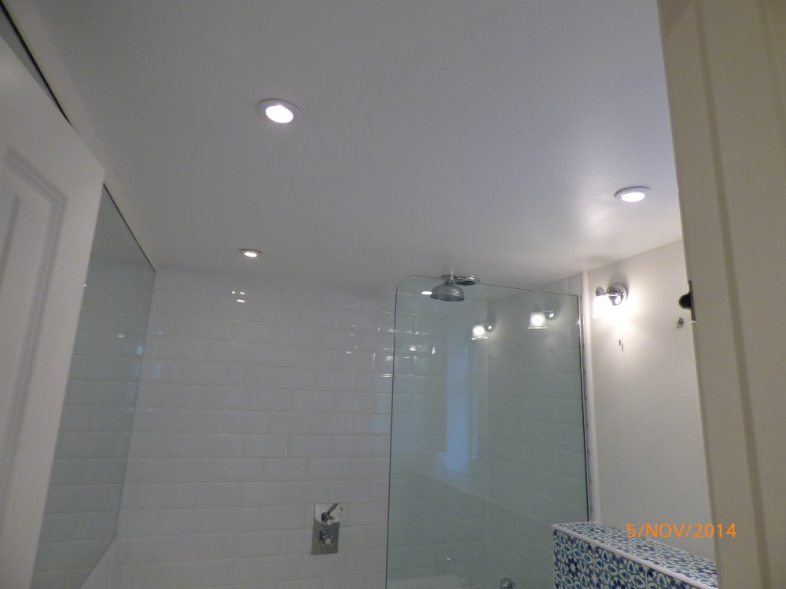 | 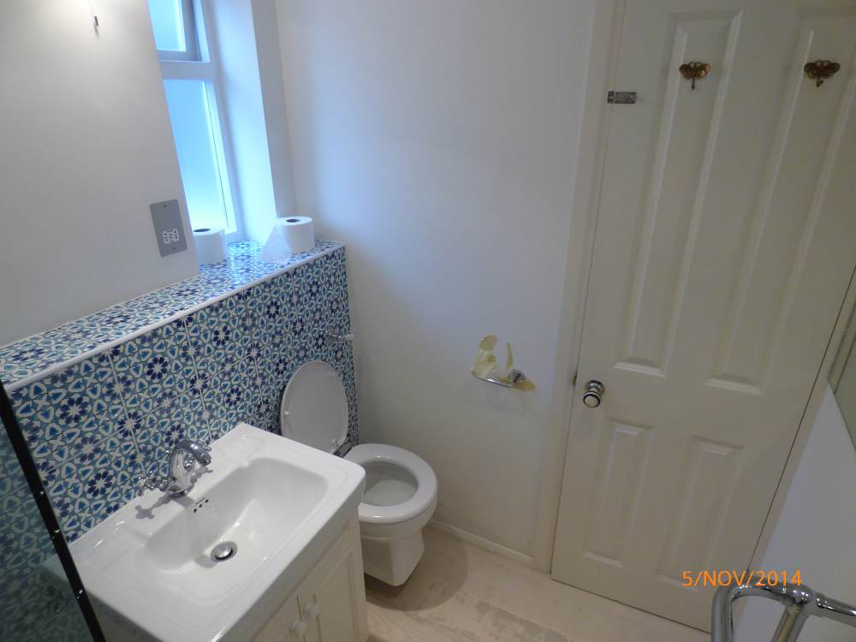
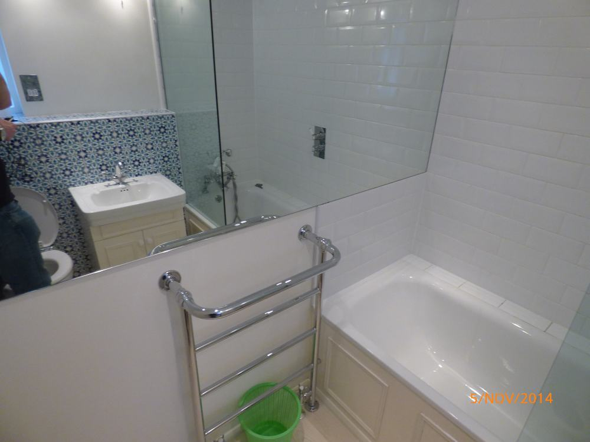 | 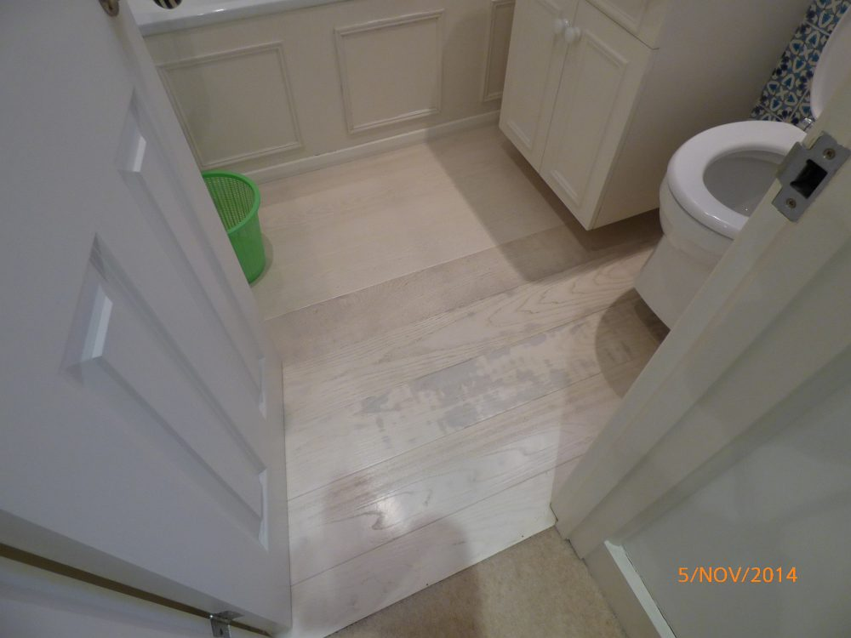 | 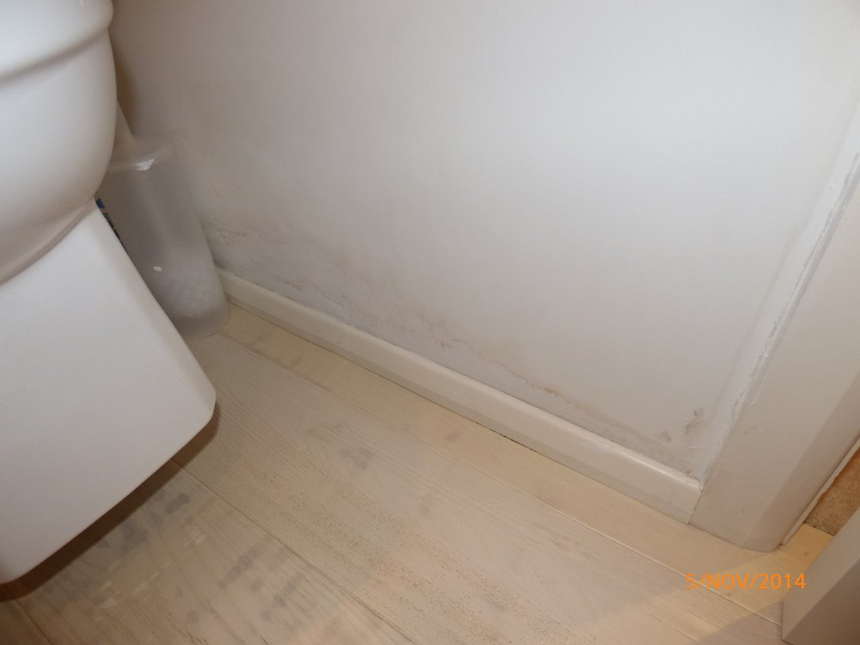 | 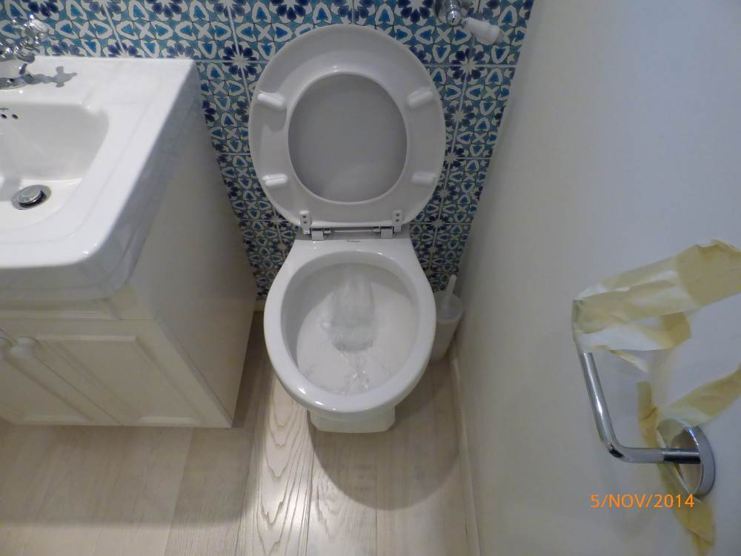
 |  | Watermarks to wall | Toilet
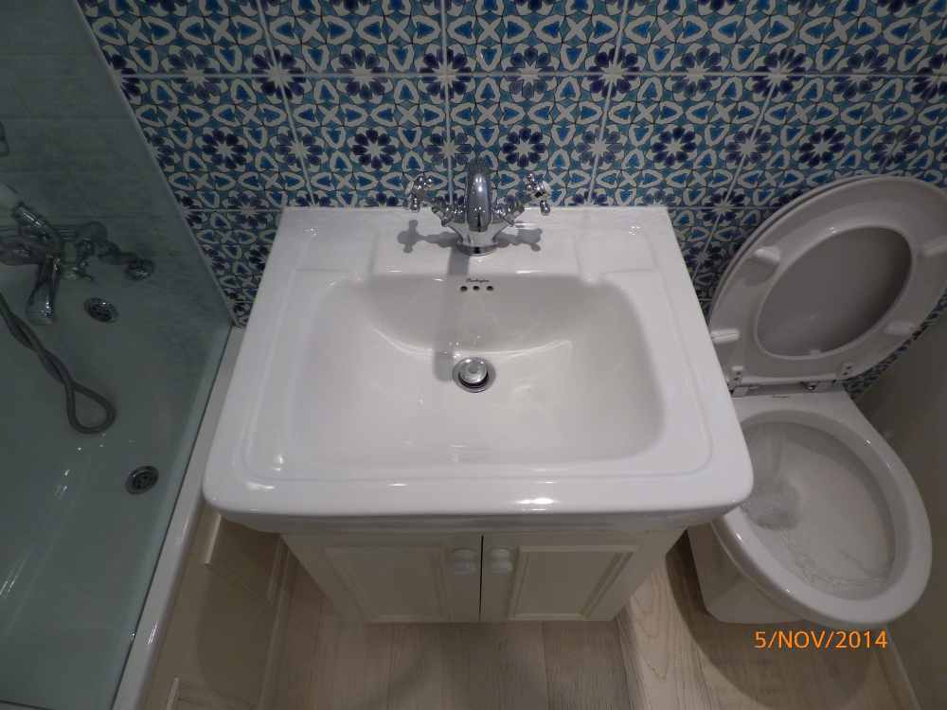 | 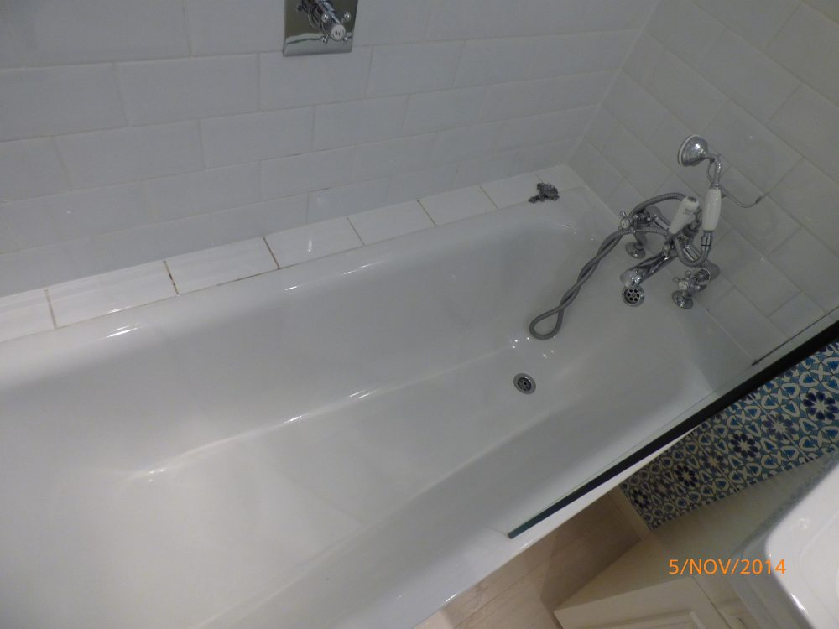 | 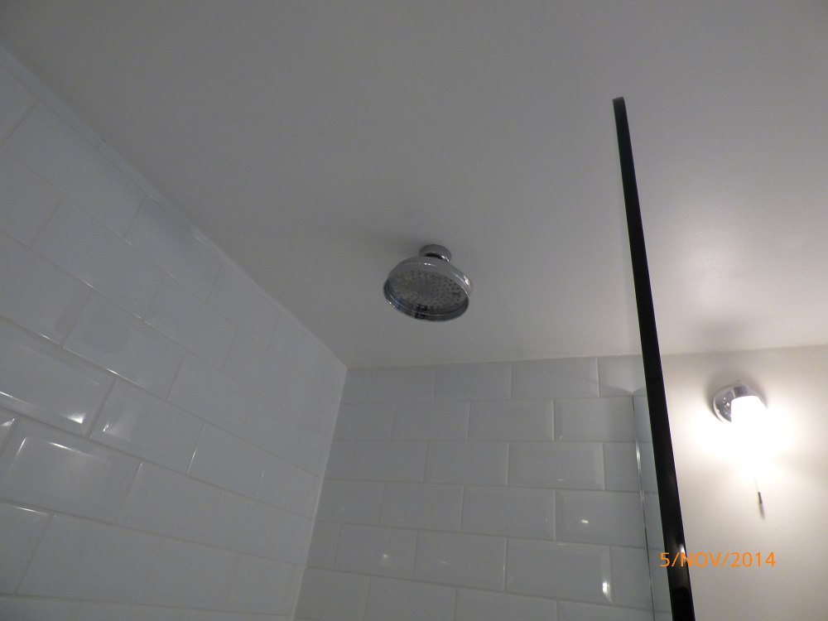
Sink | Bath | Shower

BEDROOM 2 (MIDDLE BEDROOM)
ITEM |  |  | CHECK IN COMMENTS | CHECK OUT
Exterior door frame
 | Painted magnolia. |  | Old defects under.  Several light chips to lower level.
Exterior door
 | Magnolia painted 4-panel wooden door.
 | 1 circular chrome, white and black pull.
Threshold
 | Aluminium.
Interior door frame
 | Painted magnolia. |  | 1 chip lower right hand side corner.
Interior door
 | Magnolia painted 4-panel wooden door. |  | 2 inch section of worn paintwork to upper right side corner.  2 very light marks.
 | 1 circular chrome, white and black pull. |  | Paint marked.  Missing 1 screw.
 | 2 chrome double clothes hooks. |  | Right hook slightly loose.
Flooring
 | Beige fitted wall-to-wall carpeting. |  | Not inspected below furniture.  Light draught marks to edges.  Several light furniture indentation marks.  Professionally cleaned.
 | 1 white rubber floor mounted doorstop.
Skirting boards/woodwork
 | Magnolia painted skirting boards. |  | Few general light usage marks.  Light cracking to top corners right of entrance.  Very light shrinkage corner cracks.  1 hole left hand side of the radiator.
Walls
 | Painted magnolia.
 |  | Left wall
 |  | Facing wall | 1 painted over air vent to high level.
 |  | Right wall
 |  | Rear wall
Switches and sockets
 | 1 chrome single dimmer switch.
 | 6 chrome double plug sockets.
Heating
 | 1 white metal wall mounted double panel box radiator containing:  1 metal thermostat.  1 plastic valve cover. |  | Roughly painted to front panel.
Windows
 | Magnolia painted wooden sash window containing:  4 single glazed panes.  2 metal finger pulls.  1 metal lock.  2 white sash cords.  1 built-in air vent to high level. |  | Glazing sound and clean.  Light scratch and paint marks to edges.  Fittings lightly tarnished and paint marked.  Pull cords discoloured.  Air vent discoloured.  Light marks to edges of frame where blind catches frame.
Curtains/blinds
 | 1 wooden Venetian blind with matching pelmet containing brown pull cords and wooden acorns. |  | In working order.  Clean.
Ceiling
 | Painted white.
Lighting
 | 1 long white plastic ceiling mounted pendant light fitting with circular white floral patterned frosted shade. |  | In working order.  Cable discoloured.
Built-in wardrobes
 | Wardrobe 1 (left hand side):  4 magnolia painted doors.  4 white pulls.  Magnolia painted interior.  1 metal clothes rail.  1 magnolia shelf. |  | General usage and small chips to interior.  Top section too high to inspect.
 | Wardrobe 2 (right hand side):  4 magnolia painted doors.  4 white pulls.  Magnolia painted interior.  1 metal clothes rail.  4 magnolia shelves.  1 magnolia painted divider.  1 door mounted wavy mirror to right door. |  | Interior scuffed throughout.  Several chips to flooring.  Light wear to edges.  Top section too high to fully inspect.
Furniture/accessories
 | 1 black wooden chest of drawer with 4-drawers. |  | New
 | Bed:  1 dark wooden double bed frame with wooden slats to the underside and matching headboard. |  | In good condition.  New
 | Mattress:  1 white double mattress. |  | No stains seen.  Fire label seen.  New
 | Linen:  1 white mattress protector. |  | Freshly laundered.
 | 1 small circular glass lamp with frosted glass floral patterned shade. |  | No bulb.  Unable to test.

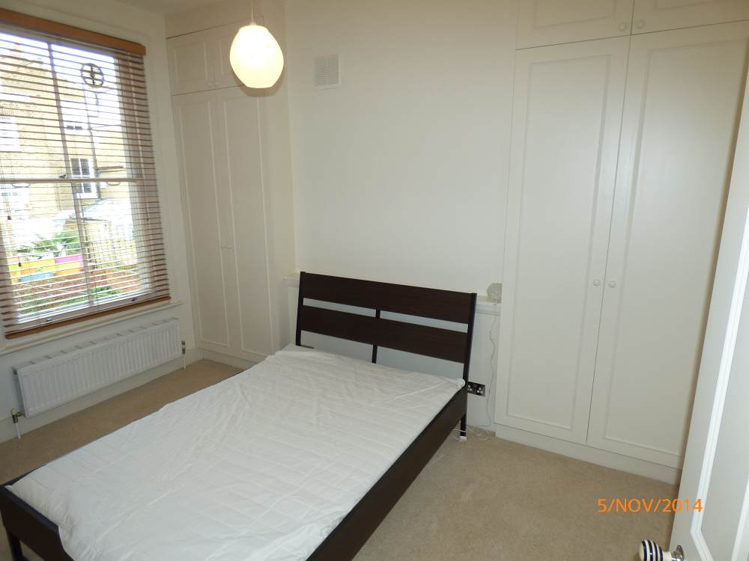 | 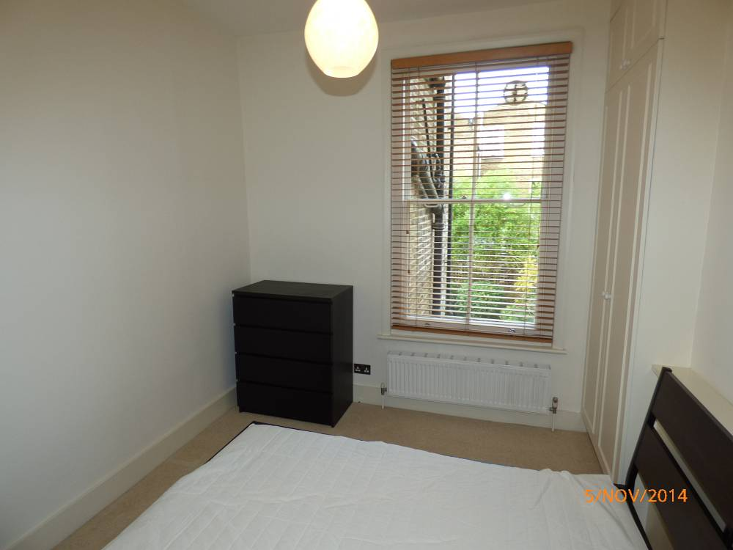 | 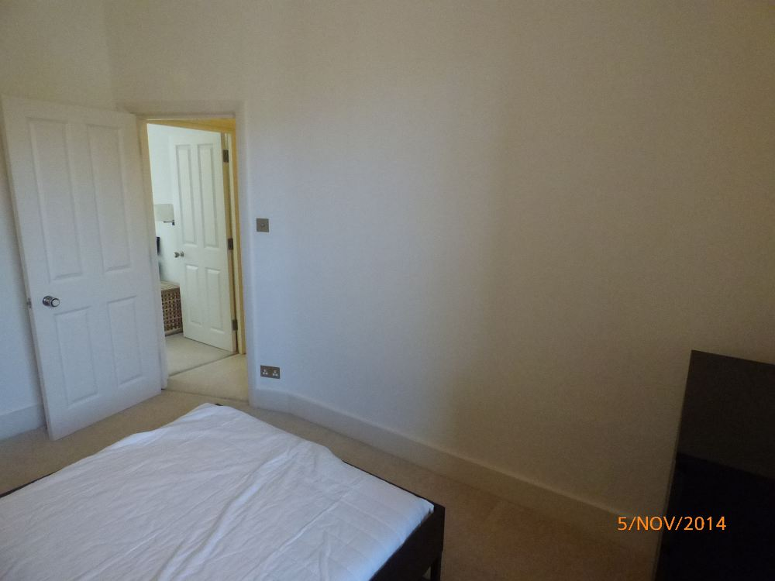 | 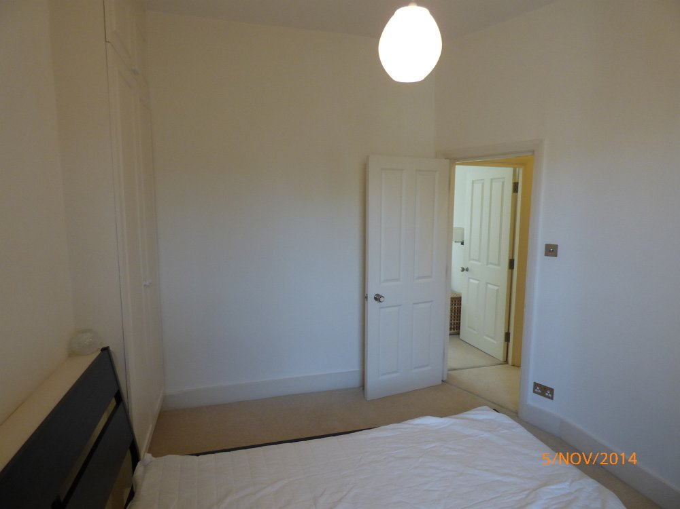
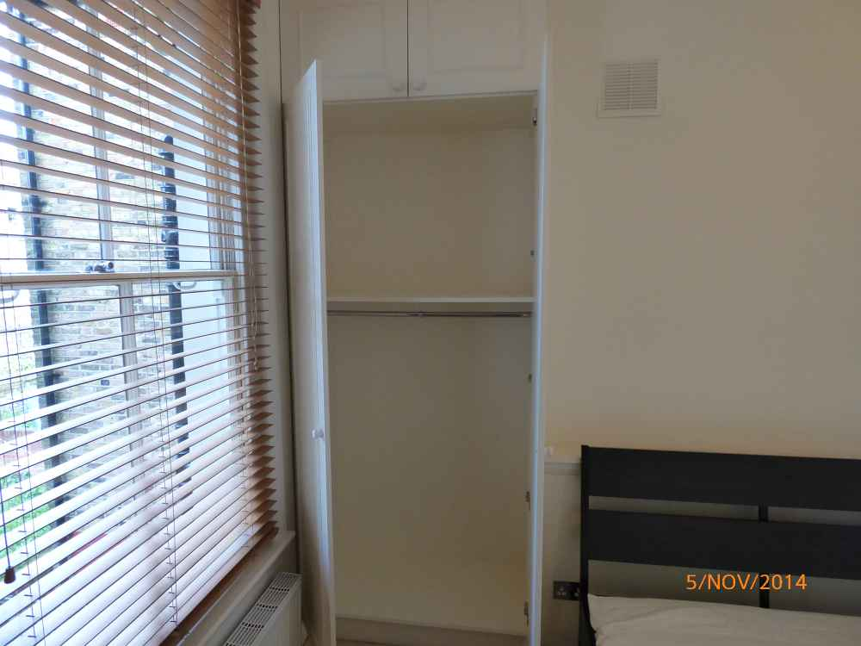 | 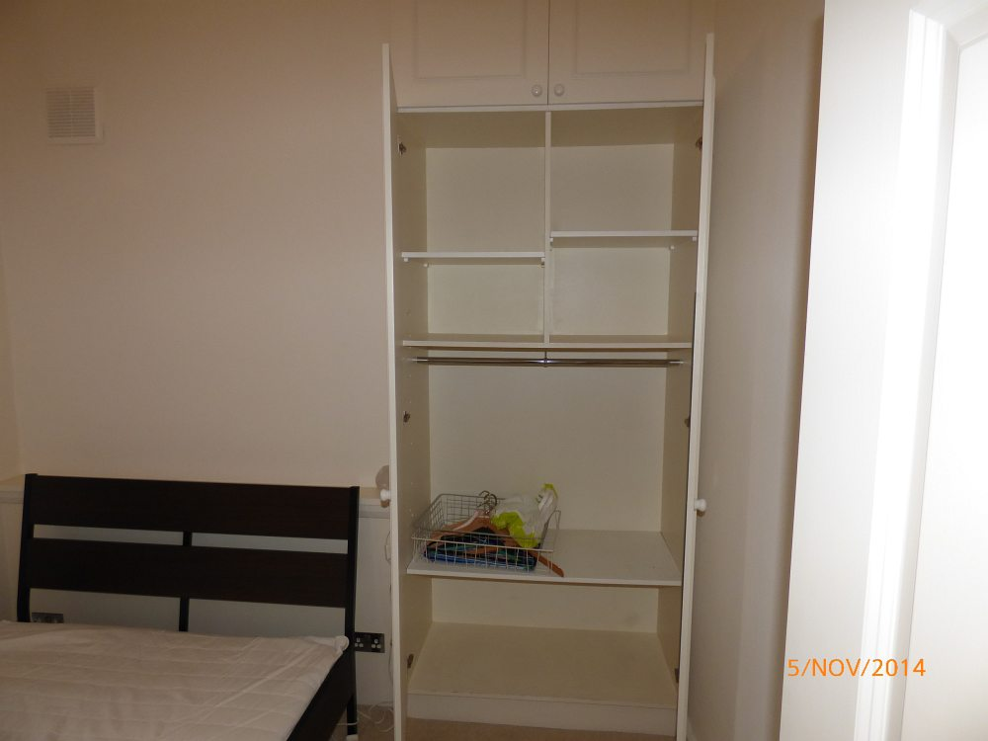

BEDROOM 3 (FRONT OF PROPERTY)
ITEM |  |  | CHECK IN COMMENTS | CHECK OUT
Exterior door frame
 | Painted magnolia. |  | Old defects under.  Several light chips to lower level.
Exterior door
 | Magnolia painted 4-panel wooden door. |  | Few light usage marks to lower level.  2 small paint chip marks.
 | 1 circular chrome, white and black pull.
Threshold
 | Aluminium.
Interior door frame
 | Painted magnolia. |  | Old defects under.  Light angle wear lower right hand side.
Interior door
 | Magnolia painted 4-panel wooden door. |  | 1 small fitment hole right hand side of right hand side clothes hook.  1 small material pad at lower level.
 | 1 circular chrome, white and black pull.
 | 2 chrome double clothes hooks.
Flooring
 | Cream fitted wall-to-wall carpeting. |  | Professionally cleaned.  Draught marks to edges.  Carpet lightly shaded through general wear.  Several light furniture indentation marks.  Several grey spot marks, mainly around bed area.
Skirting boards/woodwork
 | Magnolia painted skirting boards. |  | General usage and scuff marks.  Cabling clipped to section to left hand wall and below left hand side of window.
Walls
 | Painted magnolia.
 |  | Left wall | 1 painted over air vent to high level.  Air vent discoloured.
 |  | Facing wall | Light painted over shrinkage cracks around window.
 |  | Right wall
 |  | Rear wall
Switches and sockets
 | 2 chrome double dimmer switches.
 | 1 chrome single dimmer switch.
 | 4 chrome double plug sockets.
 | 2 white television wires with metal ends.
Heating
 | 1 x 3-section wall mounted double panel radiator containing 1 metal thermostat. |  | Light usage marks to front panel.
Windows
 | 3 magnolia painted wooden sash windows containing:  3 clear single glazed panes.  3 frost double glazed panes.  2 metal finger pulls.  1 metal lock.  2 metal locking bolts.  2 white sash cords. |  | Glazing sound and clean.  Light cracking to corners of woodwork.  Left and right hand side windows painted shut.
Curtains/blinds/shutters
 | 8 magnolia wooden double folding shutters with adjustable slats. |  | All in good condition and working.
Ceiling
 | Painted white.
Lighting
 | 1 plastic ceiling mounted pendant light fitting with circular frosted glass floral patterned shade. |  | In working order.  Wire discoloured.
 | 2 chrome wall mounted lights each with a circular cream shade. |  | Both in working order.
Built-in wardrobes
 | Wardrobe 1 (left hand side):  4 magnolia painted doors.  4 glass and chrome pulls.  Magnolia painted interior.  2 magnolia shelves.  1 metal clothes rail.  1 grey fabric clothes divider/hanger to interior. |  | Numerous usage marks to interiors.  Several minor pin size holes to interior doors.
 | Wardrobe 2:  4 magnolia painted wooden doors.  4 glass and chrome pulls.  Magnolia painted interiors.  1 metal clothes rail.  6 magnolia painted shelves.  2 magnolia painted dividers.  1 door mounted wavy mirror. |  | Interior scuffed and marked throughout.
Furniture/accessories
 | 1 black wooden chest of drawer with 4 drawers. |  | New.
 | 1 dark wooden double bed frame with wooden slats to the underside and matching headboard. |  | New.
 | Mattress:  1 grey and cream Morgedal IKEA mattress. |  | Fire label seen.  Clean.  New.
 | Linen:  1 white IKEA mattress protector. |  | Freshly laundered.  new
 | 1 additional white single mattress. |  | Fire label seen.
Miscellaneous Items
 | 1 large wicker laundry basket with lift up lid. |  | Wicker worn.  Unravelling and patchy to lid.
 | 1 wooden slatted storage box with lift-up lid.

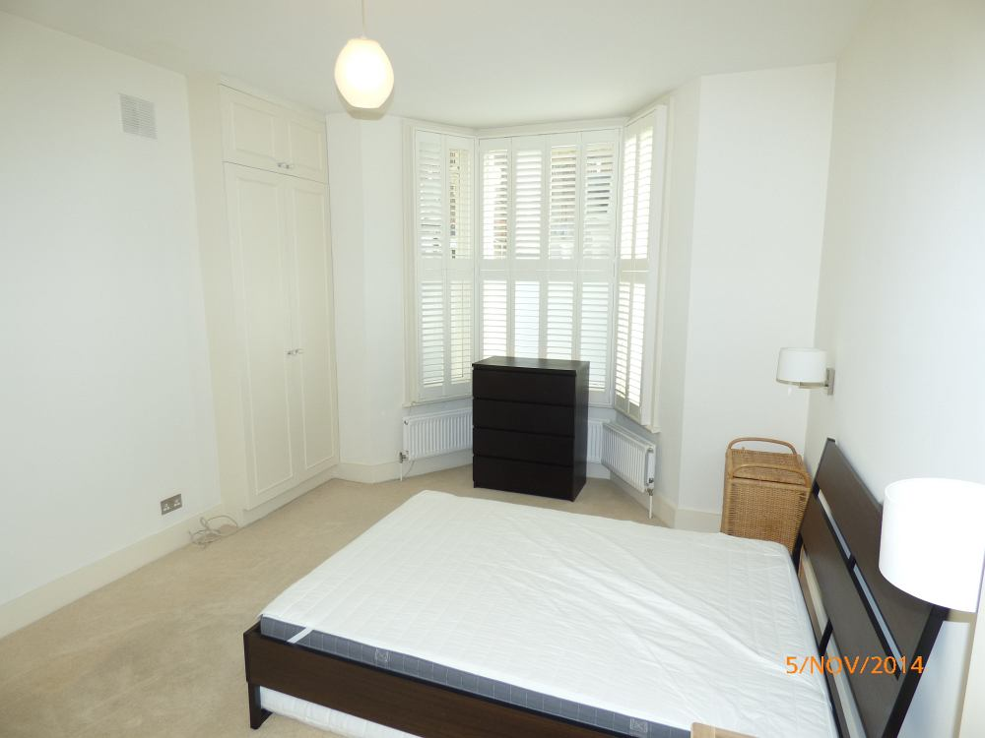 | 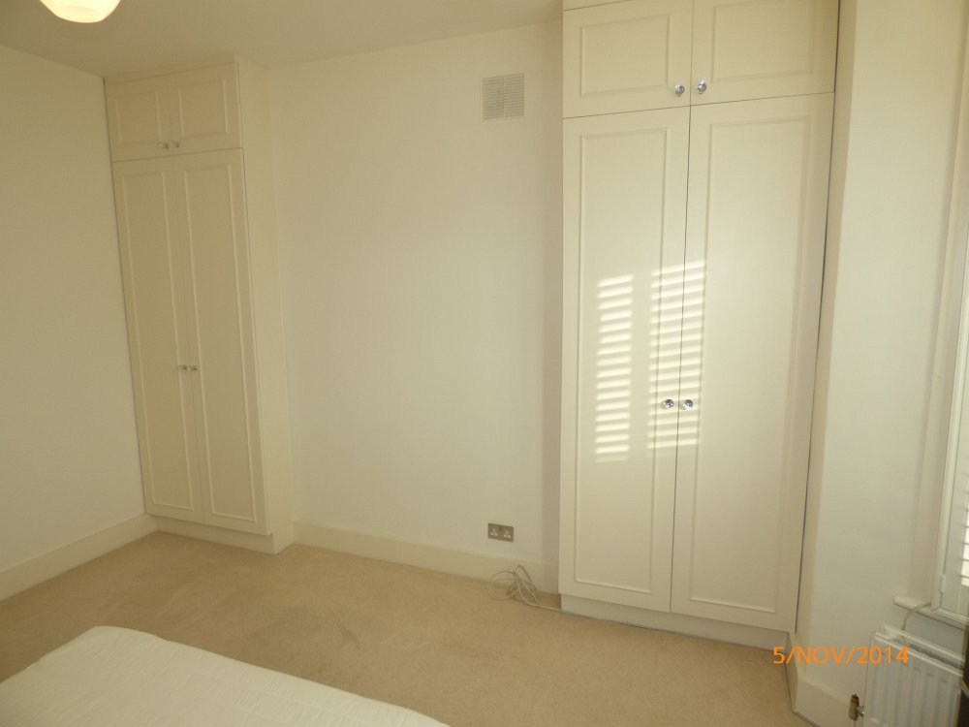 | 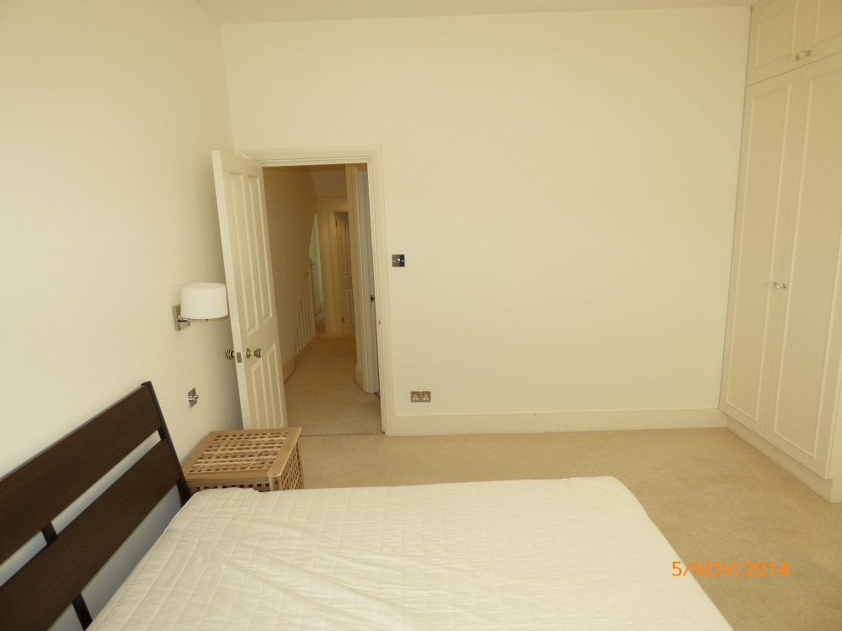 | 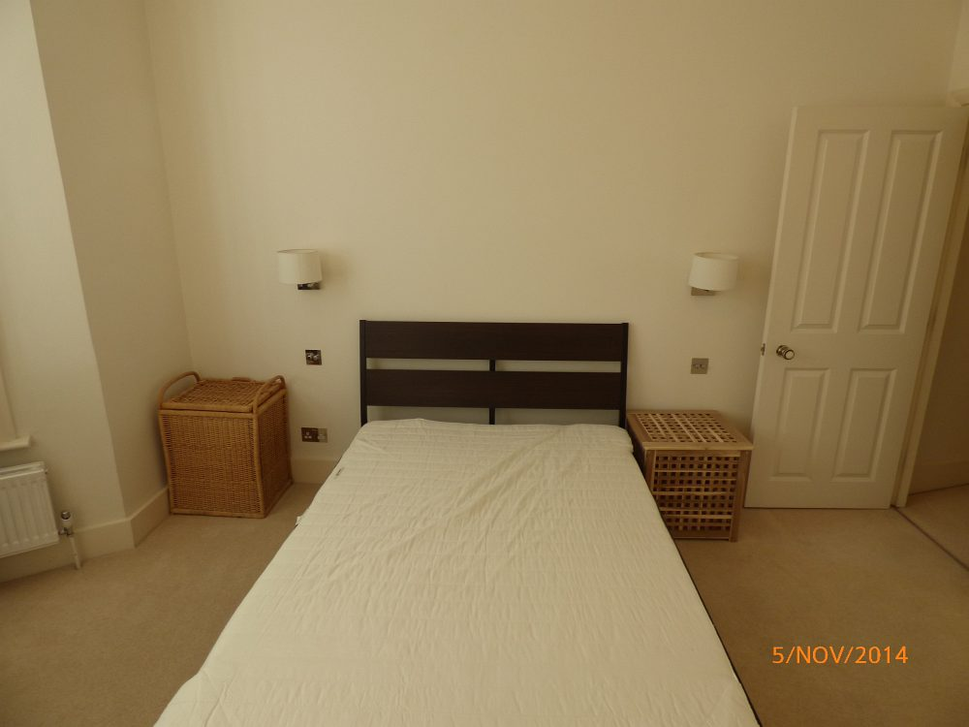
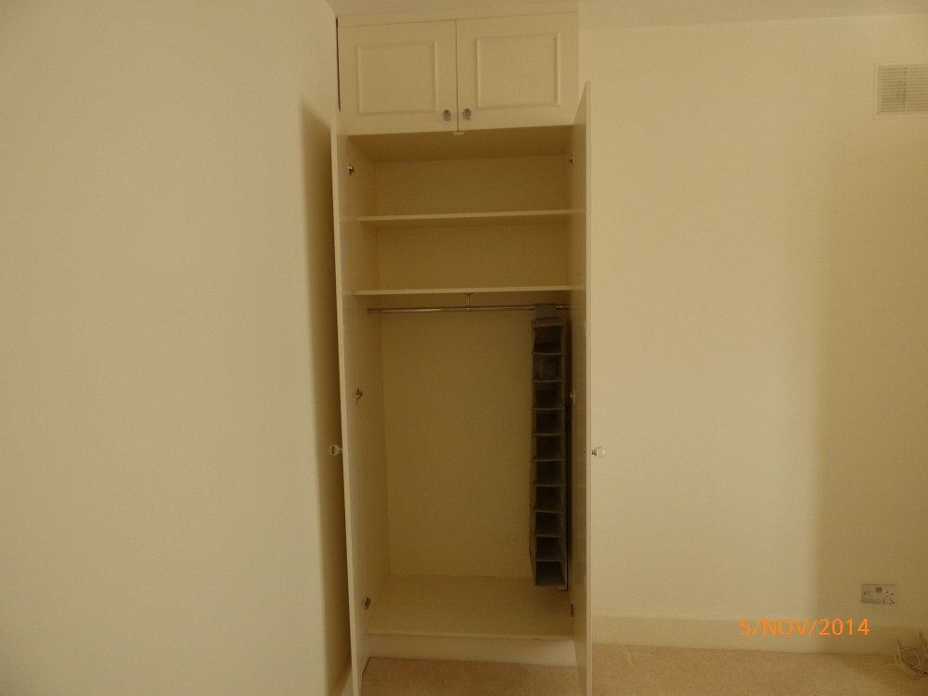 | 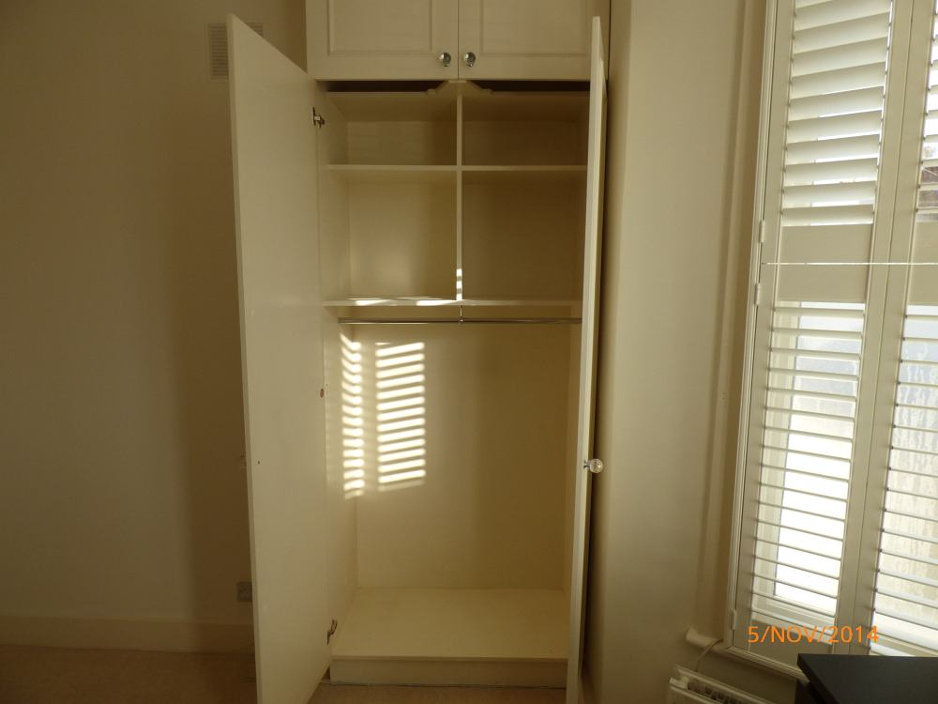 | 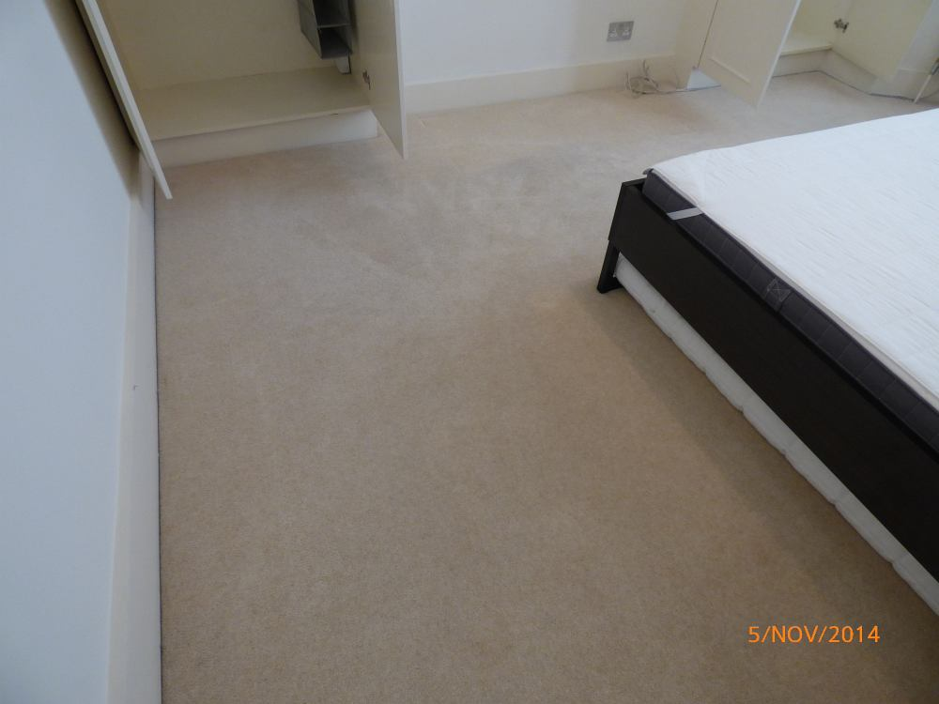 | 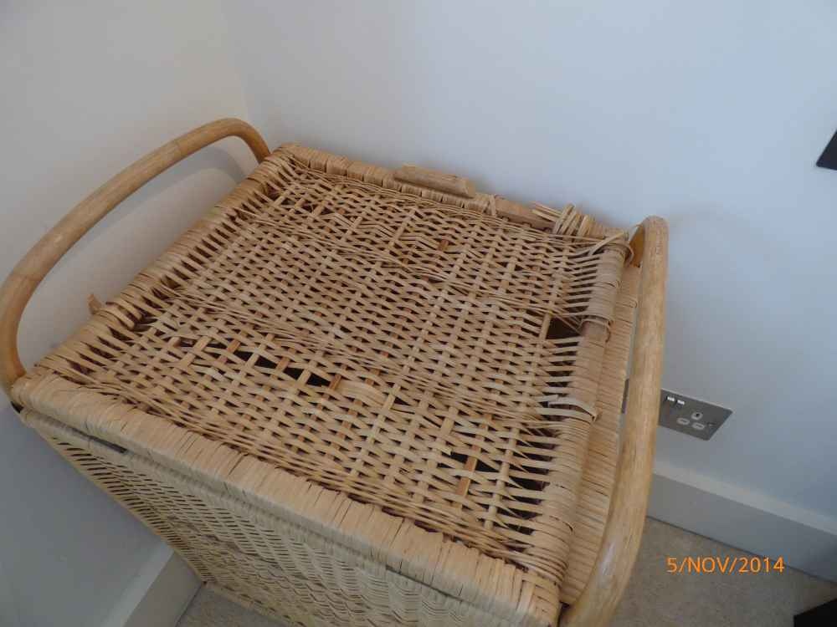
 |  | Shading to carpet | Worn wicker

REAR GARDEN
ITEM |  |  | CHECK IN COMMENTS | CHECK OUT
Flooring
 | Part concrete flooring. |  | Weathered and discoloured.  Several cracks and moss build-up.
 | 2 metal floor mounted access panels. |  | Both rusted.
 | Part lawn. |  | Recently mowed.  Quite patchy with sections missing.
 | Part soil boundary. |  | In good condition.
Walls
 | Part exposed brickwork.  Part white painted brickwork.  Part wooden slatted fencing. |  | Exposed brickwork generally discoloured
 |  | Left wall | Some moss build-up to walls at lower level.
 |  | Facing wall
 |  | Right wall
 |  | Rear wall
Lighting
 | 1 wall mounted infrared flood light. |  | Not tested
 | 4 flood lights mounted to the soil boundary. |  | Not tested.
 | 2 wall mounted infrared lights with plastic covers. |  | Not tested.  Discoloured and paint marked.
Furniture items
1 black furniture set containing:
1 x 2-seater bench.
2 chairs.
1 table.
Shed
 | Grey painted shelf with felt roof.  2 doors.  Wooden interior. |  | Interior flooring discoloured and stained with lot amounts of discolouration and water.
Miscellaneous items
 | 1 green plastic electric lawn mower with detachable basket. |  | Not tested.  Generally worn and discoloured.
 | 4 black wall mounted drain pipes.
 | 1 wall mounted Barry Bros alarm panel.
 | 1 black wall mounted extendable clothes line.
 | Large amount of ivy and shrubs. |  | All in good seasonal order.
 | Wooden step. |  | Discoloured with moss build-up.

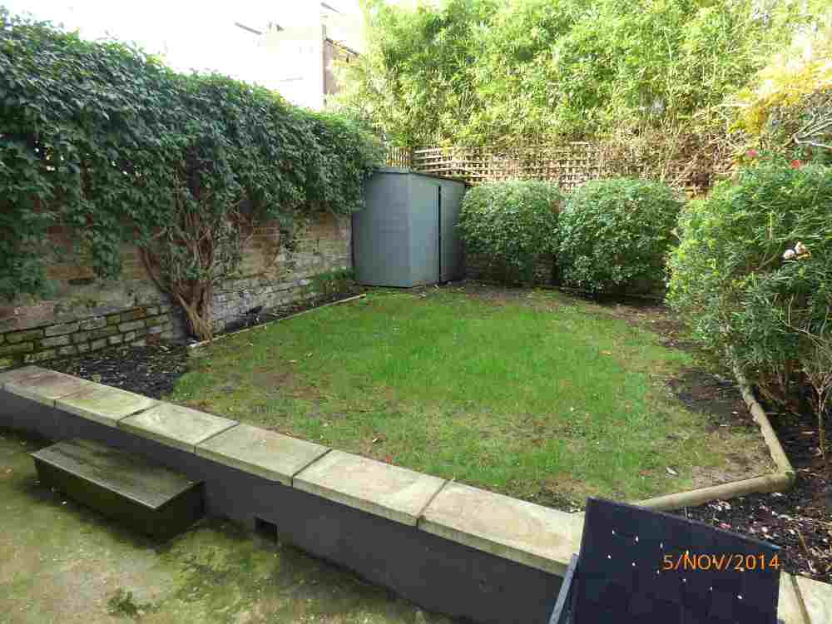 | 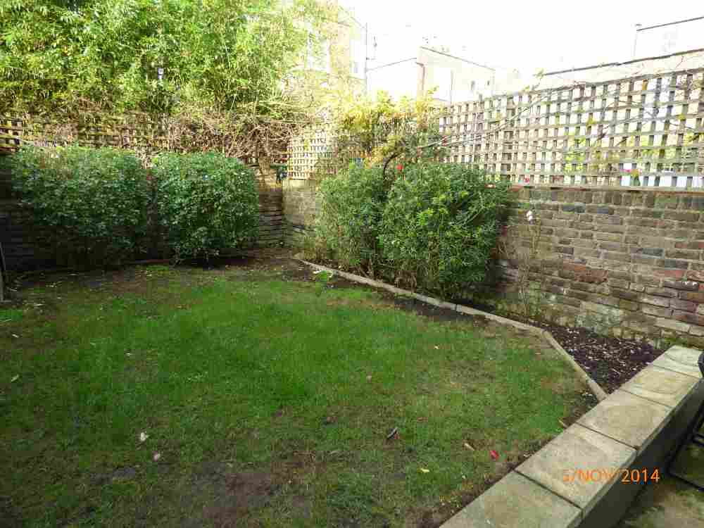 | 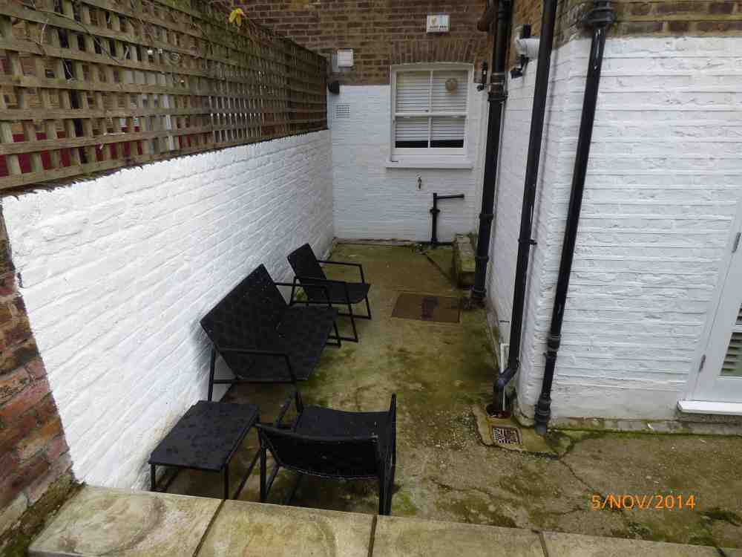 | 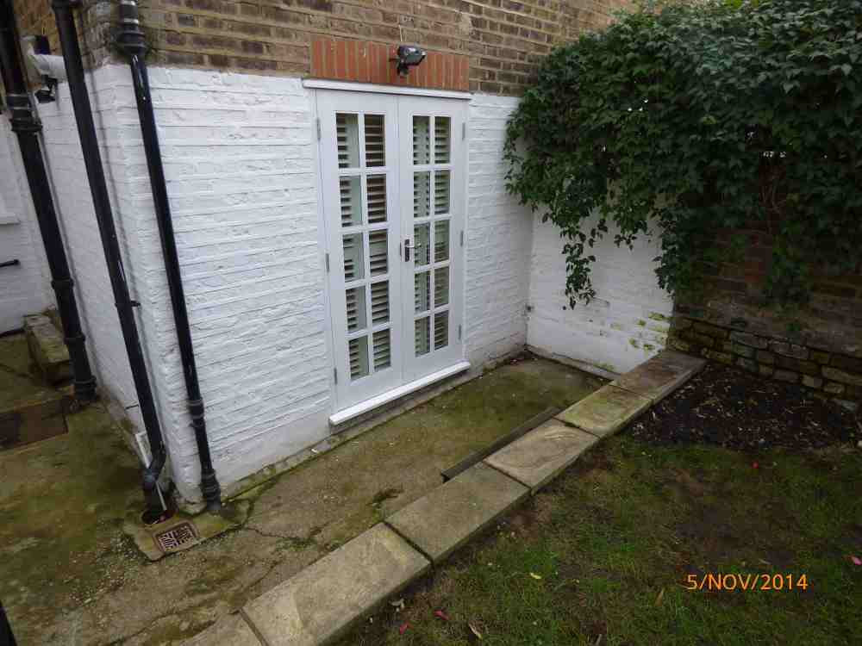
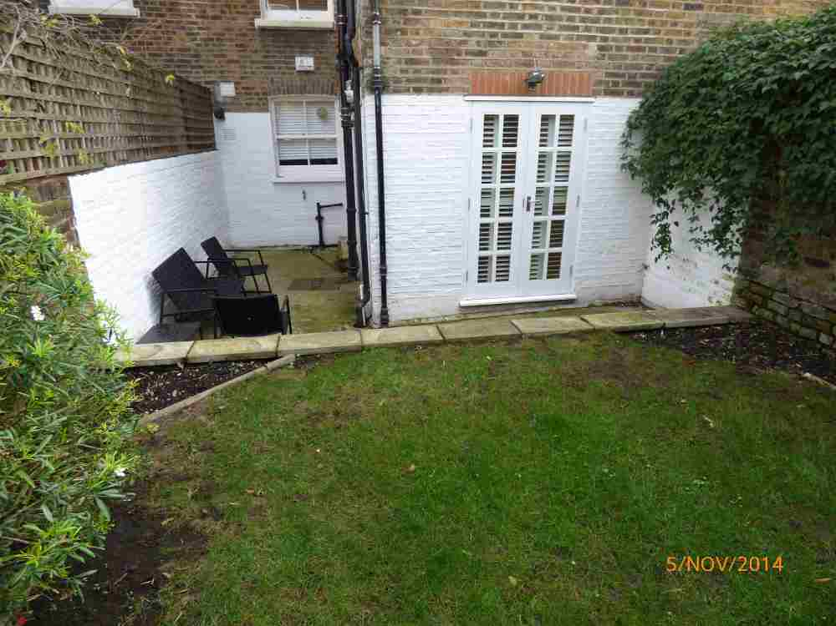 | 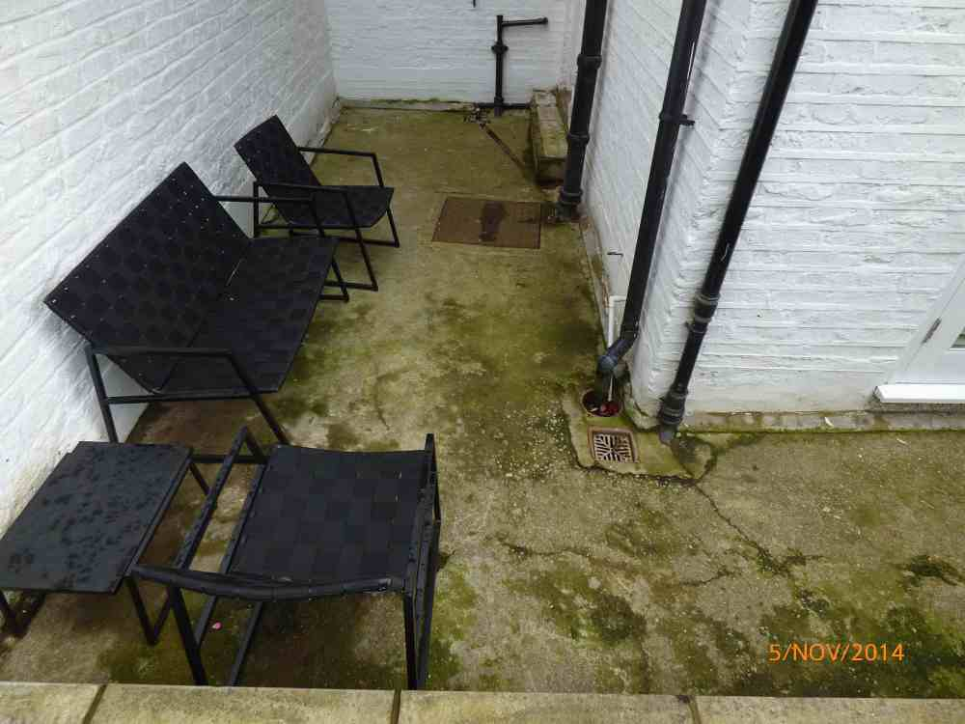 | 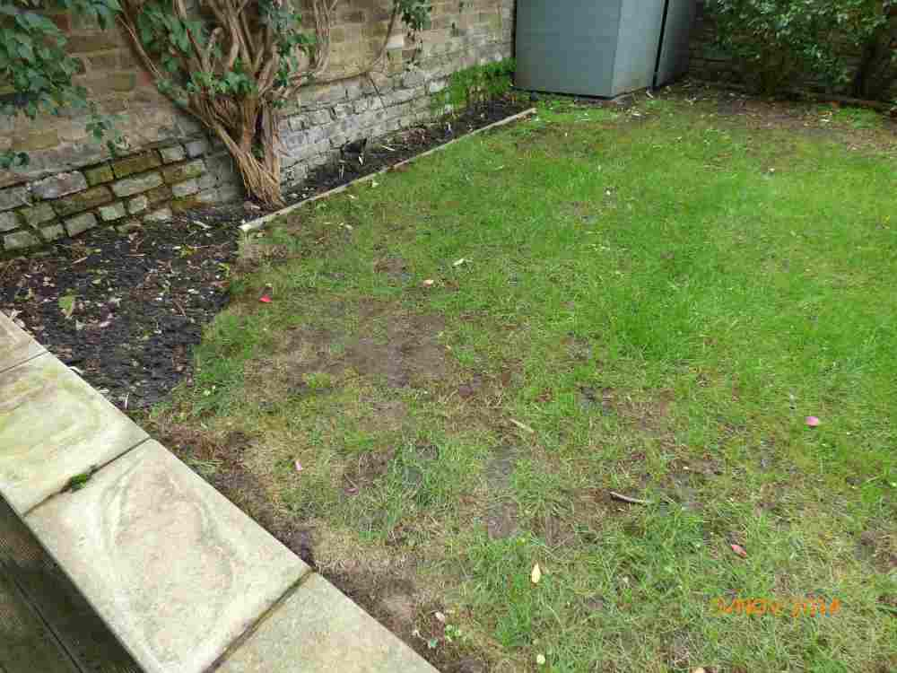 | 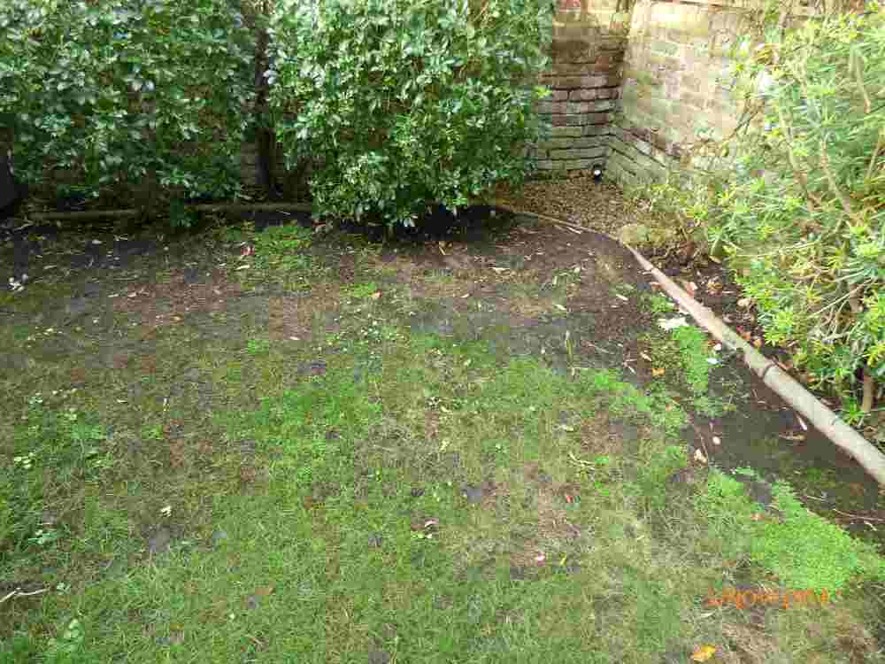
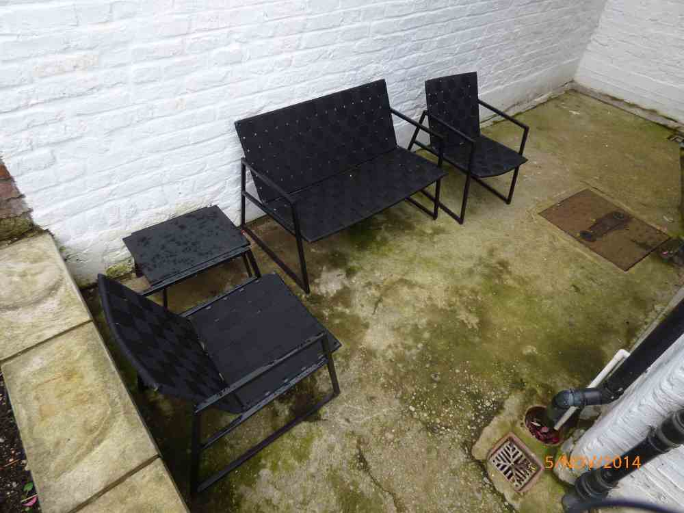 | 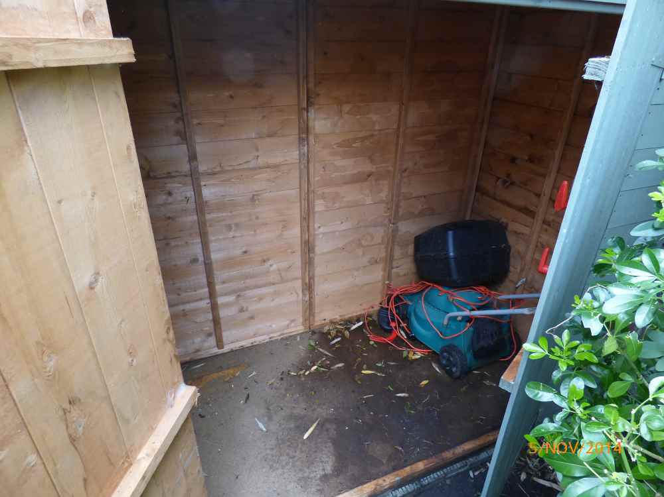
Notes.

DISCLAIMER
1. This report is a fair and accurate report, which describes the property’s contents, conditions and cleanliness for rental purposes only. This document is no guarantee of, or report on, the adequacy of, or safety of any such equipment of contents, merely a record that such items exist in the property as at the date of the inventory report and check-in or check -out and the superficial condition of same.

2. The report only extends to parts of the property that are readily accessible. All other parts of the premises, for example attics, garages, basements, lofts and cupboards full of items, are specifically excluded. The compiler cannot undertake to search in inaccessible places, through overcrowded drawers or cupboards, nor will the compiler undertake to move heavy furniture or bulky items.

3. Properties with large amounts of small items possibly included but not limited to, kitchen items such as cutlery, crockery, glass etc., prints or painting, small ornaments and linen items will not be individually itemized or described and instead be recorded as an ‘assortment’

4. It should be noted that Inside Out Inventories clerks are NOT trained in textiles, timbers, antiques, decoration or design forms. This report has been prepared for identification purposes only and in no way constitutes a valuation or statement of authenticity.

5. Unless the report is carried out in daylight hours, the garden and exterior of the premises have NOT been inspected.

6. Unless otherwise stated the inspection of the property and compilation of this report was conducted at the date stated on the front cover and all photographs included were taken during the inspection

7. This report has been compiled on the accepted principle that, in the absence of marginal comments, items are visibly free of defects, soiling, damage or missing parts. Where no comment is recorded on condition of an area or item, the area or items is accepted to be free from any noticeable and or visible soiling and damage and not further notes are required for its description.

8. Inside Out Inventories accept that the contractual terms listed within a tenancy agreement may overrule the opinion of the inventory clerk.

9. Please note items in boxes, plastic bags & other such containers are not recorded, as they are assumed to be awaiting removal.

10. Electrical appliances, machinery, boilers, gas appliances, radiators, water supply and other similar items are not tested unless individually mentioned. Lighting is solely tested to indicate whether light bulbs are working at time of inspection however, this is not an indicator that such items are functioning correctly or comply with the relevant safety regulations. Electrical items may only be tested for safety by a qualified electrician.

11. Inside Out Inventories accepts no responsibility as a result of any failure of the windows within a property or parts thereof to operate properly at all. Windows and parts thereof will not be tested for operation or function, unless individually mentioned and comments thereof are solely based on the superficial appearance of the windows, frames, fittings and sills.

12. Towels, bed linen and other similar items will only been inspected if laundered.

13. Burglar alarms and smoke detectors are not tested.

14. Meter readings may only be taken if these are located and readily accessible and, in any event, these should be checked by the relevant utility company.

15. Property left in lofts, cellars and locked rooms, which have not been inventoried, are the sole responsibility of the Landlord.

16. Where the inventory notes “Fire Safety label seen” this should not be interpreted to mean that the item complies with the “Furniture and Furnishings” (Fire)(Safety)(Amendments) 1993. It is a record that the item had a label as described or similar to that detailed, in the “Guide to the Furniture and Furnishings” (Fire)(Safety) Regulations as published by Department of Trade and Industry, January 1997, (or subsequent edition), attached at the time the inventory was compiled. It is not a statement that the item can be considered to comply with the Regulations.

17. All items of furniture and contents of the property must be returned to the same areas as stated on the inventory report to ensure an accurate check out inspection. Items not returned to original places may be marked as not found and charged for. Any items stored during the tenancy should be unpacked and returned to original places, as noted on the inventory report.

18. Inside Out Inventories will not accept responsibility for items listed as ‘not found’ on check out reports, should this be as a result of items moved and or not returned to original positions and or respective rooms by the tenant as laid out on the original inventory and or check in reports provided by the instructing principal.

19. The inspection and report has been conducted and compiled on the requirement of the instructing principal within the restricts imposed by the environment possibly including but not limited to cleaning in progress, building works in progress, inaccessible areas or content, items requiring cleaning, unavailable keys and or access and poor lighting.

20. Inside Out Inventories does not accept responsibility for any omissions within any inspection conducted and report compiled with the tenants in situ or resident at time of inspection of the property.

21. This report and comments within will remain the property of Inside Out Inventories and cannot be used or duplicated without their written permission.

22. Inside Out Inventories does not accept the responsibility for any actions associated with the task of delivery, agreement or signed declaration or lack thereof of any and all parties associated with this report and its validity.

23. It is the responsibility of the landlord and the tenant, or the respective agent, to agree between themselves the accuracy of this report. No warranty of accuracy is given concerning the contents of the information contained in this report. To the extent permitted by law, no liability (including liability to any person by reason of negligence) will be accepted by the report author, its subsidiaries, employees or agents for any direct or indirect loss or damage caused by omissions from or inaccuracies in this document.

Check-In Declaration – sign & print all names
I/we the tenant/s hereby acknowledge receipt of this inventory and accept the contents and condition of the property to be as set out in this inventory. I/we further hereby accept, acknowledge and understand that I/we have seven (7) days in which to make a closer and more thorough inspection of the property and to confirm in writing any comments or amendments to this inventory in the “check-in comments” section and to return this to the landlord or their agent.
I/we the tenant/s further accept, acknowledge and agree that unless I/we make any such written amendments or comments and return this document to the landlord or their agent within seven days of the date of my receipt of this document, this document will be the definitive basis of comparison of the contents and condition of the property at the time of the end of tenancy howsoever occasioned. I/we further accept, acknowledge and agree that this check-in declaration applies to tenant in the singular or tenants in the plural as applicable to the tenancy agreement to which this inventory relates.
Tenant/s
Landlord/Landlord’s Agent
Keys at Check-In

